Table of Contents

UNITED STATES

SECURITIES AND EXCHANGE COMMISSION

Washington, D.C. 20549

__________________________________________________________

FORM 10-Q

__________________________________________________________

- QUARTERLY REPORT PURSUANT TO SECTION 13 OR 15(d) OF THE SECURITIES EXCHANGE ACT OF 1934

For the quarterly period ended March 31, 2019

OR

- TRANSITION REPORT PURSUANT TO SECTION 13 OR 15(d) OF THE SECURITIES EXCHANGE ACT OF 1934

For the transition period from to

Commission file number: 001-35004

__________________________________________________________

FleetCor Technologies, Inc.

(Exact name of registrant as specified in its charter)

__________________________________________________________
Delaware | 72-1074903
(State or other jurisdiction of | (I.R.S. Employer
incorporation or organization) | Identification No.)
5445 Triangle Parkway, Peachtree Corners, Georgia | 30092
(Address of principal executive offices) | (Zip Code)
Registrant’s telephone number, including area code: (770) 449-0479
__________________________________________________________

Indicate by check mark whether the registrant (1) has filed all reports required to be filed by Section 13 or 15(d) of the Securities Exchange Act of 1934 during the preceding 12 months (or for such shorter period that the registrant was required to file such reports), and (2) has been subject to such filing requirements for the past 90 days. Yes ☒ No ☐

Indicate by check mark whether the registrant has submitted electronically every Interactive Data File required to be submitted pursuant to Rule 405 of Regulation S-T (§232.405 of this chapter) during the preceding 12 months (or for such shorter period that the registrant was required to submit such files). Yes ☒ No ☐

Indicate by check mark whether the registrant is a large accelerated filer, an accelerated filer, a non-accelerated filer, a smaller reporting company, or an emerging growth company. See the definitions of “large accelerated filer,” “accelerated filer,” “smaller reporting company” and "emerging growth company" in Rule 12b-2 of the Exchange Act. (Check one:)

Large accelerated filer | ☒ | Accelerated filer | ☐
Non-accelerated filer | ☐ | Smaller reporting company | ☐
Emerging growth company | ☐
If an emerging growth company, indicate by check mark if the registrant has elected not to use the extended transition period for complying with any new or revised financial accounting standards provided pursuant to Section 13(a) of the Exchange Act. ☐

Indicate by check mark whether the registrant is a shell company (as defined in Rule 12b-2 of the Exchange Act). Yes ☐ No ☒ Indicate the number of shares outstanding of each of the issuer’s classes of common stock, as of the latest practicable date.

Table of Contents
 |  |  |  | Class |  |  |  | Outstanding at April 15, 2019
 |  |  | Common Stock, $0.001 par value |  |  |  | 86,193,402
Securities registered pursuant to Section 12(b) of the Act:
 |  |  | Title of each class |  |  | Trading Symbol(s) | Name of each exchange on which registered
 |  |  | Common Stock |  |  | FLT |  | NYSE

Table of Contents

FLEETCOR TECHNOLOGIES, INC. AND SUBSIDIARIES

FORM 10-Q

For the Three Months Ended March 31, 2019

INDEX

 |  |  |  |  |  |  |  |  |  |  |  |  |  | Page
PART I—FINANCIAL INFORMATION
Item 1. | FINANCIAL STATEMENTS
 | Consolidated Balance Sheets at March 31, 2019 (unaudited) and December 31, 2018 |  |  |  |  |  |  |  |  |  |  |  |  | 1
 | Unaudited Consolidated Statements of Income for the Three Months Ended March 31, 2019 and 2018 |  |  |  |  |  |  |  |  |  |  |  |  | 2
 | Unaudited Consolidated Statements of Comprehensive Income for the Three Months Ended March 31, 2019 and 2018 |  |  |  |  |  |  |  |  |  |  |  |  | 3
 | Unaudited Statements of Cash Flows for the Three Months Ended March 31, 2019 and 2018 |  |  |  |  |  |  |  |  |  |  |  |  |  |  | 5
 | Notes to Unaudited Consolidated Financial Statements |  |  |  |  |  |  |  |  |  |  |  |  |  |  | 6
Item 2. | MANAGEMENT’S DISCUSSION AND ANALYSIS OF FINANCIAL CONDITION AND RESULTS OF OPERATIONS |  |  |  |  |  |  |  |  |  |  |  |  | 23
Item 3. | QUANTITATIVE AND QUALITATIVE DISCLOSURES ABOUT MARKET RISK |  |  |  |  |  |  |  |  |  |  |  |  | 37
Item 4. | CONTROLS AND PROCEDURES |  |  |  |  |  |  |  |  |  |  |  |  | 37
PART II—OTHER INFORMATION
Item 1. | LEGAL PROCEEDINGS |  |  |  |  |  |  |  |  |  |  |  |  | 38
Item 1A. | RISK FACTORS |  |  |  |  |  |  |  |  |  |  |  |  | 38
Item 2. | UNREGISTERED SALES OF EQUITY SECURITIES AND USE OF PROCEEDS |  |  |  |  |  |  |  |  |  |  |  |  | 39
Item 3. | DEFAULTS UPON SENIOR SECURITIES |  |  |  |  |  |  |  |  |  |  |  |  | 39
Item 4. | MINE SAFETY DISCLOSURES |  |  |  |  |  |  |  |  |  |  |  |  | 39
Item 5. | OTHER INFORMATION |  |  |  |  |  |  |  |  |  |  |  |  | 39
Item 6. | EXHIBITS |  |  |  |  |  |  |  |  |  |  |  |  | 40
SIGNATURES |  |  |  |  |  |  |  |  |  |  |  |  |  | 41

i

Table of Contents

PART I—FINANCIAL INFORMATION

Item 1. Financial Statements

FLEETCOR Technologies, Inc. and Subsidiaries

Consolidated Balance Sheets

(In Thousands, Except Share and Par Value Amounts)

 |  | March 31, 2019¹ |  |  | December 31, 2018
 |  | (Unaudited)
Assets
Current assets:
Cash and cash equivalents | $ | 1,057,465 |  | $ | 1,031,145
Restricted cash |  | 315,106 |  |  | 333,748
Accounts and other receivables (less allowance for doubtful accounts of $66,194 at March 31, 2019 and $59,963 at
December 31, 2018) |  | 1,655,459 |  |  | 1,425,815
Securitized accounts receivable—restricted for securitization investors |  | 942,000 |  |  | 886,000
Prepaid expenses and other current assets |  | 202,029 |  |  | 199,278
Total current assets |  | 4,172,059 |  |  | 3,875,986
Property and equipment, net |  | 186,251 |  |  | 186,201
Goodwill |  | 4,549,099 |  |  | 4,542,074
Other intangibles, net |  | 2,355,639 |  |  | 2,407,910
Investments |  | 26,506 |  |  | 42,674
Other assets |  | 225,361 |  |  | 147,632
Total assets | $ | 11,514,915 |  | $ | 11,202,477
Liabilities and stockholders’ equity
Current liabilities:
Accounts payable | $ | 1,518,827 |  | $ | 1,117,649
Accrued expenses |  | 311,357 |  |  | 261,594
Customer deposits |  | 768,342 |  |  | 926,685
Securitization facility |  | 942,000 |  |  | 886,000
Current portion of notes payable and lines of credit |  | 865,318 |  |  | 1,184,616
Other current liabilities |  | 156,254 |  |  | 118,669
Total current liabilities |  | 4,562,098 |  |  | 4,495,213
Notes payable and other obligations, less current portion |  | 2,708,251 |  |  | 2,748,431
Deferred income taxes |  | 494,025 |  |  | 491,946
Other noncurrent liabilities |  | 219,574 |  |  | 126,707
Total noncurrent liabilities |  | 3,421,850 |  |  | 3,367,084
Commitments and contingencies (Note 13)
Stockholders’ equity:
Common stock, $0.001 par value; 475,000,000 shares authorized; 123,406,538 shares issued and 86,189,402 shares
outstanding at March 31, 2019; and 123,035,859 shares issued and 85,845,344 shares outstanding at December 31,
2018 |  | 123 |  |  | 123
Additional paid-in capital |  | 2,382,179 |  |  | 2,306,843
Retained earnings |  | 3,989,763 |  |  | 3,817,656
Accumulated other comprehensive loss |  | (934,192) |  |  | (913,858)
Less treasury stock, 37,217,136 shares at March 31, 2019 and 37,190,515 shares at December 31, 2018 |  | (1,906,906) |  |  | (1,870,584)
Total stockholders’ equity |  | 3,530,967 |  |  | 3,340,180
Total liabilities and stockholders’ equity | $ | 11,514,915 |  | $ | 11,202,477

See accompanying notes to unaudited consolidated financial statements.

- Reflects the impact of the Company's adoption of ASU 2016-02 "Leases", on January 1, 2019, using the modified retrospective transition method. Under this method, financial results reported in periods prior to 2019 are unchanged. Refer to footnote 2.

1

Table of Contents

FLEETCOR Technologies, Inc. and Subsidiaries

Unaudited Consolidated Statements of Income

(In Thousands, Except Per Share Amounts)

Three Months Ended

March 31,

 | 2019 |  |  |  | 2018
Revenues, net | $ | 621,825 |  | $ | 585,500
Expenses:
Processing |  | 129,114 |  |  | 116,485
Selling |  | 49,261 |  |  | 47,111
General and administrative |  | 92,784 |  |  | 90,370
Depreciation and amortization |  | 67,445 |  |  | 71,502
Other operating, net |  | (955) |  |  | (55)
Operating income |  | 284,176 |  |  | 260,087
Investment loss |  | 15,660 |  |  | —
Other expense (income), net |  | 220 |  |  | (297)
Interest expense, net |  | 39,055 |  |  | 31,065
Total other expense |  | 54,935 |  |  | 30,768
Income before income taxes |  | 229,241 |  |  | 229,319
Provision for income taxes |  | 57,134 |  |  | 54,382
Net income | $ | 172,107 |  | $ | 174,937
Basic earnings per share
Basic earnings per share | $ | 2.00 |  | $ | 1.95
Diluted earnings per share | $ | 1.93 |  | $ | 1.88
Weighted average shares outstanding:
Basic shares |  | 85,941 |  |  | 89,765
Diluted shares
Diluted shares |  | 89,244 |  |  | 93,250

See accompanying notes to unaudited consolidated financial statements.

2

Table of Contents

FLEETCOR Technologies, Inc. and Subsidiaries

Unaudited Consolidated Statements of Comprehensive Income

(In Thousands)

Three Months Ended

March 31,

 |  | 2019 |  |  | 2018
Net income | $ | 172,107 |  | $ | 174,937
Other comprehensive (loss) income:
Foreign currency translation gains, net of tax |  | 373 |  |  | 43,254
Net change in derivative contracts, net of tax |  | (20,707) |  |  | —
Total other comprehensive (loss) income |  | (20,334) |  |  | 43,254
Total comprehensive income | $ | 151,773 |  | $ | 218,191

See accompanying notes to unaudited consolidated financial statements.

3

Table of Contents

FLEETCOR Technologies, Inc. and Subsidiaries

Consolidated Statements of Stockholders’ Equity

(In Thousands)

 |  |  |  |  |  |  |  |  | Additional |  |  |  |  |  |  |  | Accumulated
 |  |  |  | Common |  |  |  |  |  |  |  |  |  | Retained |  |  | Other |  |  |  |  | Treasury
 |  |  |  |  |  |  |  |  | Paid-In |  |  |  |  |  |  |  | Comprehensive |  |  |  |  |  |  |  |  |  | Total
 |  |  |  | Stock |  |  |  |  | Capital |  |  |  |  | Earnings |  |  | Loss |  |  |  |  | Stock
Balance at December 31, 2018 |  | $ |  | 123 |  |  | $ |  | 2,306,843 |  |  | $ |  | 3,817,656 |  | $ | (913,858) |  | $ |  |  | (1,870,584) |  | $ |  |  | 3,340,180
 | Net income |  |  | — |  |  |  |  | — |  |  |  |  | 172,107 |  |  | — |  |  |  |  | — |  |  |  |  | 172,107
 | Other comprehensive loss, net of tax |  |  | — |  |  |  |  | — |  |  |  |  | — |  |  | (20,334) |  |  |  |  | — |  |  |  |  | (20,334)
 | Acquisition of common stock |  |  | — |  |  |  |  | 33,000 |  |  |  |  | — |  |  | — |  |  |  |  | (36,322) |  |  |  |  | (3,322)
 | Share-based compensation |  |  | — |  |  |  |  | 12,541 |  |  |  |  | — |  |  | — |  |  |  |  | — |  |  |  |  | 12,541
 | Issuance of common stock |  |  | — |  |  |  |  | 29,795 |  |  |  |  | — |  |  | — |  |  |  |  | — |  |  |  |  | 29,795
 | Balance at March 31, 2019 | $ |  | 123 |  |  | $ |  | 2,382,179 |  |  | $ |  | 3,989,763 |  | $ | (934,192) |  | $ |  |  | (1,906,906) |  | $ |  |  | 3,530,967
 |  |  |  |  |  |  |  |  | Additional |  |  |  |  |  |  |  | Accumulated
 |  |  |  | Common |  |  |  |  |  |  |  |  |  | Retained |  |  | Other |  |  |  |  | Treasury
 |  |  |  |  |  |  |  |  | Paid-In |  |  |  |  |  |  |  | Comprehensive |  |  |  |  |  |  |  |  |  | Total
 |  |  |  | Stock |  |  |  |  | Capital |  |  |  |  | Earnings |  |  | Loss |  |  |  |  | Stock |  |  |  |  | Total
 | Balance at December 31, 2017 | $ |  | 122 |  |  | $ |  | 2,214,224 |  |  | $ |  | 2,958,921 |  | $ | (551,857) |  | $ |  |  | (944,888) |  | $ |  |  | 3,676,522
 | Net income |  |  | — |  |  |  |  | — |  |  |  |  | 174,937 |  |  | — |  |  |  |  | — |  |  |  |  | 174,937
 | Cumulative effect of change in accounting
 | principle |  |  | — |  |  |  |  | — |  |  |  |  | 47,252 |  |  | — |  |  |  |  | — |  |  |  |  | 47,252
 | Other comprehensive income from currency,
 | net of tax of $0 |  |  | — |  |  |  |  | — |  |  |  |  | — |  |  | 43,254 |  |  |  |  | — |  |  |  |  | 43,254
 | Acquisition of common stock |  |  | — |  |  |  |  | — |  |  |  |  | — |  |  | — |  |  |  |  | (88,292) |  |  |  |  | (88,292)
 | Share-based compensation |  |  | — |  |  |  |  | 14,403 |  |  |  |  | — |  |  | — |  |  |  |  | — |  |  |  |  | 14,403
 | Issuance of common stock |  |  | 1 |  |  |  |  | 19,975 |  |  |  |  | — |  |  | — |  |  |  |  | — |  |  |  |  | 19,976
 | Balance at March 31, 2018 |  | $ | 123 |  |  |  | $ | 2,248,602 |  |  |  | $ | 3,181,110 |  | $ | (508,603) |  |  | $ |  | (1,033,180) |  |  | $ |  | 3,888,052

See accompanying notes to unaudited consolidated financial statements.

4

Table of Contents

FLEETCOR Technologies, Inc. and Subsidiaries

Unaudited Consolidated Statements of Cash Flows

(In Thousands)

Three Months Ended

March 31,

 |  | 2019¹ |  |  | 2018
Operating activities
Net income | $ | 172,107 |  | $ | 174,937
Adjustments to reconcile net income to net cash provided by operating activities:
Depreciation |  | 15,132 |  |  | 12,397
Stock-based compensation |  | 12,541 |  |  | 14,403
Provision for losses on accounts receivable |  | 22,164 |  |  | 11,997
Amortization of deferred financing costs and discounts |  | 1,205 |  |  | 1,339
Amortization of intangible assets and premium on receivables |  | 52,313 |  |  | 59,105
Deferred income taxes |  | (2,696) |  |  | (4,829)
Investment loss |  | 15,660 |  |  | —
Other non-cash operating income |  | (1,574) |  |  | (57)
Changes in operating assets and liabilities (net of acquisitions):
Accounts and other receivables |  | (302,395) |  |  | (288,152)
Prepaid expenses and other current assets |  | 644 |  |  | 32,074
Other assets |  | (14,517) |  |  | (7,101)
Accounts payable, accrued expenses and customer deposits |  | 326,910 |  |  | 194,589
Net cash provided by operating activities |  | 297,494 |  |  | 200,702
Investing activities
Acquisitions, net of cash acquired |  | — |  |  | (3,875)
Purchases of property and equipment |  | (14,506) |  |  | (15,214)
Other |  | — |  |  | (3,642)
Net cash used in investing activities |  | (14,506) |  |  | (22,731)
Financing activities
Proceeds from issuance of common stock |  | 29,795 |  |  | 19,975
Repurchase of common stock |  | (3,322) |  |  | (88,292)
Borrowings on securitization facility, net |  | 56,000 |  |  | 18,000
Deferred financing costs paid and debt discount |  | (284) |  |  | —
Principal payments on notes payable |  | (32,438) |  |  | (34,500)
Borrowings from revolver |  | — |  |  | 420,258
Payments on revolver |  | (353,638) |  |  | (439,351)
Borrowings on swing line of credit, net |  | 31,032 |  |  | 5,009
Other |  | (63) |  |  | (92)
Net cash used in financing activities |  | (272,918) |  |  | (98,993)
Effect of foreign currency exchange rates on cash |  | (2,392) |  |  | 12,653

Net increase in cash and cash equivalents and restricted cash

Cash and cash equivalents and restricted cash, beginning of period

Cash and cash equivalents and restricted cash, end of period

Supplemental cash flow information

7,678 91,631

1,364,893 1,130,870

$ 1,372,571 $ 1,222,501

Cash paid for interest | $ | 46,904 |  | $ | 35,634
Cash paid for income taxes | $ | 17,894 |  | $ | 16,830

- Reflects the impact of the Company's adoption of ASU 2016-02 "Leases", on January 1, 2019, using the modified retrospective transition method. Under this method, financial results reported in periods prior to 2019 are unchanged. Refer to footnote 2.

See accompanying notes to unaudited consolidated financial statements.

5

Table of Contents

FLEETCOR Technologies, Inc. and Subsidiaries

Notes to Unaudited Consolidated Financial Statements

March 31, 2019

- Summary of Significant Accounting Policies Basis of Presentation
Throughout this report, the terms “our,” “we,” “us,” and the “Company” refers to FLEETCOR Technologies, Inc. and its subsidiaries. The Company prepared the accompanying interim consolidated financial statements in accordance with Rule 10-01 of Regulation S-X. Accordingly, they do not include all of the information and footnotes required by accounting principles generally accepted in the United States (“GAAP”). The unaudited consolidated financial statements reflect all adjustments considered necessary for fair presentation. These adjustments consist of normal recurring accruals and estimates that impact the carrying value of assets and liabilities. Actual results may differ from these estimates.

The unaudited interim consolidated financial statements should be read in conjunction with the audited consolidated financial statements and notes thereto included in the Company’s Annual Report on Form 10-K for the year ended December 31, 2018.

Foreign Currency Translation

Assets and liabilities of foreign subsidiaries are translated into U.S. dollars at the rates of exchange in effect at period-end. The related translation adjustments are made directly to accumulated other comprehensive income. Income and expenses are translated at the average monthly rates of exchange in effect during the period. Gains and losses from foreign currency transactions of these subsidiaries are included in net income. The Company recognized foreign exchange gains of $0.03 million and $0.5 million for the three months ended March 31, 2019 and 2018, respectively. The Company recorded foreign currency losses on long-term intra-entity transactions of $77.0 million and $24.4 million for the three months ended March 31, 2019 and 2018, respectively, included as a component of foreign currency translation (losses) gains, net of tax, on the Unaudited Consolidated Statements of Comprehensives Income.

Derivatives

The Company uses derivatives to (a) minimize its exposures related to changes in interest rates and (b) facilitate cross-currency corporate payments by writing derivatives to customers.

The Company is exposed to the risk of increasing interest rates because our borrowings are subject to variable interest rates. In order to mitigate this risk, the Company has elected to engage in the use of derivative instruments. Interest rate swaps designated as cash flow hedges involve the receipt of variable amounts from a counterparty in exchange for the Company making fixed-rate payments over the life of the agreements without exchange of the underlying notional amount.

Changes in the fair value of derivatives that are designated and qualify as cash flow hedges are recorded in other assets or other liabilities and offset against accumulated other comprehensive income/loss, net of tax. Cash flow hedges consist of hedges a portion of the Company's variable rate debt. Derivative fair value changes that are captured in accumulated other comprehensive income/loss are reclassified to earnings in the same period or periods the hedged item affects earnings, to the extent the instrument is effective in offsetting the change in cash flows attributable to the risk being hedged. The portions of the change in fair value that are either considered ineffective or are excluded from the measure of effectiveness are recognized immediately in interest expense, net in the unaudited consolidated statements of income.

At Cambridge Global Payments ("Cambridge"), the Company uses derivatives to facilitate cross-currency corporate payments by writing derivatives to customers, which are not designated as hedging instruments. The majority of Cambridge's revenue is from exchanges of currency at spot rates, which enable customers to make cross-currency payments. In addition, Cambridge also writes foreign currency forward and option contracts for its customers to facilitate future payments. The duration of these derivative contracts at inception is generally less than one year. The Company aggregates its foreign exchange exposures arising from customer contracts, including forwards, options and spot exchanges of currency, and economically hedges the resulting net currency risks by entering into offsetting contracts with established financial institution counterparties. The changes in fair value related to these contracts are recorded in revenues, net in the Unaudited Consolidated Statements of Income.

The Company recognizes all derivatives in "prepaid expenses and other current assets" and "other current liabilities" in the accompanying Unaudited Consolidated Balance Sheets at their fair value.

All cash flows associated with derivatives are included in cash flows from operating activities in the Unaudited Consolidated Statements of Cash Flows.

6

Table of Contents

Cash, Cash Equivalents, and Restricted Cash

Cash equivalents consist of cash on hand and highly liquid investments with original maturities of three months or less. Restricted cash represents customer deposits repayable on demand.

Revenue

The Company provides payment solutions to our business, merchant, consumer and payment network customers. Our payment solutions are primarily focused on specific commercial spend categories, including fuel, lodging, tolls, and general corporate payments, as well as gift card solutions (stored value cards). The Company provides products that help businesses of all sizes control, simplify and secure payment of various domestic and cross-border payables using specialized payment products. The Company also provides other payment solutions for fleet maintenance, employee benefits and long haul transportation-related services. Revenues from contracts with customers, within the scope of Topic 606, represent approximately 80% of total consolidated revenues, net, for the three months ended March 31, 2019.

Disaggregation of Revenues

The Company provides its services to customers across different payment solutions and geographies. Revenue by product (in millions) for the three months ended March 31 was as follows:

Revenues, net by Product Category |  |  | Three Months Ended March 31, |  |  |  | Three Months Ended March 31,
 |  |  | 2019 |  | % |  | 2018 ² | %
Fuel ¹ |  |  | 283 |  | 45% |  | 265 | 45%
Corporate Payments |  |  | 110 |  | 18% |  | 95 | 16%
Tolls ¹ |  |  | 89 |  | 14% |  | 90 | 15%
Lodging |  |  | 42 |  | 7% |  | 39 | 7%
Gift |  |  | 48 |  | 8% |  | 49 | 8%
Other¹ |  |  | 49 |  | 8% |  | 48 | 8%
Consolidated Revenues, net |  |  | 622 |  | 100% |  | 586 | 100%

Revenue by geography (in millions) for the three months ended March 31 was as follows:

Revenues, net by Geography |  |  | Three Months Ended March 31, |  |  |  | Three Months Ended March 31,
 |  |  | 2019 |  | % |  | 2018 | %
United States |  |  | 371 |  | 60% |  | 344 | 59%
Brazil |  |  | 106 |  | 17% |  | 107 | 18%
United Kingdom |  |  | 68 |  | 11% |  | 64 | 11%
Other |  |  | 77 |  | 12% |  | 71 | 12%
Consolidated Revenues, net |  |  | 622 |  | 100% |  | 586 | 100%

¹Reflects certain reclassifications of revenue between product categories as the Company realigned its Brazil business into product lines, resulting in refinement of revenue classified as fuel versus tolls and the reclassification of the E-Cash/OnRoad product being realigned to fuel from other.

- Reflects adjustments from previously disclosed amounts for the prior period to conform to current presentation.

Contract Liabilities

Deferred revenue contract liabilities for customers subject to ASC 606 were $76.1 million and $30.6 million as of March 31, 2019 and December 31, 2018, respectively. We expect to recognize substantially all of these amounts in revenues within approximately 12 months. Revenue recognized in the three months ended March 31, 2019, that was included in the deferred revenue contract liability as of December 31, 2018 was approximately $16.2 million.

7

Table of Contents

Spot Trade Offsetting

The Company uses spot trades to facilitate cross-currency corporate payments in its Cambridge business. Timing in the receipt of cash from the customer results in intermediary balances in the receivable from the customer and the payment to the customer's counterparty. In accordance with ASC Subtopic 210-20, "Offsetting," the Company applies offsetting to spot trade assets and liabilities associated with contracts that include master netting agreements, as a right of setoff exists, which the Company believes to be enforceable. As such, the Company has netted the Company's net exposure with these counterparties, with the receivables from the customer. The Company recognizes all spot trade assets, net in prepaid expense and other current assets and all spot trade liabilities, net in other current liabilities, each net at the customer level, in its Consolidated Balance Sheets at their fair value.

Adoption of New Accounting Standards

Accounting for Leases

In February 2016, the FASB issued ASU 2016-02, “Leases” (Topic 842), which requires lessees to recognize a right-of-use asset and a lease liability on the balance sheet for all leases with the exception of short-term leases. This ASU also requires disclosures to provide additional information about the amounts recorded in the financial statements. Effective January 1, 2019, the Company adopted Topic 842 using a modified retrospective approach, as discussed further in Footnote 2.

Accounting for Derivative Financial Instruments

In August 2017, the FASB issued ASU 2017-12, "Derivatives and Hedging (Topic 815): Targeted Improvements to Accounting for Hedging Activities", which amends the hedge accounting recognition and presentation requirements in ASC 815. The FASB issued accounting guidance to better align hedge accounting with a company’s risk management activities, simplify the application of hedge accounting and improve the disclosures of hedging arrangements. The guidance is effective for the Company for reporting periods beginning after December 15, 2018, and interim periods within those years. The Company adopted this guidance on January 1, 2019, which did not have a material impact on the Company's results of operations, financial condition, or cash flows. The guidance did simplify the Company's accounting for interest rate swap hedges allowing more time for the initial hedge effectiveness documentation and a qualitative assessment at each quarter end for continued effectiveness assessment.

In October 2018, the FASB issued ASU 2018-16, which amends ASC 2018-16, "Derivatives and Hedging (Topic 815): Inclusion of the Secured Overnight Financing Rate, Overnight Index Swap Rate as a Benchmark Interest Rate for Hedge Accounting Purposes," which amends the hedge accounting to add overnight index swap rates based on the secured overnight financing rate as a fifth U.S. benchmark interest rate. The Company adopted this guidance on January 1, 2019, which did not have a material impact on the Company's results of operations, financial condition, or cash flows.

Comprehensive Income Classification

In February 2018, the FASB issued ASU 2018-02, "Income Statement - Reporting Comprehensive Income (Topic 220): Reclassification of Certain Tax Effects from Accumulated Other Comprehensive Income", that gives entities the option to reclassify to retained earnings tax effects related to items that have been stranded in accumulated other comprehensive income as a result of the Tax Cuts and Jobs Act (the "Tax Act"). An entity that elects to reclassify these amounts must reclassify stranded tax effects related to the Tax Act’s change in U.S. federal tax rate for all items accounted for in other comprehensive income. These entities can also elect to reclassify other stranded effects that relate to the Tax Act but do not directly relate to the change in the federal rate. The Company adopted this guidance on January 1, 2019 and elected to not reclassify any items to retained earnings.

Non-Employee Share-Based Payments

In June 2018, the FASB issued ASU 2018-07, "Compensation—Stock Compensation (Topic 718): Improvements to Non-employee Share-Based Payment Accounting", that supersedes ASC 505-50 and expands the scope of ASC 718 to include all share-based payment arrangements related to the acquisition of goods and services from both non-employees and employees. Under the new guidance, the existing employee guidance will apply to non-employee share-based transactions (as long as the transaction is not effectively a form of financing), with the exception of specific guidance related to the attribution of compensation cost. The cost of non-employee awards will continue to be recorded as if the grantor had paid cash for the goods or services. In addition, the contractual term will be able to be used in lieu of an expected term in the option-pricing model for non-employee awards. The Company adopted this guidance on January 1, 2019, which had no impact on the Company's results of operations, financial condition, or cash flows.

Pending Adoption of Recently Issued Accounting Standards

Cloud Computing Arrangements

8

Table of Contents

On August 29, 2018, the FASB issued ASU 2018-15, "Intangibles—Goodwill and Other— Internal-Use Software (Subtopic 350-40): Customer’s Accounting for Implementation Costs Incurred in a Cloud Computing Arrangement That Is a Service Contract", that provides guidance on implementation costs incurred in a cloud computing arrangement (CCA) that is a service contract. The ASU, which was released in response to a consensus reached by the EITF at its June 2018 meeting, aligns the accounting for such costs with the guidance on capitalizing costs associated with developing or obtaining internal-use software. Specifically, the ASU amends ASC 350 to include in its scope implementation costs of a CCA that is a service contract and clarifies that a customer should apply ASC 350-40 to determine which implementation costs should be capitalized in such a CCA. The guidance is effective for the Company for fiscal years beginning after December 15, 2019, including interim periods within those fiscal years. Early adoption is permitted, including in interim periods. The guidance should be applied either retrospectively or prospectively to all implementation costs incurred after the date of adoption. The Company's adoption of this ASU is not expected to have a material impact on the results of operations, financial condition, or cash flows.

Fair Value Measurement

On August 28, 2018, the FASB issued ASU 2018-13, "Fair Value Measurement (Topic 820): Disclosure Framework—Changes to the Disclosure Requirements for Fair Value Measurement", which removes, modifies, and adds certain disclosure requirements related to fair value measurements in ASC 820. The guidance is effective for the Company for fiscal years, and interim periods within those fiscal years, beginning after December 15, 2019. The guidance on changes in unrealized gains and losses, the range and weighted average of significant unobservable inputs used to develop Level 3 fair value measurements, and the narrative description of measurement uncertainty should be applied prospectively for only the most recent interim or annual period presented in the initial fiscal year of adoption. All other guidance should be applied retrospectively to all periods presented upon their effective date. The Company is permitted to early adopt any removed or modified disclosures upon issuance of this guidance and delay adoption of the additional disclosures until their effective date. The Company's adoption of this ASU is not expected to have a material impact on the results of operations, financial condition, or cash flows.

Credit Losses on Financial Instruments

In June 2016, the FASB issued ASU 2016-13, "Financial Instruments - Credit Losses (Topic 326): Measurement of Credit Losses on Financial Instruments", which changes how companies measure and recognize credit impairment for many financial assets. The new expected credit loss model will require companies to immediately recognize an estimate of credit losses expected to occur over the remaining life of the financial assets (including trade receivables) that are in the scope of the update. The update also made amendments to the current impairment model for held-to-maturity and available-for-sale debt securities and certain guarantees. The ASU is effective for the Company on January 1, 2020. Early adoption is permitted for periods beginning on or after January 1, 2019. The Company is evaluating the effect of ASU 2016-13 on its consolidated financial statements.

2. Leases

Effective January 1, 2019, the Company adopted Topic 842 using a modified retrospective method. Under this transition method, the Company has not restated comparative periods, and prior comparative periods will be reported under the prior guidance, ASC 840. On January 1, 2019, based on the present value of the lease payments for the remaining lease term of the Company's existing leases, the Company recognized right-of-use (“ROU”) assets of $55.9 million and lease liabilities for operating leases of $65.5 million. At March 31, 2019, other assets includes a ROU asset of $66.1 million, other current liabilities includes short term operating lease liabilities of $14.3 million, and other non-current liabilities includes long term lease liabilities of $64.6 million. Finance leases are immaterial.

The Company primarily leases office space, data centers, vehicles, and equipment. Some of our leases contain variable lease payments, typically payments based on an index. The Company’s leases have remaining lease terms of one year to thirty years, some of which include options to extend from one to five years or more. The exercise of lease renewal options is typically at the Company's sole discretion; therefore, the majority of renewals to extend the lease terms are not included in ROU assets and lease liabilities as they are not reasonably certain of exercise. Variable lease payments based on an index or rate are initially measured using the index or rate in effect at lease commencement, for the purposes of transition, the rate in effect at January 1, 2019. Additional payments based on the change in an index or rate are recorded as a period expense when incurred. Lease modifications result in remeasurement of the lease liability as of the modification date.

For contracts entered into on or after the effective date or at the inception of a contract the Company assessed whether the contract is, or contains, a lease. The assessment is based on: (1) whether the contract involves the use of a distinct identified asset, (2) whether the Company obtains the right to substantially all the economic benefit from the use of the asset throughout the period, and (3) whether the Company has the right to direct the use of the asset. The Company elected the package of practical expedients to not reassess prior conclusions related to contracts containing leases, lease classification and initial direct costs for all leases. Therefore, leases entered into prior to January 1, 2019, are accounted for under the prior accounting standard and were not reassessed. The Company has also elected not to recognize ROU assets and lease liabilities for short-term leases that have a term of twelve months or less. The effect of short-term leases would not be material our ROU assets and lease liability.

9

Table of Contents

Under ASC 842, a Company discounts future lease obligations by the rate implicit in the contract, unless the rate cannot be readily determined. As most of our leases do not provide an implicit rate, the Company uses our incremental borrowing rate based on the information available at the lease commencement date in determining the present value of the lease payments. In determining the borrowing rate, the Company considered the applicable lease terms, the Company's cost of borrowing, and for leases denominated in a foreign currency, the collateralized borrowing rate that the Company would obtain to borrow in the same currency in which the lease is denominated.

Total lease costs for the three months ended March 31, 2019 were $4.4 million.

The supplementary cash and non-cash disclosures for the three months ended March 31, 2019 are as follows (in millions):

 |  | Three Months Ended
 |  | March 31, 2019
Cash paid for operating lease liabilities | $ | 4,607
Right-of-use assets obtained in exchange for new
operating lease obligations ¹ | $ | 69,744
Weighted-average remaining lease term (years) |  | 7.5
Weighted-average discount rate |  | 3.73%
- Includes $55.9 million for operating leases existing on January 1, 2019

Maturities of lease liabilities as of March 31, 2019 were as follows (in thousands):

2020 | $ | 16,570
2021 |  | 14,540
2022 |  | 11,543
2023 |  | 9,720
2024 |  | 8,580
Thereafter |  | 31,802
Total Lease Payments |  | 92,755
Less imputed interest |  | (13,844)
Present value of lease liabilities | $ | 78,911

3. Accounts Receivable

The Company maintains a $1.2 billion revolving trade accounts receivable Securitization Facility. Accounts receivable collateralized within our Securitization Facility relate to our U.S. trade receivables resulting from charge card activity. Pursuant to the terms of the Securitization Facility, the Company transfers certain of its domestic receivables, on a revolving basis, to FLEETCOR Funding LLC (Funding) a wholly-owned bankruptcy remote subsidiary. In turn, Funding transfers, on a revolving basis, up to $1.2 billion of undivided ownership interests in this pool of accounts receivable to a multi-seller, asset-backed commercial paper conduit (Conduit). Funding maintains a subordinated interest, in the form of over-collateralization, in a portion of the receivables sold to the Conduit. Purchases by the Conduit are financed with the sale of highly-rated commercial paper.

The Company utilizes proceeds from the transferred assets as an alternative to other forms of financing to reduce its overall borrowing costs. The Company has agreed to continue servicing the sold receivables for the financial institution at market rates, which approximates the Company’s cost of servicing. The Company retains a residual interest in the accounts receivable sold as a form of credit enhancement. The residual interest’s fair value approximates carrying value due to its short-term nature. Funding determines the level of funding achieved by the sale of trade accounts receivable, subject to a maximum amount.

The Company’s Unaudited Consolidated Balance Sheets and Statements of Income reflect the activity related to securitized accounts receivable and the corresponding securitized debt, including interest income, fees generated from late payments, provision for losses on accounts receivable and interest expense. The cash flows from borrowings and repayments, associated with the securitized debt, are presented as cash flows from financing activities.

The Company’s accounts receivable and securitized accounts receivable include the following at March 31, 2019 and December 31, 2018 (in thousands):

10

Table of Contents

 |  | March 31, 2019 |  |  | December 31, 2018
Gross domestic accounts receivable | $ | 746,954 |  | $ | 668,154
Gross domestic securitized accounts receivable |  | 942,000 |  |  | 886,000
Gross foreign receivables |  | 974,699 |  |  | 817,624
Total gross receivables |  | 2,663,653 |  |  | 2,371,778
Less allowance for doubtful accounts |  | (66,194) |  |  | (59,963)
Net accounts and securitized accounts receivable | $ | 2,597,459 |  | $ | 2,311,815

A rollforward of the Company’s allowance for doubtful accounts related to accounts receivable for the three month period ended March 31 is as follows (in thousands):

 | 2019 |  |  |  | 2018
Allowance for doubtful accounts beginning of period | $ | 59,963 |  | $ | 46,031
Provision for bad debts |  | 22,164 |  |  | 11,997
Write-offs |  | (15,933) |  |  | (9,039)
Allowance for doubtful accounts end of period | $ | 66,194 |  | $ | 48,989

4. Fair Value Measurements

Fair value is a market-based measurement that reflects assumptions that market participants would use in pricing an asset or liability. GAAP discusses valuation techniques, such as the market approach (comparable market prices), the income approach (present value of future income or cash flow), and the cost approach (cost to replace the service capacity of an asset or replacement cost). These valuation techniques are based upon observable and unobservable inputs. Observable inputs reflect market data obtained from independent sources, while unobservable inputs reflect the Company’s market assumptions.

As the basis for evaluating such inputs, a three-tier value hierarchy prioritizes the inputs used in measuring fair value as follows:

- Level 1: Observable inputs such as quoted prices for identical assets or liabilities in active markets.

- Level 2: Observable inputs other than quoted prices that are directly or indirectly observable for the asset or liability, including quoted prices for similar assets or liabilities in active markets; quoted prices for similar or identical assets or liabilities in markets that are not active; and model-derived valuations whose inputs are observable or whose significant value drivers are observable.
- Level 3: Unobservable inputs for which there is little or no market data, which require the reporting entity to develop its own assumptions. The fair value hierarchy also requires an entity to maximize the use of observable inputs and minimize the use of unobservable inputs when measuring fair value.

11

Table of Contents

The following table presents the Company’s financial assets and liabilities which are measured at fair values on a recurring basis at March 31, 2019 and December 31, 2018, (in thousands).

 |  | Fair Value |  |  | Level 1 |  |  | Level 2 |  |  | Level 3
March 31, 2019
Assets:
Repurchase agreements | $ | 625,926 |  | $ | — |  | $ | 625,926 |  | $ | —
Money market |  | 50,891 |  |  | — |  |  | 50,891 |  |  | —
Certificates of deposit |  | 35,156 |  |  | — |  |  | 35,156 |  |  | —
Foreign exchange contracts |  | 40,074 |  |  | — |  |  | 40,074 |  |  | —
Total assets | $ | 752,047 |  | $ | — |  | $ | 752,047 |  | $ | —
Cash collateral for foreign exchange contracts | $ | 8,111 |  | $ | — |  | $ | — |  | $ | —
Liabilities:
Interest rate swaps | $ | 27,569 |  | $ | — |  | $ | 27,569
Foreign exchange contracts |  | 39,977 |  |  | — |  |  | 39,977 |  |  | —
Total liabilities | $ | 67,546 |  | $ | — |  | $ | 67,546 |  | $ | —
Cash collateral obligation for foreign exchange contracts
Cash collateral obligation for foreign exchange contracts | $ | 40,832 |  | $ | — |  | $ | — |  | $ | —
December 31, 2018
Assets:
Repurchase agreements | $ | 581,293 |  | $ | — |  | $ | 581,293 |  | $ | —
Money market |  | 50,644 |  |  | — |  |  | 50,644 |  |  | —
Certificates of deposit |  | 22,412 |  |  | — |  |  | 22,412 |  |  | —
Foreign exchange contracts |  | 68,814 |  |  | 21 |  |  | 68,793 |  |  | —
Total assets | $ | 723,163 |  | $ | 21 |  | $ | 723,141 |  | $ | —
Cash collateral for foreign exchange contracts | $ | 9,644 |  | $ | — |  | $ | — |  | $ | —
Liabilities:
Foreign exchange contracts | $ | 72,125 |  | $ | — |  | $ | 72,125 |  | $ | —
Total liabilities | $ | 72,125 |  | $ | — |  | $ | 72,125 |  | $ | —
Cash collateral obligation for foreign exchange contracts | $ | 73,140 |  | $ | — |  | $ | — |  | $ | —

The Company has highly-liquid investments classified as cash equivalents, with original maturities of 90 days or less, included in our Unaudited Consolidated Balance Sheets. The Company utilizes Level 2 fair value determinations derived from directly or indirectly observable (market based) information to determine the fair value of these highly liquid investments. The Company has certain cash and cash equivalents that are invested on an overnight basis in repurchase agreements, money markets and certificates of deposit. The value of overnight repurchase agreements is determined based upon the quoted market prices for the treasury securities associated with the repurchase agreements. The value of money market instruments is the financial institutions' month-end statement, as these instruments are not tradeable and must be settled directly by us with the respective financial institution. Certificates of deposit are valued at cost, plus interest accrued. Given the short-term nature of these instruments, the carrying value approximates fair value. Foreign exchange derivative contracts are carried at fair value, with changes in fair value recognized in the Unaudited Consolidated Statements of Income. The fair value of the Company's derivatives is derived with reference to a valuation from a derivatives dealer operating in an active market, which approximates the fair value of these instruments. The fair value represents what would be received and or paid by the Company if the contracts were terminated as of the reporting date. Cash collateral received for foreign exchange derivatives is recorded within customer deposits in the Company's Unaudited Consolidated Balance Sheet. Cash collateral paid for foreign exchange derivatives is recorded within restricted cash in the Company's Unaudited Consolidated Balance Sheet. The carrying value of interest rate swap contracts is at fair value, which is determined based on current and forward interest rates as of the balance sheet date and is classified within Level 2.

The level within the fair value hierarchy and the measurement technique are reviewed quarterly. Transfers between levels are deemed to have occurred at the end of the quarter. There were no transfers between fair value levels during the periods presented for 2019 and 2018.

The Company’s assets that are measured at fair value on a nonrecurring basis or are evaluated with periodic testing for impairment include property, plant and equipment, investments, goodwill and other intangible assets. Estimates of the fair

12

Table of Contents

value of assets acquired and liabilities assumed in business combinations are generally developed using key inputs such as management’s projections of cash flows on a held-and-used basis (if applicable), discounted as appropriate, management’s projections of cash flows upon disposition and discount rates. Accordingly, these fair value measurements are in Level 3 of the fair value hierarchy.

For derivatives that will be accounted for as hedging instruments, the Company formally designates and documents, at inception, the financial instrument as a hedge of a specific underlying exposure, the risk management objective and the strategy for undertaking the hedge transaction. In addition, the Company formally assesses, both at the inception and at least quarterly thereafter, whether the financial instruments used in hedging transactions are effective at offsetting changes in cash flows of the related underlying exposures. Any ineffective portion of a financial instrument's change in fair value is immediately recognized into earnings. The Company determines the fair values of its derivatives based on quoted market prices or pricing models using current market rates.

The notional amounts of the derivative financial instruments do not necessarily represent amounts exchanged by the parties and, therefore, are not a direct measure of our exposure to the financial risks described above. The amounts exchanged are calculated by reference to the notional amounts and by other terms of the derivatives, such as interest rates, foreign currency exchange rates, commodity rates or other financial indices. The Company's derivatives are straightforward over-the-counter instruments with liquid markets.

The Company regularly evaluates the carrying value of its investments and during the first quarter of 2019, determined that the fair value of its telematics investment was below cost and recorded an impairment of the investment of $15.7 million based on observable price changes. Since initial date of investments, the Company has recorded cumulative impairment losses of $136.3 million.

The fair value of the Company’s cash, accounts receivable, securitized accounts receivable and related facility, prepaid expenses and other current assets, accounts payable, accrued expenses, customer deposits and short-term borrowings approximate their respective carrying values due to the short-term maturities of the instruments. The carrying value of the Company’s debt obligations approximates fair value as the interest rates on the debt are variable market based interest rates that reset on a quarterly basis. These are each Level 2 fair value measurements, except for cash, which is a Level 1 fair value measurement.

5. Stockholders' Equity

The Company's Board of Directors has approved a stock repurchase program (the "Program") under which the Company may purchase up to an aggregate of $2.1 billion of its common stock over the

following 18 month period. The Program was updated most recently on January 23, 2019, the Company's Board of Directors, with an authorized increase in the size of the program by an

additional $500 million. With the increase and giving effect to the Company's $1.6 billion of previous repurchases, the Company may repurchase up to $545 million in shares of its common stock at

any time prior to February 1, 2020.

Any stock repurchases may be made at times and in such amounts as deemed appropriate. The timing and amount of stock repurchases, if any, will depend on a variety of factors including the stock price, market conditions, corporate and regulatory requirements, and any additional constraints related to material inside information the Company may possess. Any repurchases have been and are expected to be funded by a combination of available cash flow from the business, working capital and debt.

On December 14, 2018, as part of the Program, the Company entered an accelerated stock repurchase agreement ("2018 ASR Agreement") with a third-party financial institution to repurchase $220 million of its common stock. Pursuant to the 2018 ASR Agreement, the Company delivered $220 million in cash and received 1,057,035 shares based on a stock price of $176.91 on December 14, 2018. The 2018 ASR Agreement was completed on January 29, 2019, at which time the Company received 117,751 additional shares based on a final weighted average per share purchase price during the repurchase period of $187.27.

The Company accounted for the ASR Agreement as two separate transactions: (i) as shares of reacquired common stock for the shares delivered to the Company upon effectiveness of each ASR agreement and (ii) as a forward contract indexed to the Company's common stock for the undelivered shares. The initial delivery of shares was included in treasury stock at cost and results in an immediate reduction of the outstanding shares used to calculate the weighted average common shares outstanding for basic and diluted earnings per share. The forward contracts indexed to the Company's own common stock met the criteria for equity classification, and these amounts were initially recorded in additional paid-in capital.

Since the beginning of the Program, 9,052,163 shares for an aggregate purchase price of $1.6 billion have been repurchased.

6. Stock-Based Compensation

13

Table of Contents

The Company has Stock Incentive Plans (the Plans) pursuant to which the Company’s board of directors may grant stock options or restricted stock to employees.

On February 7, 2018, the stockholders of the Company approved the FleetCor Technologies, Inc. Amended and Restated 2010 Equity Incentive Plan (the "Amended Plan") which was authorized and approved by the Company's Board of Directors on December 20, 2017. The Amended Plan amends the Company’s existing 2010 Equity Incentive Plan (as amended, the "Prior Plan") to, among other things, increase the number of shares of common stock available for issuance from 13,250,000 to 16,750,000 and make certain other amendments to the Prior Plan.

The table below summarizes the expense related to share-based payments recognized in the three months ended March 31 (in thousands):

Three Months Ended

March 31,

 | 2019 |  |  |  | 2018
Stock options | $ | 10,165 |  | $ | 10,699
Restricted stock |  | 2,376 |  |  | 3,704
Stock-based compensation | $ | 12,541 |  | $ | 14,403

The tax benefits recorded on stock based compensation were $9.9 million and $8.1 million for the three months ended March 31, 2019 and 2018, respectively.

The following table summarizes the Company’s total unrecognized compensation cost related to stock-based compensation as of March 31, 2019 (cost in thousands):

 |  |  |  | Weighted Average
 | Unrecognized |  |  | Period of Expense
 | Compensation |  |  | Recognition
 | Cost |  |  | (in Years)
Stock options | $ | 53,415 | 1.21
Restricted stock |  | 11,967 | 0.75
Total | $ | 65,382

Stock Options

Stock options are granted with an exercise price estimated to be equal to the fair market value on the date of grant as authorized by the Company’s board of directors. Options granted have vesting provisions ranging from one to five years and vesting of the options is generally based on the passage of time or performance. Stock option grants are subject to forfeiture if employment terminates prior to vesting.

The following summarizes the changes in the number of shares of common stock under option for the three months ended March 31, 2019 (shares/options and aggregate intrinsic value in thousands):

 |  |  |  |  |  |  |  |  | Weighted |  |  | Weighted
 |  |  |  |  |  |  |  |  | Average |  |  | Average Fair
 |  |  |  | Weighted |  | Options |  |  | Exercise |  |  | Value of
 |  |  |  | Average |  | Exercisable |  |  | Price of |  |  | Options |  |  | Aggregate
 |  |  |  | Exercise |  | at End of |  |  | Exercisable |  |  | Granted |  |  | Intrinsic
 | Shares |  |  | Price |  | Period |  |  | Options |  |  | During the Period |  |  | Value
Outstanding at December 31, 2018 | 7,616 |  | $ | 117.58 | 5,174 |  |  | $ | 98.39 |  |  | $ |  |  | 518,954
Granted | 140 |  |  | 255.47 |  |  |  |  |  | $ |  | 56.47
Exercised | (278) |  |  | 107.15 |  |  |  |  |  |  |  |  |  |  | 38,752
Forfeited | (18) |  |  | 153.37
Outstanding at March 31, 2019 | 7,460 |  | $ | 119.91 | 4,987 |  |  | $ | 98.80 |  |  | $ |  |  | 945,049
Expected to vest as of March 31, 2019 | 2,473 |  | $ | 162.48

The aggregate intrinsic value of stock options exercisable at March 31, 2019 was $737.0 million. The weighted average remaining contractual term of options exercisable at March 31, 2019 was 5.1 years.

14

Table of Contents

The fair value of stock option awards granted was estimated using the Black-Scholes option pricing model with the following weighted-average assumptions for grants or modifications during the three months ended March 31, 2019 and 2018:

 |  | March 31,
2019 |  |  |  |  | 2018
Risk-free interest rate |  | 2.49% |  |  | 2.46%
Dividend yield |  | — |  |  | —
Expected volatility |  | 26.64% |  |  | 27.11%
Expected life (in years) |  | 4.0 |  |  | 3.9

Restricted Stock

Awards of restricted stock and restricted stock units are independent of stock option grants and are subject to forfeiture if employment terminates prior to vesting. The vesting of shares granted is generally based on the passage of time, performance or market conditions, or a combination of these. Shares vesting based on the passage of time have vesting provisions of one to three years.

The following table summarizes the changes in the number of shares of restricted stock and restricted stock units for the three months ended March 31, 2019 (shares in thousands):

 |  |  |  |  | Weighted
 |  |  |  |  | Average
 |  |  |  |  | Grant Date
 | Shares |  |  |  | Fair Value
Outstanding at December 31, 2018 |  | 174 |  | $ | 190.73
Granted |  | 77 |  |  | 228.53
Vested |  | (104) |  |  | 201.05
Canceled or forfeited |  | (23) |  |  | 209.43
Outstanding at March 31, 2019 |  | 124 |  | $ | 216.03

- Acquisitions 2018 Acquisitions
On December 27, 2018, the Company completed an acquisition of an online gift card solution provider with an aggregate purchase price of $17.0 million, net of cash acquired of $11.0 million and made deferred payments of $3.9 million related to acquisitions occurring in prior years. The accounting for this acquisition is preliminary as the Company is still completing the valuation of goodwill, intangible assets, income taxes and evaluation of acquired contingencies. The following table summarizes the preliminary acquisition accounting for the acquisition (in thousands):

 |  | Trade and other receivables | $ |  |  |  | 10,214
 |  | Prepaid expenses and other |  |  |  |  | 267
 |  | Property and equipment |  |  |  |  | 161
 |  | Other long term assets |  |  |  |  | 135
 |  | Goodwill |  |  |  |  | 18,896
 |  | Customer relationships and other identifiable intangible assets |  |  |  |  | 9,170
 |  | Liabilities assumed |  |  |  |  | (19,423)
 |  | Deferred tax liabilities |  |  |  |  | (2,376)
 |  | Aggregate purchase price |  |  | $ |  | 17,044
The estimated fair value of intangible assets acquired and the related estimated useful lives consisted of the following (in thousands):
 |  |  |  | Useful Lives (in
 |  |  |  | Years) |  |  | Value
 | Customer relationships and other identifiable intangible assets |  | 10 |  |  | $ | 9,170
 |  |  |  |  |  | $ | 9,170
 |  |  | 15

Table of Contents

During 2018, the Company acquired other assets of $4.2 million and payments on a seller note for a prior acquisition of $1.6 million. The Company financed the acquisitions using a combination of existing cash and borrowings under its existing credit facility.

8. Goodwill and Other Intangible Assets

A summary of changes in the Company’s goodwill by reportable business segment is as follows (in thousands):

 |  |  |  |  | Acquisition
 |  |  |  |  | Accounting |  |  | Foreign
 |  | December 31, 2018 |  |  | Adjustments |  |  | Currency |  |  | March 31, 2019
Segment
North America | $ | 3,087,875 |  | $ | 2,711 |  | $ | 4,574 |  | $ | 3,095,160
International |  | 1,454,199 |  |  | — |  |  | (260) |  |  | 1,453,939
 | $ | 4,542,074 |  | $ | 2,711 |  | $ | 4,314 |  | $ | 4,549,099

As of March 31, 2019 and December 31, 2018, other intangible assets consisted of the following (in thousands):

 |  |  |  |  |  |  | March 31, 2019 |  |  |  |  |  |  |  |  | December 31, 2018
 | Weighted-
 | Avg
 | Useful |  |  | Gross |  |  |  |  |  | Net |  |  | Gross |  |  |  |  |  | Net
 | Lives |  |  | Carrying |  |  | Accumulated |  |  | Carrying |  |  | Carrying |  |  | Accumulated |  |  | Carrying
 | (Years) |  |  | Amounts |  |  | Amortization |  |  | Amount |  |  | Amounts |  |  | Amortization |  |  | Amount
Customer and vendor
relationships | 17.1 |  | $ | 2,620,473 |  | $ | (818,268) |  | $ | 1,802,205 |  | $ | 2,625,270 |  | $ | (776,383) |  | $ | 1,848,887
Trade names and trademarks—
indefinite lived | N/A |  |  | 479,421 |  |  | — |  |  | 479,421 |  |  | 479,555 |  |  | — |  |  | 479,555
Trade names and trademarks—
other | 14.3 |  |  | 4,959 |  |  | (2,577) |  |  | 2,382 |  |  | 2,957 |  |  | (2,501) |  |  | 456
Software | 5.9 |  |  | 213,601 |  |  | (159,491) |  |  | 54,110 |  |  | 212,733 |  |  | (152,416) |  |  | 60,317
Non-compete agreements | 4.1 |  |  | 47,971 |  |  | (30,450) |  |  | 17,521 |  |  | 47,009 |  |  | (28,314) |  |  | 18,695
Total other intangibles |  |  | $ | 3,366,425 |  | $ | (1,010,786) |  | $ | 2,355,639 |  | $ | 3,367,524 |  | $ | (959,614) |  | $ | 2,407,910

Changes in foreign exchange rates resulted in a $4.3 million increase to the carrying values of other intangible assets in the three months ended March 31, 2019. Amortization expense related to intangible assets for the three months ended March 31, 2019 and 2018 was $51.2 million and $57.8 million, respectively.

9. Debt

The Company’s debt instruments consist primarily of term notes, revolving lines of credit and a Securitization Facility as follows (in thousands):

16

Table of Contents

 |  | March 31, 2019 |  |  | December 31, 2018
Term Loan A note payable (a), net of discounts | $ | 2,484,495 |  | $ | 2,515,519
Term Loan B note payable (a), net of discounts |  | 343,319 |  |  | 344,180
Revolving line of credit A Facility(a) |  | 490,000 |  |  | 655,000
Revolving line of credit B Facility(a) |  | 159,922 |  |  | 345,446
Revolving line of credit C Facility(a) |  | 35,000 |  |  | 35,000
Revolving line of credit B Facility - foreign swing line (a) |  | 30,749 |  |  | —
Other debt(c) |  | 30,084 |  |  | 37,902
Total notes payable and other obligations |  | 3,573,569 |  |  | 3,933,047
Securitization Facility(b) |  | 942,000 |  |  | 886,000
Total notes payable, credit agreements and Securitization Facility | $ | 4,515,569 |  | $ | 4,819,047
Current portion | $ | 1,807,318 |  | $ | 2,070,616
Long-term portion |  | 2,708,251 |  |  | 2,748,431
Total notes payable, credit agreements and Securitization Facility | $ | 4,515,569 |  | $ | 4,819,047
______________________

- The Company has a Credit Agreement and provides for senior secured credit facilities consisting of a revolving credit facility in the amount of $1.285 billion, a term loan A facility in the amount of $2.525 billion and a term loan B facility in the amount of $350 million as of March 31, 2019. The revolving credit facility consists of (a) a revolving A credit facility in the amount of $800 million, with sublimits for letters of credit and swing line loans, (b) a revolving B facility in the amount of $450 million with borrowings in U.S. Dollars, Euros, British Pounds, Japanese Yen or other currency as agreed in advance, and a sublimit for swing line loans, and (c) a revolving C facility in the amount of $35 million for borrowings in U.S. Dollars, Australian Dollars or New Zealand Dollars. The Credit Agreement also includes an accordion feature for borrowing an additional $750 million in term A, term B, revolver A or revolver B debt. Proceeds from the credit facilities may be used for working capital purposes, acquisitions, and other general corporate purposes. The maturity date for the term A loan and revolving credit facilities

is December 19, 2023. The maturity date for the term B loan is August 2, 2024.

Interest on amounts outstanding under the Credit Agreement (other than the term B loan) accrues based on the British Bankers Association LIBOR Rate (the Eurocurrency Rate), plus a margin based on a leverage ratio, or our option, the Base Rate (defined as the rate equal to the highest of (a) the Federal Funds Rate plus 0.50%, (b) the prime rate announced by Bank of America, N.A., or (c) the Eurocurrency Rate plus 1.00%) plus a margin based on a leverage ratio. Interest on the term B loan facility accrues based on the Eurocurrency Rate plus 2.00% for Eurocurrency Loans or the Base Rate plus 1.00% for Base Rate Loans. In addition, the Company pays a quarterly commitment fee at a rate per annum ranging from 0.20% to 0.40% of the daily unused portion of the credit facility.

At March 31, 2019, the interest rate on the term A loan and the revolving A facility was 4.00%, the interest rate on the the revolving B facility U.S. Dollar borrowings ($70 million) was

3.99%, the interest rate on the revolving B facility British Pounds borrowings ($90 million) was 2.23%, the interest rate on the term B loan was 4.50%, the interest rate on the revolving C facility was 4.00% and the interest rate on the foreign swing line loan was 2.17%. The unused credit facility fee was 0.30% for all revolving facilities at March 31, 2019.

- The Company is party to a $1.2 billion receivables purchase agreement (Securitization Facility) that was amended on February 8, 2019 and April 22, 2019. There is a program fee equal to one month LIBOR plus 0.90% or the Commercial Paper Rate plus 0.80%. The program fee was 2.53% plus 0.88% as of March 31, 2019 and 2.52% plus 0.89% as of December 31, 2018. The unused facility fee is payable at a rate of 0.40% per annum as of March 31, 2019 and December 31, 2018.

- Other debt includes the long-term portion of deferred payments associated with business acquisitions.

The Company was in compliance with all financial and non-financial covenants at March 31, 2019. The Company has entered into interest rate swap cash flow contracts with U.S. dollar notional amounts in order to reduce the variability of cash flows in the previously unhedged interest payments associated with $2.0 billion of variable rate debt. Refer to Footnote 14 for further details.

10. Income Taxes

17

Table of Contents

Our tax provision or benefit from income taxes for interim periods is determined using an estimate of our annual effective tax rate, adjusted for discrete items, if any, that are taken into account in the relevant period. Each quarter we update our estimate of the annual effective tax rate, and if our estimated tax rate changes, we make a cumulative adjustment. Our quarterly tax provision and our quarterly estimate of our annual effective tax rate, are subject to variation due to several factors, including variability in accurately predicting our pre-tax and taxable income and loss and the mix of jurisdictions to which they relate. Additionally, our effective tax rate can be more or less volatile based on the amount of pre-tax income or loss. For example, the impact of discrete items and non-deductible expenses on our effective tax rate is greater when our pre-tax income is lower.

The provision for income taxes differs from amounts computed by applying the U.S. federal tax rate of 21% for 2019 and 2018 to income before income taxes for the three months ended March 31, 2019 and 2018 due to the following (in thousands):

 |  | 2019 |  |  |  |  |  |  | 2018
Computed “expected” tax expense | $ | 48,141 |  |  | 21.0 % |  | $ | 48,157 | 21.0 %
Changes resulting from:
Foreign income tax differential |  | (4,692) |  |  | (2.0)% |  |  | 2,016 | 0.9 %
Excess tax benefit related to stock-based compensation |  | (6,385) |  |  | (2.8)% |  |  | (4,624) | (2.0)%
State taxes net of federal benefits |  | 3,551 |  |  | 1.5 % |  |  | 3,373 | 1.5 %
Foreign-sourced nontaxable income |  | (56) |  |  | — % |  |  | (6,588) | (2.9)%
Foreign withholding |  | 5,275 |  |  | 2.3 % |  |  | 5,471 | 2.4 %
GILTI, net of foreign tax credits |  | 2,433 |  |  | 1.1 % |  |  | 4,921 | 2.1 %
Change in valuation allowance |  | 3,289 |  |  | 1.4 % |  |  | — |  |  | — %
Other |  | 5,578 |  |  | 2.4 % |  |  | 1,656 | 0.7 %
Provision for income taxes | $ | 57,134 |  |  | 24.9 % |  | $ | 54,382 | 23.7 %

11. Earnings Per Share

The Company reports basic and diluted earnings per share. Basic earnings per share is computed by dividing net income attributable to shareholders of the Company by the weighted average number of common shares outstanding during the reported period. Diluted earnings per share reflect the potential dilution related to equity-based incentives using the treasury stock method. The calculation and reconciliation of basic and diluted earnings per share for the three months ended March 31 follows (in thousands, except per share data):

Three Months Ended

March 31,

 | 2019 |  |  |  | 2018
Net income | $ | 172,107 |  | $ | 174,937
Denominator for basic earnings per share
Denominator for basic earnings per share |  | 85,941 |  |  | 89,765
Dilutive securities |  | 3,303 |  |  | 3,485
Denominator for diluted earnings per share |  | 89,244 |  |  | 93,250
Basic earnings per share | $ | 2.00 |  | $ | 1.95
Diluted earnings per share | $ | 1.93 |  | $ | 1.88

Diluted earnings per share for the three months ended March 31, 2019 and 2018 excludes the effect of 0.1 million shares of common stock, for both periods, that may be issued upon the exercise of employee stock options because such effect would be anti-dilutive. Diluted earnings per share also excludes the effect of 0.1 million and 0.2 million shares of performance based restricted stock for which the performance criteria have not yet been achieved for the three month periods ended March 31, 2019 and 2018, respectively.

12. Segments

The Company reports information about its operating segments in accordance with the authoritative guidance related to segments. The Company’s reportable segments represent components of the business for which separate financial information is evaluated regularly by the chief operating decision maker in determining how to allocate resources and in assessing performance. The Company operates in two reportable segments, North America and International. There were no inter-segment sales.

The Company’s segment results are as follows for the three month periods ended March 31 (in thousands):

18

Table of Contents

Three Months Ended

March 31,

 | 2019 |  |  |  | 2018
Revenues, net:
North America | $ | 396,899 |  | $ | 364,270
International |  | 224,926 |  |  | 221,230
 | $ | 621,825 |  | $ | 585,500
Operating income:
North America | $ | 172,411 |  | $ | 155,950
International |  | 111,765 |  |  | 104,137
 | $ | 284,176 |  | $ | 260,087
Depreciation and amortization:
North America | $ | 38,292 |  | $ | 38,675
International |  | 29,153 |  |  | 32,827
 | $ | 67,445 |  | $ | 71,502
Capital expenditures:
North America | $ | 8,377 |  | $ | 8,411
International |  | 6,129 |  |  | 6,803
 | $ | 14,506 |  | $ | 15,214

13. Commitments and Contingencies

In the ordinary course of business, the Company is involved in various pending or threatened legal actions, arbitration proceedings, claims, subpoenas, and matters relating to compliance with laws and regulations (collectively, legal proceedings). Based on our current knowledge, management presently does not believe that the liabilities arising from these legal proceedings will have a material adverse effect on our consolidated financial condition, results of operations or cash flows. However, it is possible that the ultimate resolution of these legal proceedings could have a material adverse effect on our results of operations and financial condition for any particular period.

Shareholder Class Action and Derivative Lawsuits

On June 14, 2017, a shareholder filed a class action complaint in the United States District Court for the Northern District of Georgia against the Company and certain of its officers and directors on behalf of all persons who purchased or otherwise acquired the Company’s stock between February 5, 2016 and May 2, 2017. On October 13, 2017, the shareholder filed an amended complaint asserting claims on behalf of a putative class of all persons who purchased or otherwise acquired the Company's common stock between February 4, 2016 and May 3, 2017. The complaint alleges that the defendants made false or misleading statements regarding fee charges and the reasons for its earnings and growth in certain press releases and other public statements in violation of the federal securities laws. Plaintiff seeks class certification, unspecified monetary damages, costs, and attorneys’ fees. The Company disputes the allegations in the complaint and intends to vigorously defend against the claims.

On July 10, 2017, a shareholder derivative complaint was filed against the Company and certain of the Company’s directors and officers in the United States District Court for the Northern District of Georgia seeking recovery on behalf of the Company. The derivative complaint alleges that the defendants issued a false and misleading proxy statement in violation of the federal securities laws; that defendants breached their fiduciary duties by causing or permitting the Company to make allegedly false and misleading public statements concerning the Company’s fee charges, and financial and business prospects; and that certain defendants breached their fiduciary duties through allegedly improper sales of stock. The complaint seeks unspecified monetary damages on behalf of the Company, corporate governance reforms, disgorgement of profits, benefits and compensation by the defendants, restitution, costs, and attorneys’ and experts’ fees. On September 20, 2018, the court entered an order deferring the case pending a ruling on the parties’ anticipated motions for summary judgment in the putative shareholder class action, or until otherwise agreed to by the parties. On January 9, 2019, a similar shareholder derivative complaint was filed in the Superior Court of Gwinnett County, Georgia, which is stayed pending a ruling on the parties' anticipated motions for summary judgment in the putative shareholder class action, or until otherwise agreed by the parties. The defendants dispute the allegations in the derivative complaints and intend to vigorously defend against the claims.

On February 1, 2019, Schultz Transfer Systems, Inc. filed a complaint against Fleetcor Technologies Operating Company, LLC (“Fleetcor LLC”) in the United States District Court for the Northern District of Georgia. The plaintiff alleges that it is a Fleetcor LLC customer and member of the Fuelman program, and that Fleetcor LLC overcharged the plaintiff for fees and fuel through the Fuelman program. Based on these allegations, the plaintiff asserts claims for breach of contract, breach of the

19

Table of Contents

covenant of good faith and fair dealing, fraud, fraudulent concealment, money had and received, and unjust enrichment. The plaintiff seeks to represent a class defined as all persons, including corporate entities, who were enrolled in the Fuelman program between June 2016 and the present. On April 1, 2019, the Company filed a motion to compel arbitration and to dismiss the case, which is pending with the court. The Company disputes the allegations in the complaint and intends to vigorously defend against these claims.

Estimating an amount or range of possible losses resulting from litigation proceedings is inherently difficult and requires an extensive degree of judgment, particularly where the matters involve indeterminate claims for monetary damages, and are in the stages of the proceedings where key factual and legal issues have not been resolved. For these reasons, we are currently unable to predict the ultimate timing or outcome of, or reasonably estimate the possible losses or a range of possible losses resulting from the matters described above.

14. Derivative Financial Instruments and Hedging Activities

Foreign Currency Derivatives

The Company writes derivatives, primarily foreign currency forward contracts, option contracts, and swaps, mostly with small and medium size enterprises that are customers and derives a currency spread from this activity. Derivative transactions include:

- Forward contracts, which are commitments to buy or sell at a future date a currency at a contract price and will be settled in cash.

- Option contracts, which gives the purchaser, the right, but not the obligation to buy or sell within a specified time a currency at a contracted price that may be settled in cash.

- Swap contracts, which are commitments to settlement in cash at a future date or dates, usually on an overnight basis.

The credit risk inherent in derivative agreements represents the possibility that a loss may occur from the nonperformance of a counterparty to the agreements. The Company performs a review of the credit risk of these counterparties at the inception of the contract and on an ongoing basis. The Company also monitors the concentration of its contracts with any individual counterparty against limits at the individual counterparty level. The Company anticipates that the counterparties will be able to fully satisfy their obligations under the agreements, but takes action when doubt arises about the counterparties' ability to perform. These actions may include requiring customers to post or increase collateral, and for all counterparties, the possible termination of the related contracts. The Company does not designate any of its foreign exchange derivatives as hedging instruments in accordance with ASC 815.

The aggregate equivalent U.S. dollar notional amount of foreign exchange derivative customer contracts held by the Company as of March 31, 2019 and December 31, 2018 (in millions) is presented in the table below. Notional amounts do not reflect the netting of offsetting trades, although these offsetting positions may result in minimal overall market risk. Aggregate derivative notional amounts can fluctuate from period to period in the normal course of business based on market conditions, levels of customer activity and other factors.

 |  | Notional
 |  | March 31, 2019 |  | December 31, 2018
Foreign exchange contracts:
Swaps | $ | 552.9 | $ | 929.5
Futures, forwards and spot |  | 3,886.7 |  | 3,249.9
Written options |  | 4,179.7 |  | 3,688.8
Purchased options |  | 3,420.6 |  | 2,867.2
Total | $ | 12,039.9 | $ | 10,735.4

The majority of customer foreign exchange contracts are written in currencies such as the U.S. Dollar, Canadian Dollar, British Pound, Euro and Australian Dollar.

20

Table of Contents

The following table summarizes the fair value of foreign currency derivatives reported in the Unaudited Consolidated Balance Sheets as of March 31, 2019 and December 31, 2018 (in millions):

Derivatives - undesignated:

Foreign exchange contracts Cash collateral
Total net derivative assets and liabilities

 |  |  |  | March 31, 2019 |  |  |  |  |  |  |  |  |  |  |  | December 31, 2018
 | Fair Value, Gross |  |  |  |  |  | Fair Value, Net |  |  |  |  |  | Fair Value, Gross |  |  |  |  |  | Fair Value, Net
 |  |  |  | Derivative |  |  | Derivative |  |  | Derivative |  |  | Derivative |  |  | Derivative |  |  | Derivative |  |  | Derivative
Derivative Assets |  |  |  | Liabilities |  |  | Assets |  |  | Liabilities |  |  | Assets |  |  | Liabilities |  |  | Assets |  |  | Liabilities
 | 82.3 |  |  | 82.2 |  |  | 40.1 |  |  | 40.0 |  |  | 109.5 |  |  | 112.9 |  |  | 68.8 |  |  | 72.1
 | 8.1 |  |  | 40.8 |  |  | 8.1 |  |  | 40.8 |  |  | 9.6 |  |  | 73.1 |  |  | 9.6 |  |  | 73.1
$ | 74.2 |  | $ | 41.4 |  | $ | 32.0 |  | $ | (0.8) |  | $ | 99.9 | $ |  | 39.8 | $ |  | 59.2 | $ |  | (1.0)

The fair values of derivative assets and liabilities associated with contracts which include netting language that the Company believes to be enforceable have been netted to present the Company's net exposure with these counterparties. The Company recognizes all derivative assets, net in prepaid expense and other current assets and all derivative liabilities, net in other current liabilities, after netting at the customer level, as right of offset exists, in its Unaudited Consolidated Balance Sheets at their fair value. The gain or loss on the fair value is recognized immediately within revenues, net in the Unaudited Consolidated Statements of Income. The Company does not offset fair value amounts recognized for the right to reclaim cash collateral or the obligation to return cash collateral. The derivative assets and derivative liabilities in the preceding table were recorded in other current assets and other current liabilities at each balance sheet date, respectively, in the Unaudited Consolidated Balance Sheet. The Company receives cash from customers as collateral for trade exposures, which is recorded within cash and cash equivalents and customer deposits in the Unaudited Consolidated Balance Sheet. The customer has the right to recall their collateral in the event exposures move in their favor, they unwind all outstanding trades or they cease to do business with the Company.

Cash Flow Hedges

On January 22, 2019, the Company entered into three interest rate swap cash flow contracts. The objective of these interest rate swaps is to reduce the variability of cash flows in the previously unhedged interest payments associated with $2.0 billion of variable rate debt, the sole source of which is due to changes in the LIBOR benchmark interest rate. As of March 31, 2019, the Company had the following outstanding interest rate derivatives that are designated as cash flow hedges of interest rate risk (in millions):

 | Notional Amount as of March 31,
 |  | 2019 | Fixed Rates | Maturity Date
Interest Rate Derivative:
Interest Rate Swap | $ | 1,000 | 2.56% | January 31, 2022
Interest Rate Swap |  | 500 | 2.56% | January 31, 2023
Interest Rate Swap |  | 500 | 2.55% | December 19, 2023

These swap agreements qualify as hedging instruments and have been designated as cash flow hedges. For each of these swaps, the Company will pay a fixed monthly rate and receive 1-Month LIBOR.

The table below presents the fair value of the Company’s interest rate swap derivative financial instruments as well as their classification on the Unaudited Consolidated Balance Sheets as of March 31, 2019. See Note 4 for additional information on the fair value of the Company’s interest rate swaps.

 |  |  | As of March 31, 2019
 |  | Balance Sheet Location |  | Fair Value
Derivatives designated as cash flow hedges:
Interest rate swap liabilities |  | Other liabilities | $ | 27.6
 | 21

Table of Contents

The table below displays the effect of the Company’s derivative financial instruments in the Unaudited Consolidated Statement of Income and other comprehensive loss for the three months ended

March 31, 2019 (in millions):

 |  | 2019
Interest Rate Swaps:
Amount of loss recognized in other comprehensive income on derivatives, net of tax of $6.9
million | $ | 20.7

Amount of loss reclassified from accumulated other comprehensive income into interest expense

0.2

The estimated net amount of the existing losses expected to be reclassified into earnings within the next 12 months is approximately $1.7 million at March 31, 2019.

15. Subsequent Events

On April 1, 2019, the Company completed two acquisitions. The Company acquired NvoicePay, a provider of full AP automation for businesses. The Company also made a small international acquisition. The aggregate purchase price of these acquisitions is approximately $255 million. These acquisitions are not material to the financial results of the Company.

22

Table of Contents

Item 2. Management’s Discussion and Analysis of Financial Condition and Results of Operations

The following discussion and analysis of our financial condition and results of operations should be read in conjunction with the unaudited consolidated financial statements and related notes appearing elsewhere in this report. In addition to historical information, this discussion contains forward-looking statements that involve risks, uncertainties and assumptions that could cause actual results to differ materially from management’s expectations. See “Special Cautionary Notice Regarding Forward-Looking Statements”. All foreign currency amounts that have been converted into U.S. dollars in this discussion are based on the exchange rate as reported by OANDA for the applicable periods.

This management’s discussion and analysis should also be read in conjunction with the management’s discussion and analysis and consolidated financial statements and related notes included in our Annual Report on Form 10-K for the year ended December 31, 2018.

General Business

FLEETCOR i is a leading global business payments company that simplifies the way businesses manage and pay their expenses. The FLEETCOR portfolio of brands help companies automate, secure, digitize and control payments to, or on behalf of, their employees and suppliers. FLEETCOR serves businesses, partners and merchants in North America, Latin America, Europe, and Asia Pacific. FLEETCOR’s predecessor company was organized in the United States in 1986, and FLEETCOR had its initial public offering in 2010.

FLEETCOR has two reportable segments, North America and International. We report these two segments as they align with our senior executive organizational structure, reflect how we organize and manage our employees around the world, manage operating performance, contemplate the differing regulatory environments in North America versus other geographies, and help us isolate the impact of foreign exchange fluctuations on our financial results.

Our payment solutions provide our customers with a payment method designed to be superior to and more robust and effective than what they use currently, whether they use a competitor’s product or another alternative method such as cash or check. Our solutions are comprised of payment products, networks and associated services.

FLEETCOR is a global payments company primarily focused on business to business payments. We simplify the way businesses manage and pay for expenses and operate in five categories: Fuel, Lodging, Tolls, Corporate Payments and Gift. Our products are focused on delivering a better, more efficient way to pay, through specialized products, systems, and payment and merchant networks. While the actual payment mechanisms vary from category to category, they are structured to afford control and reporting to the end user. The methods of payment generally function like a charge card, prepaid card, one-time use virtual card, and electronic RFID, etc. Each category is unique in its focus, customer base and target markets, but they also share a number of characteristics. Customers are primarily business to business, have recurring revenue models, specialized networks which create barriers to entry, have high EBITDA margins, and have similar selling systems, which can be leveraged in each business. Additionally, we provide other payment products including fleet maintenance, employee benefits and long haul transportation-related services. Our products are used in 82 countries around the world, with our primary geographies being the U.S., Brazil and the United Kingdom, which combined accounted for approximately 88% of our revenue in 2018.

FLEETCOR uses both proprietary and third-party networks to deliver our payment solutions. FLEETCOR owns and operates proprietary networks with well-established brands throughout the world, bringing incremental sales and loyalty to affiliated merchants. Third-party networks are used to broaden payment product acceptance and use. In 2018, we processed approximately 2.9 billion transactions within these networks, of which approximately 1.4 billion were related to our Gift product line.

FLEETCOR capitalizes on its products’ specialization with sales and marketing efforts by deploying product-dedicated sales forces to target specific customer segments. We market our products directly through multiple sales channels, including field sales, telesales and digital marketing, and indirectly through our partners, which include major oil companies, leasing companies, petroleum marketers, value-added resellers (VARs) and referral partners.

We believe that our size and scale, product breadth and specialization, geographic reach, proprietary networks, robust distribution capabilities and advanced technology contribute to our industry leading position.

Executive Overview

We operate in two segments, which we refer to as our North America and International segments. Our revenue is generally reported net of the cost for underlying products and services. In this report, we refer to this net revenue as “revenue". See “Results of Operations” for additional segment information.

23

Table of Contents

Revenues, net, by Segment. For the three months ended March 31, 2019 and 2018, our North America and International segments generated the following revenue (in millions):

 |  |  |  | Three Months Ended March 31,
 |  |  | 2019 |  |  |  |  | 2018
 |  |  |  | % of |  |  |  |  | % of
(Unaudited) |  | Revenues, net |  | total |  |  | Revenues, net |  | total
(Unaudited) |  | Revenues, net |  | revenues, net |  |  | Revenues, net |  | revenues, net
North America | $ | 396.9 | 63.8% |  |  | $ | 364.3 | 62.2%
International |  | 224.9 | 36.2% |  |  |  | 221.2 | 37.8%
 | $ | 621.8 | 100.0% |  |  | $ | 585.5 | 100.0%

Revenues, net, Net Income and Net Income Per Diluted Share. Set forth below are revenues, net, net income and net income per diluted share for the three months ended March 31, 2019 and 2018 (in millions, except per share amounts).

 |  | Three Months Ended March 31,
(Unaudited) |  | 2019 |  |  | 2018
Revenues, net | $ | 621.8 |  | $ | 585.5
Net income | $ | 172.1 |  | $ | 174.9
Net income per diluted share | $ | 1.93 |  | $ | 1.88

Adjusted Net Income and Adjusted Net Income Per Diluted Share. Set forth below are adjusted net income and adjusted net income per diluted share for the three months ended March 31, 2019 and 2018 (in millions, except per share amounts).

 | Three Months Ended March 31,
(Unaudited) | 2019 |  |  | 2018
Adjusted net income | $ | 238.4 |  | $ | 233.5
Adjusted net income per diluted share | $ | 2.67 |  | $ | 2.50

Adjusted net income and adjusted net income per diluted share are supplemental non-GAAP financial measures of operating performance. See the heading entitled “Management’s Use of Non-GAAP Financial Measures” for more information and a reconciliation of the non-GAAP financial measure to the most directly comparable financial measure calculated in accordance with GAAP. We use adjusted net income and adjusted net income per diluted share to eliminate the effect of items that we do not consider indicative of our core operating performance on a consistent basis.

Sources of Revenue

Transactions. In both of our segments, we derive revenue from transactions. A transaction is defined as a purchase by a customer utilizing one of our payment products at a participating merchant.

The following diagram illustrates a typical transaction flow, which is representative of many, but not all, of our businesses.

Illustrative Transaction Flow
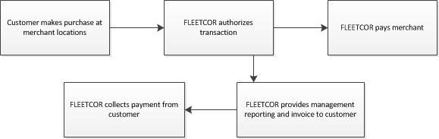

24

Table of Contents

The revenue we derive from transactions is generated from both customers and merchants. Customers may include commercial businesses (obtained through direct and indirect channels), as well as partners for whom we manage payment programs. Merchants, who may also be customers under relevant accounting guidance, may include those merchants affiliated with our proprietary networks or those participating in the third-party networks we utilize.

From our customers and partners, we generate revenue through a variety of program fees, including transaction fees, card fees, network fees and charges. These fees may be charged as fixed amounts, costs plus a mark-up, or based on a percentage of the transaction purchase amounts, or a combination thereof. Our programs include other fees and charges associated with late payments and based on customer credit risk.

From our merchants and third-party networks, we generate revenue mostly from the difference between the amount charged to a customer and the amount paid to the merchant or network for a given transaction, as well as network fees and charges in certain businesses. The amount paid to a merchant or network may be calculated as (i) the merchant’s wholesale product cost plus a markup; (ii) the transaction purchase amount less a percentage discount; or (iii) the transaction purchase amount less a fixed fee per unit.

For a transaction involving the purchase of fuel where the amount paid to the merchant is calculated under the cost plus markup model, we refer to the difference between the amount charged to the customer and the amount paid to the merchant as revenue tied to fuel-price spreads. In all other cases, we refer to the difference between the amount charged to the customer and the amount paid to the merchant for a given transaction as interchange revenue.

The following table presents revenue and revenue per key performance metric by product for the three months ended March 31, 2019 and 2018 (in millions).*

 |  |  |  |  |  |  |  |  |  |  |  |  | As Reported |  |  |  |  |  |  |  |  |  |  | Pro Forma and Macro Adjusted4
 |  |  |  |  |  |  |  |  |  |  |  |  | Three Months Ended March 31, |  |  |  |  |  |  |  |  |  |  | Three Months Ended March 31,
(Unaudited) |  |  |  |  |  |  |  |  |  | 2019 |  |  | 2018 | 2 |  | Change |  | % Change |  |  | 2019 |  |  | 2018 |  |  | Change |  | % Change
FUEL
'- Revenues, net¹ |  |  |  |  |  |  |  |  | $ | 283.0 |  | $ | 265.4 | $ |  | 17.5 |  | 7 % |  | $ | 279.1 |  | $ | 254.8 |  | $ | 24.4 |  | 10 %
'- Transactions¹ |  |  |  |  |  |  |  |  |  | 122.3 |  |  | 125.4 |  |  | (3.1) |  | (2)% |  |  | 119.8 |  |  | 118.7 |  |  | 1.1 |  | 1 %
'- Revenues, net per transaction |  |  |  |  |  |  |  |  | $ | 2.31 |  | $ | 2.12 | $ |  | 0.20 |  | 9 % |  | $ | 2.33 |  | $ | 2.15 |  | $ | 0.18 |  | 9 %
CORPORATE PAYMENTS
'- Revenues, net |  |  |  |  |  |  |  |  | $ | 110.3 |  | $ | 94.8 | $ |  | 15.5 |  | 16 % |  | $ | 112.0 |  | $ | 94.8 |  | $ | 17.2 |  | 18 %
'- Transactions |  |  |  |  |  |  |  |  |  | 13.3 |  |  | 10.9 |  |  | 2.4 |  | 22 % |  |  | 13.3 |  |  | 10.9 |  |  | 2.4 |  | 22 %
'- Revenues, net per transaction |  |  |  |  |  |  |  |  | $ | 8.30 |  | $ | 8.69 | $ |  | (0.39) |  | (5)% |  | $ | 8.43 |  | $ | 8.69 |  | $ | (0.27) |  | (3)%
'- Spend volume |  |  |  |  |  |  |  |  |  | 15,529 |  |  | 13,398 |  |  | 2,131 |  | 16 % |  |  | 15,814 |  |  | 13,398 |  |  | 2,416 |  | 18 %
'- Revenue, net per spend $ |  |  |  |  |  |  |  |  |  | 0.71% |  |  | 0.71% |  |  | —% |  | — % |  |  | 0.71% |  |  | 0.71% |  |  | —% |  | — %
TOLLS
'- Revenues, net¹ |  |  |  |  |  |  |  |  | $ | 88.9 |  | $ | 89.5 | $ |  | (0.6) |  | (1)% |  | $ | 103.2 |  | $ | 89.5 |  | $ | 13.7 |  | 15 %
'- Tags (average monthly) |  |  |  |  |  |  |  |  |  | 5.0 |  |  | 4.7 |  |  | 0.3 |  | 6 % |  |  | 5.0 |  |  | 4.7 |  |  | 0.3 |  | 6 %
'- Revenues, net per tag |  |  |  |  |  |  |  |  | $ | 17.94 |  | $ | 19.11 | $ |  | (1.17) |  | (6)% |  | $ | 20.83 |  | $ | 19.11 |  | $ | 1.72 |  | 9 %
LODGING
'- Revenues, net |  |  |  |  |  |  |  |  | $ | 41.8 |  | $ | 39.4 | $ |  | 2.4 |  | 6 % |  | $ | 41.8 |  | $ | 39.4 |  | $ | 2.4 |  | 6 %
'- Room nights |  |  |  |  |  |  |  |  |  | 4.0 |  |  | 5.4 |  |  | (1.4) |  | (26)% |  |  | 4.0 |  |  | 5.4 |  |  | (1.4) |  | (26)%
'- Revenues, net per room night |  |  |  |  |  |  |  |  | $ | 10.48 |  | $ | 7.27 | $ |  | 3.20 |  | 44 % |  | $ | 10.48 |  | $ | 7.27 |  | $ | 3.20 |  | 44 %
GIFT
'- Revenues, net |  |  |  |  |  |  |  |  | $ | 48.4 |  | $ | 48.6 | $ |  | (0.2) |  | — % |  | $ | 48.4 |  | $ | 49.8 |  | $ | (1.4) |  | (3)%
'- Transactions |  |  |  |  |  |  |  |  |  | 330.8 |  |  | 349.6 |  |  | (18.9) |  | (5)% |  |  | 330.8 |  |  | 349.9 |  |  | (19.1) |  | (5)%
'- Revenues, net per transaction |  |  |  |  |  |  |  |  | $ | 0.15 |  | $ | 0.14 | $ |  | 0.01 |  | 5 % |  | $ | 0.15 |  | $ | 0.14 |  | $ | — |  | 3 %
OTHER³
'- Revenues, net¹ |  |  |  |  |  |  |  |  | $ | 49.4 |  | $ | 47.7 | $ |  | 1.7 |  | 4 % |  | $ | 52.1 |  | $ | 47.7 |  | $ | 4.4 |  | 9 %
'- Transactions¹ |  |  |  |  |  |  |  |  |  | 12.4 |  |  | 12.2 |  |  | 0.3 |  | 2 % |  |  | 12.4 |  |  | 12.2 |  |  | 0.3 |  | 2 %
'- Revenues, net per transaction |  |  |  |  |  |  |  |  | $ | 3.98 |  | $ | 3.93 | $ |  | 0.05 |  | 1 % |  | $ | 4.20 |  | $ | 3.93 |  | $ | 0.27 |  | 7 %
 | FLEETCOR CONSOLIDATED REVENUES
 | '- Revenues, net |  |  |  |  |  |  |  | $ | 621.8 |  | $ | 585.5 | $ |  | 36.3 |  | 6 % |  | $ | 636.7 |  | $ | 576.0 |  | $ | 60.6 |  | 11 %

25

Table of Contents

- Reflects certain reclassifications of revenue between product categories as the Company realigned its Brazil business into product lines, resulting in refinement of revenue classified as fuel versus tolls and the reclassification of the E-Cash/OnRoad product being realigned to fuel from other.

- Reflects adjustments from previously disclosed amounts for the prior period to conform to current presentation.

³ Other includes telematics, maintenance, food, and transportation related businesses.

- See heading entitled "Management’s Use of Non-GAAP Financial Measures" for a reconciliation of Pro forma and Macro Adjusted revenue by product and metrics, non-GAAP measures, to the comparable financial measure calculated in accordance with GAAP.

* Columns may not calculate due to rounding.

Revenue per transaction is derived from the various revenue types as discussed above and can vary based on geography, the relevant merchant relationship, the payment product utilized and the types of products or services purchased, the mix of which would be influenced by our acquisitions, organic growth in our business, and the overall macroeconomic environment, including fluctuations in foreign currency exchange rates, fuel prices and fuel spread margins. Revenue per transaction per customer changes as the level of services we provide to a customer increases or decreases, as macroeconomic factors change and as adjustments are made to merchant and customer rates. See “Results of Operations” for further discussion of transaction volumes and revenue per transaction.

Sources of Expenses

We incur expenses in the following categories:

- Processing—Our processing expense consists of expenses related to processing transactions, servicing our customers and merchants, bad debt expense and cost of goods sold related to our hardware sales in certain businesses.
- Selling—Our selling expenses consist primarily of wages, benefits, sales commissions (other than merchant commissions) and related expenses for our sales, marketing and account management personnel and activities.
- General and administrative—Our general and administrative expenses include compensation and related expenses (including stock-based compensation) for our executives, finance and accounting, information technology, human resources, legal and other administrative personnel. Also included are facilities expenses, third-party professional services fees, travel and entertainment expenses, and other corporate-level expenses.

- Depreciation and amortization—Our depreciation expenses include depreciation of property and equipment, consisting of computer hardware and software (including proprietary software development amortization expense), card-reading equipment, furniture, fixtures, vehicles and buildings and leasehold improvements related to office space. Our amortization expenses include amortization of intangible assets related to customer and vendor relationships, trade names and trademarks, software and non-compete agreements. We are amortizing intangible assets related to business acquisitions and certain private label contracts associated with the purchase of accounts receivable.

- Other operating, net—Our other operating, net includes other operating expenses and income items that do not relate to our core operations or that occur infrequently.

- Investment loss—Our investment results relate to impairment charges related to our investments.

- Other expense (income), net—Our other expense (income), net includes proceeds/costs from the sale of assets, foreign currency transaction gains or losses and other miscellaneous operating costs and revenue.
- Interest expense, net—Our interest expense, net includes interest income on our cash balances and interest expense on our outstanding debt, ineffectiveness on interest rate swaps and on our Securitization Facility. We have historically invested our cash primarily in short-term money market funds.
- Provision for income taxes—Our provision for income taxes consists primarily of corporate income taxes related to profits resulting from the sale of our products and services on a global basis.

Factors and Trends Impacting our Business

We believe that the following factors and trends are important in understanding our financial performance:

- Global economic conditions—Our results of operations are materially affected by conditions in the economy generally, both in North America and internationally. Factors affected by the economy include our transaction volumes, the credit risk of our customers and changes in tax laws across the globe. These factors affected our businesses in both our North America and International segments.

- Foreign currency changes—Our results of operations are significantly impacted by changes in foreign currency rates; namely, by movements of the Australian dollar, Brazilian real, British pound, Canadian dollar, Czech koruna, Euro, Mexican peso, New Zealand dollar and Russian ruble, relative to the U.S. dollar. Approximately 60% and 59% of our revenue in the three months ended March 31, 2019 and 2018, respectively, was derived in U.S. dollars and was not

26

Table of Contents

affected by foreign currency exchange rates. See “Results of Operations” for information related to foreign currency impact on our total revenue, net.

- Fuel prices—Our fleet customers use our products and services primarily in connection with the purchase of fuel. Accordingly, our revenue is affected by fuel prices, which are subject to significant volatility. A change in retail fuel prices could cause a decrease or increase in our revenue from several sources, including fees paid to us based on a percentage of each customer’s total purchase. Changes in the absolute price of fuel may also impact unpaid account balances and the late fees and charges based on these amounts. We believe approximately 13% and 14% of revenues, net were directly impacted by changes in fuel price in the three months ended March 31, 2019 and 2018, respectively.

- Fuel-price spread volatility—A portion of our revenue involves transactions where we derive revenue from fuel-price spreads, which is the difference between the price charged to a fleet customer for a transaction and the price paid to the merchant for the same transaction. In these transactions, the price paid to the merchant is based on the wholesale cost of fuel. The merchant’s wholesale cost of fuel is dependent on several factors including, among others, the factors described above affecting fuel prices. The fuel price that we charge to our customer is dependent on several factors including, among others, the fuel price paid to the merchant, posted retail fuel prices and competitive fuel prices. We experience fuel-price spread contraction when the merchant’s wholesale cost of fuel increases at a faster rate than the fuel price we charge to our customers, or the fuel price we charge to our customers decreases at a faster rate than the merchant’s wholesale cost of fuel. The inverse of these situations produces fuel-price spread expansion. We believe approximately 5% and 4% of revenues, net were directly impacted by fuel-price spreads in the three months ended March 31, 2019 and 2018, respectively.

- Acquisitions—Since 2002, we have completed over 75 acquisitions of companies and commercial account portfolios. Acquisitions have been an important part of our growth strategy, and it is our intention to continue to seek opportunities to increase our customer base and diversify our service offering through further strategic acquisitions. The impact of acquisitions has, and may continue to have, a significant impact on our results of operations and may make it difficult to compare our results between periods.

- Interest rates—Our results of operations are affected by interest rates. We are exposed to market risk to changes in interest rates on our cash investments and debt. On January 22, 2019, the Company entered into three interest rate swap cash flow contracts. The objective of these interest rate swaps is to reduce the variability of cash flows in the previously unhedged interest payments associated with $2.0 billion of variable rate debt, the sole source of which is due to changes in the LIBOR benchmark interest rate. For each of these swaps, the Company will pay a fixed monthly rate and receive 1-Month LIBOR.

- Expenses— Over the long term, we expect that our general and administrative expense will decrease as a percentage of revenue as our revenue increases. To support our expected revenue growth, we plan to continue to incur additional sales and marketing expense by investing in our direct marketing, third-party agents, internet marketing, telemarketing and field sales force.

- Taxes— We pay taxes in many different taxing jurisdictions, including the U.S., most U.S. states and many non-U.S. jurisdictions. The tax rates in certain non-U.S. taxing jurisdictions are higher than the U.S. tax rate. Thus, our effective tax rate is impacted not only as a result of tax law changes such as the Tax Cuts and Jobs Act ("Tax Act"), but also as our earnings fluctuate between taxing jurisdictions.

Acquisitions and Investments

On December 27, 2018, the Company completed an acquisition of an online gift card solution provider with an aggregate purchase price of $17.0 million, net of cash acquired of $11.0 million and made deferred payments of $3.9 million related to acquisitions occurring in prior years. During 2018, the Company acquired other assets of $4.2 million and payments on a seller note for a prior acquisition of $1.6 million.

On April 1, 2019, the Company completed two acquisitions. The Company acquired NvoicePay, a provider of full AP automation for businesses. The Company also made a small international acquisition. The aggregate purchase price of these acquisitions is approximately $255 million.

27

Table of Contents

Results of Operations

Three months ended March 31, 2019 compared to the three months ended March 31, 2018

The following table sets forth selected consolidated statement of income and selected operational data for the three months ended March 31, 2019 and 2018 (in millions, except percentages)*.

 |  |  | Three Months Ended |  | % of total |  | Three Months Ended March 31, |  |  | % of total |  |  | Increase
 | (Unaudited) |  | March 31, 2019 |  | revenue |  |  | 2018 |  | revenue |  |  | (decrease) |  | % Change
 | Revenues, net:
 | North America | $ | 396.9 | 63.8 % |  |  | $ | 364.3 | 62.2 % |  |  | $ | 32.6 | 9.0 %
 | International |  | 224.9 | 36.2 % |  |  |  | 221.2 | 37.8 % |  |  |  | 3.7 | 1.7 %
 | Total revenues, net |  | 621.8 | 100.0 % |  |  |  | 585.5 | 100.0 % |  |  |  | 36.3 | 6.2 %
 | Consolidated operating expenses:
 | Processing |  | 129.1 | 20.8 % |  |  |  | 116.5 | 19.9 % |  |  |  | 12.6 | 10.8 %
 | Selling |  | 49.3 | 7.9 % |  |  |  | 47.1 | 8.0 % |  |  |  | 2.2 | 4.6 %
 | General and administrative |  | 92.8 | 14.9 % |  |  |  | 90.4 | 15.4 % |  |  |  | 2.4 | 2.7 %
 | Depreciation and amortization |  | 67.4 | 10.8 % |  |  |  | 71.5 | 12.2 % |  |  |  | (4.1) | (5.7)%
 | Other operating, net |  | (1.0) | (0.2)% |  |  |  | (0.1) |  | — % |  |  | (0.9) |  | NM
 | Operating income |  | 284.2 |  | 45.7 % |  |  | 260.1 |  | 44.4 % |  |  | 24.1 |  | 9.3 %
 | Investment loss |  | 15.7 | 2.5 % |  |  |  | — |  | — % |  |  | 15.7 |  | NM
 | Other expense (income), net |  | 0.2 |  | — % |  |  | (0.3) | (0.1)% |  |  |  | (0.5) |  | NM
 | Interest expense, net |  | 39.1 | 6.3 % |  |  |  | 31.1 | 5.3 % |  |  |  | 8.0 | 25.7 %
 | Provision for income taxes |  | 57.1 | 9.2 % |  |  |  | 54.4 | 9.3 % |  |  |  | 2.8 | 5.1 %
 | Net income | $ | 172.1 | 27.7 % |  |  | $ | 174.9 | 29.9 % |  |  | $ | (2.8) | (1.6)%
 | Operating income for segments:
 | North America | $ | 172.4 |  |  |  | $ | 156.0 |  |  |  | $ | 16.5 | 10.6 %
 | International |  | 111.8 |  |  |  |  | 104.1 |  |  |  |  | 7.6 | 7.3 %
 | Operating income | $ | 284.2 |  |  |  | $ | 260.1 |  |  |  | $ | 24.1 | 9.3 %
 | Operating margin for segments:
 | North America |  | 43.4% |  |  |  |  | 42.8% |  |  |  |  | 0.6%
 | International |  | 49.7% |  |  |  |  | 47.1% |  |  |  |  | 2.6%
 | Total |  | 45.7% |  |  |  |  | 44.4% |  |  |  |  | 1.3%
 | NM = Not Meaningful
*The sum of the columns and rows may not calculate due to rounding.

Revenues

Our consolidated revenues were $621.8 million in the three months ended March 31, 2019, an increase of $36.3 million or 6.2%, from $585.5 million in the three months ended March 31, 2018. The increase in our consolidated revenue was primarily due to:
- Organic growth of approximately 11% on a constant fuel price, fuel spread margin, foreign currency and acquisition basis, driven by increases in both volume and revenue per transaction in certain of our payment programs.
- Although we cannot precisely measure the impact of the macroeconomic environment, in total we believe it had a negative impact on our consolidated revenue for the three months ended March 31, 2019 over the comparable period in 2018 of approximately $23 million. Foreign exchange rates had an unfavorable impact on consolidated revenues in the three months ended March 31, 2019 over the comparable period in 2018 of approximately $28 million, primarily due to unfavorable changes in foreign exchange rates mostly in Brazil and the U.K., partially offset by favorable fuel spread margins of approximately $5 million, in the three months ended March 31, 2019 over the comparable period in 2018. The impact of changes in fuel prices was essentially neutral.

28

Table of Contents

North America segment revenues

North America revenues were $396.9 million in the three months ended March 31, 2019, an increase of $32.6 million or 9.0%, from $364.3 million in the three months ended March 31, 2018. The increase in our North America segment revenue was primarily due to:

- Organic growth of approximately 9%, on a constant fuel price, fuel spread margin and acquisition and disposition basis, driven by increases in both volume and revenue per transaction in certain of our payment programs.
- Although we cannot precisely measure the impact of the macroeconomic environment, in total we believe it had a positive impact on our North America segment revenue in three months ended March 31, 2019 over the comparable period in 2018 of approximately $3 million, primarily due to favorable fuel spread margins of approximately $5 million, partially offset by the unfavorable impact of foreign exchanges rates in Canada of $1 million and lower fuel prices of approximately $1 million.

International segment revenues

International segment revenues were $224.9 million in the three months ended March 31, 2019, an increase of $3.7 million or 1.7%, from $221.2 million in the three months ended March 31, 2018.

The increase in our International segment revenue was primarily due to:

- Organic growth of approximately 13% on a constant fuel price, fuel spread margin and acquisition basis, driven by increases in both volume and revenue per transaction in certain of our payment programs.
- Although we cannot precisely measure the impact of the macroeconomic environment, in total we believe it had a negative impact on our International segment revenue for the three months ended March 31, 2019 over the comparable period in 2018 of approximately $26 million. Unfavorable foreign exchange rates negatively impacted consolidated revenues by approximately $27 million primarily due to unfavorable changes in foreign exchange rates mostly in Brazil and the U.K., partially offset by the favorable impact of higher fuel prices on consolidated revenues of approximately $1 million.

Revenues by geography and product category. Set forth below are further breakdowns of revenue by geography and product category for the three months ended March 31, 2019 and 2018 (in millions).

 |  |  |  |  |  | Three Months Ended March 31,
 | Revenues, net by Geography |  |  | 2019 |  |  |  |  | 2018
 |  |  |  |  |  | % of total |  |  |  |  | % of total
 | (Unaudited) |  |  | Revenues, net |  | revenues, net |  | Revenues, net |  |  | revenues, net
 | United States |  | $ | 371 |  | 60% |  | $ | 344 |  | 59%
 | Brazil |  |  | 106 |  | 17% |  |  | 107 |  | 18%
 | United Kingdom |  |  | 68 |  | 11% |  |  | 64 |  | 11%
 | Other |  |  | 77 |  | 12% |  |  | 71 |  | 12%
 | Consolidated revenues, net |  | $ | 622 |  | 100% |  | $ | 586 |  | 100%

 |  |  |  |  |  |  | Three Months Ended March 31,
 | Revenues, net by Product Category¹ |  |  |  | 2019 |  |  |  |  |  | 2018
 |  |  | Revenues, |  |  |  |  |  |  | Revenues, |  |  | % of total
 | (Unaudited) |  | net |  |  |  | % of total revenues, net |  |  | net² |  |  | revenues, net
 | Fuel |  | $ | 283 | 45% |  |  |  | $ | 265 | 45%
 | Corporate Payments |  |  | 110 | 18% |  |  |  |  | 95 | 16%
 | Tolls |  |  | 89 | 14% |  |  |  |  | 90 | 15%
 | Lodging |  |  | 42 | 7% |  |  |  |  | 39 | 7%
 | Gift |  |  | 48 | 8% |  |  |  |  | 49 | 8%
 | Other |  |  | 49 | 8% |  |  |  |  | 48 | 8%
 | Consolidated revenues, net |  | $ | 622 | 100% |  |  |  | $ | 586 | 100%

¹Reflects certain reclassifications of revenue between product categories as the Company realigned its Brazil business into product lines, resulting in refinement of revenue classified as fuel versus tolls and the reclassification of the E-Cash/OnRoad product being realigned to fuel from other.
- Reflects adjustments from previously disclosed amounts for the prior period to conform to current presentation.

29

Table of Contents

Consolidated operating expenses

Processing. Processing expenses were $129.1 million in the three months ended March 31, 2019, an increase of $12.6 million or 10.8%, from $116.5 million in the comparable prior period. Increases in processing expenses were primarily due to organic growth in the business and incremental bad debt expense of approximately $10 million, partially offset by the favorable impact of fluctuations in foreign exchange rates of approximately $6 million.

Selling. Selling expenses were $49.3 million in the three months ended March 31, 2019, an increase of $2.2 million or 4.6%, from $47.1 million in the comparable prior period. Increases in selling expenses are primarily due to additional spending in certain lines of business, partially offset by the favorable impact of fluctuations in foreign exchange rates of approximately $2 million.

General and administrative. General and administrative expenses were $92.8 million in the three months ended March 31, 2019, an increase of $2.4 million or 2.7%, from $90.4 million in the comparable prior period. The increase was primarily due to higher third party consulting fees, software license costs and acquisition related expenses over the comparable prior period. These increases were partially offset by a decrease in stock compensation expense of approximately $2 million and the favorable impacts from fluctuations in foreign exchange rates of approximately $4 million.

Depreciation and amortization. Depreciation and amortization expenses were $67.4 million in the three months ended March 31, 2019, a decrease of $4.1 million or 5.7%, from $71.5 million in the comparable prior period. The decrease was primarily due to the favorable impact of foreign exchange rates of approximately $4 million and acquisition related intangible assets that have become fully amortized.

Investment loss. Investment loss of $15.7 million was recorded in the three months ended March 31, 2019 related to an impairment charge to our telematics investment. During the first quarter of 2019, we determined that the fair value of our investment was below cost and recorded an impairment of the investment of $15.7 million based on observable price changes.

Interest expense, net. Interest expense was $39.1 million in the three months ended March 31, 2019, an increase of $8.0 million or 25.7%, from $31.1 million in the comparable prior period. The increase in interest expense is primarily due to the impact of additional borrowings to repurchase our common stock, as well as increases in LIBOR. The following table sets forth the average interest rates paid on borrowings under our Credit Facility, excluding the related unused credit facility fees.

 | Three Months Ended March 31,
(Unaudited) | 2019 |  |  | 2018
Term loan A | 4.00% |  |  | 3.27%
Term loan B | 4.50% |  |  | 3.61%
Revolver A, B & C USD Borrowings | 4.00% |  |  | 3.25%
Revolver B GBP Borrowings | 2.23% |  |  | 2.06%
Foreign swing line | 2.18% |  |  | 2.13%

The average unused credit facility fee for Credit Facility was 0.30% and 0.33% in the three month periods ending March 31, 2019 and 2018, respectively. On January 22, 2019, we entered

into three interest rate swap cash flow contracts. The objective of these interest rate swaps is to reduce the variability of cash flows in the previously unhedged interest payments associated with $2 billion of variable rate debt, associated with the one month LIBOR benchmark interest rate. During the three months ended March 31, 2019, as a result of these swaps, we incurred additional interest expense of $0.2 million or 0.06% over the average LIBOR rates on $2 billion of borrowings.

Provision for income taxes. The provision for income taxes was $57.1 million in the three months ended March 31, 2019, an increase of $2.8 million or 5.1%, from $54.4 million in the comparable prior period. We provide for income taxes during interim periods based on an estimate of our effective tax rate for the year. Discrete items and changes in the estimate of the annual tax rate are recorded in the period they occur. Our effective tax rate for the three months ended March 31, 2019 was 24.9% compared to 23.7% for three months ended March 31, 2018.

Our effective tax rate for the three months ended March 31, 2019 reflects the impact of the non-cash impairment charge in our telematics investment. The impairment charge resulted in a reduction in the basis in the investment for book purposes but not tax purposes. Although the temporary book to tax difference resulted in the Company increasing its deferred tax asset related to its investment, the Company also increased its valuation allowance against the deferred tax asset. Excluding this non-cash item, our tax rate in the first quarter of 2019 would have been 23.3%.

30

Table of Contents

We pay taxes in many different taxing jurisdictions, including the U.S., most U.S. states and many non-U.S. jurisdictions. The tax rates in certain non-U.S. taxing jurisdictions are lower than the U.S.

tax rate. Consequently, as our earnings fluctuate between taxing jurisdictions, our effective tax rate fluctuates.

Net income. For the reasons discussed above, our net income decreased to $172.1 million in the three months ended March 31, 2019, a decrease of $2.8 million or 1.6%, from $174.9 million in the three months ended March 31, 2018.

Operating income and operating margin

Consolidated operating income. Operating income was $284.2 million in the three months ended March 31, 2019, an increase of $24.1 million or 9.3%, from $260.1 million in the comparable prior period. Our operating margin was 45.7% and 44.4% for the three months ended March 31, 2019 and 2018, respectively. These increases were driven primarily by organic growth. These increases were partially offset by the negative impact of the macroeconomic environment of approximately $8 million, driven by unfavorable movements in foreign exchange rates.

For the purpose of segment operating results, we calculate segment operating income by subtracting segment operating expenses from segment revenue. Segment operating margin is calculated by dividing segment operating income by segment revenue.

North America segment operating income. North America operating income was $172.4 million in the three months ended March 31, 2019, an increase of $16.5 million or 10.6%, from $156.0 million in the comparable prior period. North America operating margin was 43.4% and 42.8% for the three months ended March 31, 2019 and 2018, respectively. These increases were due primarily to organic growth and the positive impact of the macroeconomic environment of approximately $4 million, driven by higher fuel price spreads, partially offset by higher bad debt expense.

International segment operating income. International operating income was $111.8 million in the three months ended March 31, 2019, an increase of $7.6 million or 7.3%, from $104.1 million in the comparable prior period. International operating margin was 49.7% and 47.1% for the three months ended March 31, 2019 and 2018, respectively. These increases were due primarily to organic growth. These increases were partially offset by the negative impact of the macroeconomic environment of approximately $12 million, driven primarily by unfavorable movements in foreign exchange rates.

Liquidity and capital resources

Our principal liquidity requirements are to service and repay our indebtedness, make acquisitions of businesses and commercial account portfolios, repurchase shares of our common stock and meet working capital, tax and capital expenditure needs.

Sources of liquidity. At March 31, 2019, our cash balances totaled $1,372.6 million, with approximately $315.1 million restricted. Restricted cash represents customer deposits in the Czech Republic and in our Comdata business in the U.S., as well as collateral received from customers for cross-currency transactions in our Cambridge business, which are restricted from use other than to repay customer deposits, as well as secure and settle cross-currency transactions.

At March 31, 2019, cash and cash equivalents held in foreign subsidiaries where we have determined we are permanently reinvested is $761.5 million. All of the cash and cash equivalents held by our foreign subsidiaries, excluding restricted cash, are available for general corporate purposes. Our current intent is to permanently reinvest these funds outside of the U.S. Our current expectation for funds held in our foreign subsidiaries is to use the funds to finance foreign organic growth, to pay for potential future foreign acquisitions and to repay any foreign borrowings that may arise from time to time. We currently believe that funds generated from our U.S. operations, along with available borrowing capacity in the U.S. will be sufficient to fund our U.S. operations for the foreseeable future, and therefore do not foresee a need to repatriate cash held by our foreign subsidiaries to fund our U.S. operations. We are currently evaluating undistributed foreign earnings for which we have not provided deferred taxes for foreign withholding tax, as these earnings are considered to be indefinitely reinvested. The amount of these unrecorded deferred taxes is not expected to be material.

We utilize an accounts receivable Securitization Facility to finance a majority of our domestic receivables, to lower our cost of borrowing and more efficiently use capital. We generate and record accounts receivable when a customer makes a purchase from a merchant using one of our card products and generally pay merchants before collecting the receivable. As a result, we utilize the Securitization Facility as a source of liquidity to provide the cash flow required to fund merchant payments while we collect customer balances. These balances are primarily composed of charge balances, which are typically billed to the customer on a weekly, semimonthly or monthly basis, and are generally required to be paid within 14 days of billing. We also consider the undrawn amounts under our Securitization Facility and Credit Facility as funds available for working capital purposes and acquisitions. At March 31, 2019, we had no additional liquidity under our Securitization Facility. At March 31, 2019, we had approximately $569 million available under our Credit Facility.

31

Table of Contents

Based on our current forecasts and anticipated market conditions, we believe that our current cash balances, our available borrowing capacity and our ability to generate cash from operations, will be sufficient to fund our liquidity needs for at least the next twelve months. However, we regularly evaluate our cash requirements for current operations, commitments, capital requirements and acquisitions, and we may elect to raise additional funds for these purposes in the future, either through the issuance of debt or equity securities. We may not be able to obtain additional financing on terms favorable to us, if at all.

Cash flows

The following table summarizes our cash flows for the three month periods ended March 31, 2019 and 2018 (in millions).

 |  | Three Months Ended March 31,
(Unaudited) |  | 2019 |  |  | 2018
Net cash provided by operating activities | $ | 297.5 |  | $ | 200.7
Net cash used in investing activities |  | (14.5) |  |  | (22.7)
Net cash used in financing activities |  | (272.9) |  |  | (99.0)

Operating activities. Net cash provided by operating activities was $297.5 million in the three months ended March 31, 2019, an increase from $200.7 million in the comparable prior period. The increase in operating cash flows was primarily due to higher net income and favorable working capital adjustments primarily due to the timing of cash receipts and payments in the three months ended March 31, 2019 over the comparable period in 2018.

Investing activities. Net cash used in investing activities was $14.5 million in the three months ended March 31, 2019 compared to $22.7 million in the three months ended March 31, 2018. The decrease was primarily due to a reduction in cash outlay for acquisitions.

Financing activities. Net cash used in financing activities was $272.9 million in the three months ended March 31, 2019, compared to $99.0 million in the three months ended March 31, 2018. The increased use of cash is primarily due to a reduction in net borrowings of $306.5 million on our Credit Facility. These additional uses of cash were partially offset by an increase in borrowings of $38 million on our Securitization Facility and fewer repurchases of our common stock of $85 million in the three months ended March 31, 2019 over the comparable period in 2018.

Capital spending summary

Our capital expenditures were $14.5 million in the three months ended March 31, 2019, a decrease of $0.7 million or 4.7%, from $15.2 million in the comparable prior period, an immaterial amount.

Credit Facility

FLEETCOR Technologies Operating Company, LLC, and certain of our domestic and foreign owned subsidiaries, as designated co-borrowers (the “Borrowers”), are parties to a $4.33 billion Credit Agreement (the "Credit Agreement"), with Bank of America, N.A., as administrative agent, swing line lender and local currency issuer, and a syndicate of financial institutions (the “Lenders”), which has been amended multiple times. The Credit Agreement provides for senior secured credit facilities consisting of a revolving credit facility in the amount of $1.285 billion, a term loan A facility in the amount of $2.525 billion and a term loan B facility in the amount of $350.0 million as of March 31, 2019. The revolving credit facility consists of (a) a revolving A credit facility in the amount of $800 million, with sublimits for letters of credit and swing line loans, (b) a revolving B facility in the amount of $450 million for borrowings in U.S. Dollars, Euros, British Pounds, Japanese Yen or other currency as agreed in advance, and a sublimit for swing line loans, and (c) a revolving C facility in the amount of $35 million for borrowings in U.S. Dollars, Australian Dollars or New Zealand Dollars. The Credit Agreement also includes an accordion feature for borrowing an additional $750 million in term A, term B, revolver A or revolver B debt. Proceeds from the Credit Facility may be used for working capital purposes, acquisitions, and other general corporate purposes. The term A and revolver maturity dates are December 19, 2023, and the term B maturity date is August 2, 2024.

Interest on amounts outstanding under the Credit Agreement (other than the term B loan) accrues based on the British Bankers Association LIBOR Rate (the Eurocurrency Rate), plus a margin based on a leverage ratio, or our option, the Base Rate (defined as the rate equal to the highest of (a) the Federal Funds Rate plus 0.50%, (b) the prime rate announced by Bank of America, N.A., or (c) the Eurocurrency Rate plus 1.00%) plus a margin based on a leverage ratio. Interest on the term B loan facility accrues based on the Eurocurrency Rate plus 2.00% for Eurocurrency Loans and at the Base Rate plus 1.00% for Base Rate Loans. In addition, we pay a quarterly commitment fee at a rate per annum ranging from 0.20% to 0.40% of the daily unused portion of the credit facility.

At March 31, 2019, the interest rate on the term A loan and the revolving A facility was 4.00%, the interest rate on the revolving B facility U.S. Dollar borrowings ($70 million) was 3.99%, the interest rate on the revolving B British Pounds borrowings ($90 million) was 2.23%, the interest rate on the term B loan was 4.50%, the interest rate on the revolving C facility was 4.00% and

32

Table of Contents

the interest rate on the foreign swing line loan was 2.17%. The unused credit facility fee was 0.30% for all revolving facilities at March 31, 2019.

The term loans are payable in quarterly installments and are due on the last business day of each March, June, September, and December with the final principal payment due on the respective maturity date. Borrowings on the revolving line of credit are repayable at our option of one, two, three or six months after borrowing, depending on the term of the borrowing on the facility. Borrowings on the foreign swing line of credit are due no later than ten business days after such loan is made.

The Credit Facility contains representations, warranties and events of default, as well as certain affirmative and negative covenants, customary for financings of this nature. These covenants include limitations on the ability to pay dividends and make other restricted payments under certain circumstances and compliance with certain financial ratios. As of March 31, 2019, we were in compliance with each of the covenants under the Credit Facility.

Our Credit Agreement contains a number of negative covenants restricting, among other things, limitations on liens (with exceptions for our Securitization Facility) and investments, incurrence or guarantees of indebtedness, mergers, acquisitions, dissolutions, liquidations and consolidations, dispositions, dividends and other restricted payments and prepayments of other indebtedness. In particular, we are not permitted to make any restricted payments (which includes any dividend or other distribution) except that we may declare and make dividend payments or other distributions to our stockholders so long as (i) on a pro forma basis both before and after the distribution the consolidated leverage ratio is not greater than 3.25:1.00 and we are in compliance with the financial covenants and (ii) no default or event of default shall exist or result therefrom. The Credit Agreement also contains customary events of default. The Credit Agreement includes financial covenants where the Company is required to maintain a consolidated leverage ratio to consolidated EBITDA of less than (i) 4.00 to 1.00 as of the end of any fiscal quarter provided that in connection with any Material Acquisition the leverage ratio may be increased to 4.25 to 1.00 for the quarter in which the Material Acquisition is consummated and the next three fiscal quarters; and a consolidated interest coverage ratio of no higher than 4.00 to 1.0.

The obligations of the Borrowers under the Credit Agreement are secured by substantially all of the assets of FLEETCOR and its domestic subsidiaries, pursuant to a security agreement and includes a pledge of (i) 100% of the issued and outstanding equity interests owned by us of each Domestic Subsidiary and (2) 66% of the voting shares of the first-tier foreign subsidiaries, but excluding real property, personal property located outside of the U.S., accounts receivables and related assets subject to the Securitization Facility and certain investments required under money transmitter laws to be held free and clear of liens.

At March 31, 2019, we had $2.5 billion in borrowings outstanding on the term A loan, excluding the related debt discount, $344.8 million in borrowings outstanding on term B loan, excluding the related debt discount, $490.0 million in borrowings outstanding on the revolving A facility, $159.9 million in borrowings outstanding on the revolving B facility, excluding the swing line, $35.0 million in borrowings outstanding on the revolving C facility and $30.7 million in borrowings outstanding on the revolving B swing line facility. We have unamortized debt issuance costs of $7.9 million related to the Revolver as of March 31, 2019 recorded within other assets in the unaudited consolidated balance sheet. We have unamortized debt discounts and debt issuance costs related to the term loans of $9.5 million and $0.8 million at March 31, 2019, respectively.

During the three months ended March 31, 2019, we made principal payments of $32.4 million on the term loans, $165.0 million on the revolving A facility, $188.6 million on the revolving B facility, and $4.3 million on the swing line revolving facilities.

Cash Flow Hedges

On January 22, 2019, the Company entered into three interest rate swap cash flow contracts. The objective of these interest rate swaps is to reduce the variability of cash flows in the previously unhedged interest payments associated with $2.0 billion of variable rate debt, the sole source of which is due to changes in the LIBOR benchmark interest rate. These swap agreements qualify as hedging instruments and have been designated as cash flow hedges. For each of these swaps, the Company will pay a fixed monthly rate and receive 1-Month LIBOR. We reclassified approximately $0.2 million of losses from accumulated other comprehensive income into interest expense $0.2 million during the three months ended March 31, 2019 as a result of these hedges.

Securitization Facility

We are a party to a receivables purchase agreement among FleetCor Funding LLC, as seller, PNC Bank, National Association as administrator, and various purchaser agents, conduit purchasers and related committed purchasers parties thereto, which was amended and restated for the fifth time as of November 14, 2014. We refer to this arrangement as the Securitization Facility. There have been several amendments to the Securitization Facility the latest on April 22, 2019. The Securitization Facility expires on November 14, 2020 and contains certain customary financial covenants.

There is a program fee equal to one month LIBOR plus 0.90% or the Commercial Paper Rate plus 0.80%. The program fee was 2.53% plus 0.88% and 2.52% plus 0.89% as of March 31, 2019 and December 31, 2018, respectively. The unused facility fee is

33

Table of Contents

payable at a rate of 0.40% as of March 31, 2019 and December 31, 2018, respectively. We have unamortized debt issuance costs of $1.1 million related to the Securitization Facility as of March 31, 2019 recorded within other assets in the unaudited consolidated balance sheet.

The Securitization Facility provides for certain termination events, which includes nonpayment, upon the occurrence of which the administrator may declare the facility termination date to have occurred, may exercise certain enforcement rights with respect to the receivables, and may appoint a successor servicer, among other things.

We were in compliance with the financial covenant requirements related to our Securitization Facility as of March 31, 2019.

Stock Repurchase Program

The Company's Board of Directors has approved a stock repurchase program (the "Program") under which the Company may purchase up to an aggregate of $2.1 billion of its common stock over the

following 18 month period. The Program was updated most recently on January 23, 2019, the Company's Board of Directors, with an authorized increase in the size of the program by an

additional $500 million. With the increase and giving effect to the Company's $1.6 billion of previous repurchases, the Company may repurchase up to $545 million in shares of its common stock at

any time prior to February 1, 2020.

Any stock repurchases may be made at times and in such amounts as deemed appropriate. The timing and amount of stock repurchases, if any, will depend on a variety of factors including the stock price, market conditions, corporate and regulatory requirements, and any additional constraints related to material inside information the Company may possess. Any repurchases have been and are expected to be funded by a combination of available cash flow from the business, working capital and debt.

On December 14, 2018, as part of the Program, the Company entered an accelerated stock repurchase agreement ("2018 ASR Agreement") with a third-party financial institution to repurchase $220 million of its common stock. Pursuant to the 2018 ASR Agreement, the Company delivered $220 million in cash and received 1,057,035 shares based on a stock price of $176.91 on December 14, 2018. The 2018 ASR Agreement was completed on January 29, 2019, at which time the Company received 117,751 additional shares based on a final weighted average per share purchase price during the repurchase period of $187.27.

Since the beginning of the Program, 9,052,163 shares for an aggregate purchase price of $1.6 billion have been repurchased.

Critical accounting policies and estimates

In applying the accounting policies that we use to prepare our consolidated financial statements, we necessarily make accounting estimates that affect our reported amounts of assets, liabilities, revenue and expenses. Some of these estimates require us to make assumptions about matters that are highly uncertain at the time we make the accounting estimates. We base these assumptions and the resulting estimates on historical information and other factors that we believe to be reasonable under the circumstances, and we evaluate these assumptions and estimates on an ongoing basis. In many instances, however, we reasonably could have used different accounting estimates and, in other instances, changes in our accounting estimates could occur from period to period, with the result in each case being a material change in the financial statement presentation of our financial condition or results of operations. We refer to estimates of this type as critical accounting estimates.

Accounting estimates necessarily require subjective determinations about future events and conditions. During the three months ended March 31, 2019, other than noted in footnote 1, "Summary of Significant Accounting Policies" and footnote 2, "Leases", related to our adoption of new lease guidance, we have not adopted any new critical accounting policies that had a significant impact upon our consolidated financial statements, have not changed any critical accounting policies and have not changed the application of any critical accounting policies from the year ended December 31, 2018. For critical accounting policies, refer to the Critical Accounting Estimates in Item 7 – Management’s Discussion and Analysis of Financial Condition and Results of Operations included in our Annual Report on Form 10-K for the year ended December 31, 2018 and our summary of significant accounting policies in Note 1 of our notes to the unaudited consolidated financial statements in this Form 10-Q.

Management’s Use of Non-GAAP Financial Measures

We have included in the discussion above certain financial measures that were not prepared in accordance with GAAP. Any analysis of non-GAAP financial measures should be used only in conjunction with results presented in accordance with GAAP. Below, we define the non-GAAP financial measures, provide a reconciliation of the non-GAAP financial measure to the most directly comparable financial measure calculated in accordance with GAAP, and discuss the reasons that we believe this information is useful to management and may be useful to investors.

Pro forma and macro adjusted revenue and key performance metric by product. We define the pro forma and macro adjusted revenue as revenue, net as reflected in our statement of income, adjusted to eliminate the impact of the macroeconomic environment and the impact of acquisitions and dispositions. The macroeconomic environment includes the impact that market

34

Table of Contents

fuel spread margins, fuel prices and foreign exchange rates have on our business. We use pro forma and macro adjusted revenue and key performance metric to evaluate the organic growth in our revenue and the associated performance metric. Set forth below is a reconciliation of pro forma and macro adjusted revenue and key performance metric to the most directly comparable GAAP measure, revenue, net and performance metric (in millions):

 |  |  |  |  |  |  |  |  |  |  |  |  | Revenue |  |  |  |  |  | Key Performance Metric
 |  |  |  |  |  |  |  |  |  |  |  | Three Months Ended March 31, |  |  |  |  |  |  | Three Months Ended March 31,
 | (Unaudited) |  |  |  |  |  |  |  |  |  |  | 2019* |  |  | 2018* |  | 2019* |  |  |  | 2018*
 | FUEL
 | Pro forma and macro adjusted |  |  |  |  |  |  |  |  |  |  | $ | 279.1 |  | $ | 254.8 | 119.8 |  |  |  | 118.7
 | Impact of acquisitions/dispositions/Uber |  |  |  |  |  |  |  |  |  |  |  | 7.7 |  |  | 10.7 | 2.5 |  |  |  | 6.7
 | Impact of fuel prices/spread |  |  |  |  |  |  |  |  |  |  |  | 5.7 |  |  | — |  |  | — |  | —
 | Impact of foreign exchange rates |  |  |  |  |  |  |  |  |  |  |  | (9.6) |  |  | — |  |  | — |  | —
 | As reported |  |  |  |  |  |  |  |  |  |  | $ | 283.0 |  | $ | 265.4 |  | 122.3 |  |  | 125.4
 | CORPORATE PAYMENTS - TRANSACTIONS
 | Pro forma and macro adjusted |  |  |  |  |  |  |  |  |  |  | $ | 112.0 |  | $ | 94.8 | 13.3 |  |  |  | 10.9
 | Impact of acquisitions/dispositions |  |  |  |  |  |  |  |  |  |  |  | — |  |  | — |  |  | — |  | —
 | Impact of fuel prices/spread |  |  |  |  |  |  |  |  |  |  |  | — |  |  | — |  |  | — |  | —
 | Impact of foreign exchange rates |  |  |  |  |  |  |  |  |  |  |  | (1.6) |  |  | — |  |  | — |  | —
 | As reported |  |  |  |  |  |  |  |  |  |  | $ | 110.3 |  | $ | 94.8 |  | 13.3 |  |  | 10.9
 | CORPORATE PAYMENTS - SPEND
 | Pro forma and macro adjusted |  |  |  |  |  |  |  |  |  |  |  |  |  |  |  | 15,813.7 |  |  |  | 13,398.0
 | Impact of acquisitions/dispositions |  |  |  |  |  |  |  |  |  |  |  |  |  |  |  |  |  | — |  | —
 | Impact of fuel prices/spread |  |  |  |  |  |  |  |  |  |  |  | Intentionally Left Blank |  |  |  |  |  | — |  | —
 | Impact of foreign exchange rates |  |  |  |  |  |  |  |  |  |  |  |  |  |  |  |  | (284.3) |  |  | —
 | As reported |  |  |  |  |  |  |  |  |  |  |  |  |  |  |  |  | 15,529.5 |  |  | 13,398.0
 | TOLLS - TAGS
 | Pro forma and macro adjusted |  |  |  |  |  |  |  |  |  |  | $ | 103.2 |  | $ | 89.5 | 5.0 |  |  |  | 4.7
 | Impact of acquisitions/dispositions |  |  |  |  |  |  |  |  |  |  |  | — |  |  | — |  |  | — |  | —
 | Impact of fuel prices/spread |  |  |  |  |  |  |  |  |  |  |  | — |  |  | — |  |  | — |  | —
 | Impact of foreign exchange rates |  |  |  |  |  |  |  |  |  |  |  | (14.3) |  |  | — |  |  | — |  | —
 | As reported |  |  |  |  |  |  |  |  |  |  | $ | 88.9 |  | $ | 89.5 |  | 5.0 |  |  | 4.7
 | LODGING - ROOM NIGHTS
 | Pro forma and macro adjusted |  |  |  |  |  |  |  |  |  |  | $ | 41.8 |  | $ | 39.4 | 4.0 |  |  |  | 5.4
 | Impact of acquisitions/dispositions |  |  |  |  |  |  |  |  |  |  |  | — |  |  | — |  |  | — |  | —
 | Impact of fuel prices/spread |  |  |  |  |  |  |  |  |  |  |  | — |  |  | — |  |  | — |  | —
 | Impact of foreign exchange rates |  |  |  |  |  |  |  |  |  |  |  | — |  |  | — |  |  | — |  | —
 | As reported |  |  |  |  |  |  |  |  |  |  | $ | 41.8 |  | $ | 39.4 |  | 4.0 |  |  | 5.4
 | GIFT - TRANSACTIONS
 | Pro forma and macro adjusted |  |  |  |  |  |  |  |  |  |  | $ | 48.4 |  | $ | 49.8 | 330.8 |  |  |  | 349.9
 | Impact of acquisitions/dispositions |  |  |  |  |  |  |  |  |  |  |  | — |  |  | (1.2) |  |  | — |  | (0.3)
 | Impact of fuel prices/spread |  |  |  |  |  |  |  |  |  |  |  | — |  |  | — |  |  | — |  | —
 | Impact of foreign exchange rates |  |  |  |  |  |  |  |  |  |  |  | — |  |  | — |  |  | — |  | —
 | As reported |  |  |  |  |  |  |  |  |  |  | $ | 48.4 |  | $ | 48.6 |  | 330.8 |  |  | 349.6
 | OTHER¹- TRANSACTIONS
 | Pro forma and macro adjusted |  |  |  |  |  |  |  |  |  |  | $ | 52.1 |  | $ | 47.7 | 12.4 |  |  |  | 12.2
 | Impact of acquisitions/dispositions |  |  |  |  |  |  |  |  |  |  |  | — |  |  | — |  |  | — |  | —
 | Impact of fuel prices/spread |  |  |  |  |  |  |  |  |  |  |  | — |  |  | — |  |  | — |  | —
 | Impact of foreign exchange rates |  |  |  |  |  |  |  |  |  |  |  | (2.7) |  |  | — |  |  | — |  | —
 | As reported |  |  |  |  |  |  |  |  |  |  | $ | 49.4 |  | $ | 47.7 |  | 12.4 |  |  | 12.2
 | FLEETCOR CONSOLIDATED REVENUES
 | Pro forma and macro adjusted |  |  |  |  |  |  |  |  |  |  | $ | 636.7 |  | $ | 576.0
 | Impact of acquisitions/dispositions |  |  |  |  |  |  |  |  |  |  |  | 7.7 |  |  | 9.5
 | Impact of fuel prices/spread |  |  |  |  |  |  |  |  |  |  |  | 5.7 |  |  | — |  |  | Intentionally Left Blank
 | Impact of foreign exchange rates |  |  |  |  |  |  |  |  |  |  |  | (28.2) |  |  | —
 | As reported |  |  |  |  |  |  |  |  |  |  | $ | 621.8 |  | $ | 585.5

* Columns may not calculate due to rounding.

¹Other includes telematics, maintenance, and transportation related businesses.

35

Table of Contents

Adjusted net income and adjusted net income per diluted share. We have defined the non-GAAP measure adjusted net income as net income as reflected in our statement of income, adjusted to eliminate (a) non-cash stock based compensation expense related to share based compensation awards, (b) amortization of deferred financing costs, discounts and intangible assets, and amortization of the premium recognized on the purchase of receivables, (c) other non-recurring items, including the impact of the Tax Act, impairment charges, asset write-offs, restructuring costs, gains due to disposition of assets and a business, loss on extinguishment of debt, legal settlements, and the unauthorized access impact.

We have defined the non-GAAP measure adjusted net income per diluted share as the calculation previously noted divided by the weighted average diluted shares outstanding as reflected in our statement of income.

We use adjusted net income to eliminate the effect of items that we do not consider indicative of our core operating performance. We believe it is useful to exclude non-cash stock based compensation expense from adjusted net income because non-cash equity grants made at a certain price and point in time do not necessarily reflect how our business is performing at any particular time and stock based compensation expense is not a key measure of our core operating performance. We also believe that amortization expense can vary substantially from company to company and from period to period depending upon their financing and accounting methods, the fair value and average expected life of their acquired intangible assets, their capital structures and the method by which their assets were acquired. Therefore, we have excluded amortization expense from adjusted net income. We also believe one-time non-recurring gains, losses, and impairment charges do not necessarily reflect how our investments and business are performing. We believe that adjusted net income and adjusted net income per diluted share are appropriate supplemental measures of financial performance and may be useful to investors to understanding our operating performance on a consistent basis. Adjusted net income and adjusted net income per diluted share are not intended to be a substitute for GAAP financial measures and should not be used as such.

Set forth below is a reconciliation of adjusted net income and adjusted net income per diluted share to the most directly comparable GAAP measure, net income and net income per diluted share (in thousands, except per share amounts)*:

 |  | Three Months Ended March 31,
(Unaudited) |  | 2019 |  |  | 2018
Net income | $ | 172,107 |  | $ | 174,937
Stock based compensation |  | 12,541 |  |  | 14,403
Amortization of intangible assets, premium on receivables, deferred financing costs and
discounts |  | 53,518 |  |  | 60,444
Impairment of investment |  | 15,660 |  |  | —
Restructuring costs |  | — |  |  | 1,929
Total pre-tax adjustments |  | 81,719 |  |  | 76,776
Income tax impact of pre-tax adjustments at the effective tax rate¹ |  | (15,411) |  |  | (18,207)
Adjusted net income | $ | 238,415 |  | $ | 233,506
Adjusted net income per diluted share | $ | 2.67 |  | $ | 2.50
Diluted shares |  | 89,244 |  |  | 93,250

*Columns may not calculate due to rounding.

- Excludes the results of the Company's investments on our effective tax rate, as results from our investments are reported within the consolidated statements of income on a post-tax basis and no tax-over-book outside basis differences related to our investments reversed during 2019.

36

Table of Contents

Special Cautionary Notice Regarding Forward-Looking Statements

This report contains forward-looking statements within the meaning of the federal securities laws. Statements that are not historical facts, including statements about FleetCor's beliefs, expectations and future performance, are forward-looking statements. Forward-looking statements can be identified by the use of words such as “anticipate,” “intend,” “believe,” “estimate,” “plan,” “seek,” “project” or “expect,” “may,” “will,” “would,” “could” or “should,” the negative of these terms or other comparable terminology.

These forward-looking statements are not a guarantee of performance, and you should not place undue reliance on such statements. We have based these forward-looking statements largely on our current expectations and projections about future events. Forward-looking statements are subject to many uncertainties and other variable circumstances, such as delays or failures associated with implementation; fuel price and spread volatility; changes in credit risk of customers and associated losses; the actions of regulators relating to payment cards or investigations; failure to maintain or renew key business relationships; failure to maintain competitive offerings; failure to maintain or renew sources of financing; failure to complete, or delays in completing, anticipated new partnership arrangements or acquisitions and the failure to successfully integrate or otherwise achieve anticipated benefits from such partnerships or acquired businesses; failure to successfully expand business internationally; other risks related to our international operations, including the potential impact to our business as a result of the United Kingdom's referendum to leave the European Union; the impact of foreign exchange rates on operations, revenue and income; the effects of general economic and political conditions on fueling patterns and the commercial activity of fleets; risks related to litigation; risks related to unauthorized access to systems and information; as well as the other risks and uncertainties identified under the caption “Risk Factors” in our Annual Report on Form 10-K for the year ended December 31, 2018 filed with the Securities and Exchange Commission on March 1, 2019 and this Quarterly Report. These factors could cause our actual results and experience to differ materially from any forward-looking statement. Given these risks and uncertainties, you are cautioned not to place undue reliance on these forward-looking statements. The forward-looking statements included in this report are made only as of the date hereof. We do not undertake, and specifically disclaim, any obligation to update any such statements or to publicly announce the results of any revisions to any of such statements to reflect future events or developments.

Item 3. Quantitative and Qualitative Disclosures About Market Risk

As of March 31, 2019, there have been no material changes to our market risk from that disclosed in our Annual Report on Form 10-K for the year ended December 31, 2018.

Item 4. Controls and Procedures

Evaluation of Disclosure Controls and Procedures

As of March 31, 2019, management carried out, under the supervision and with the participation of our Chief Executive Officer and Chief Financial Officer, an evaluation of the effectiveness of the design and operation of our disclosure controls and procedures (as defined in Rules 13a-15(e) and 15d-15(e) under the Securities Exchange Act of 1934). Based on this evaluation, our Chief Executive Officer and Chief Financial Officer concluded that, as of March 31, 2019, our disclosure controls and procedures were effective in ensuring that information required to be disclosed by us in the reports that we file or submit under the Securities Exchange Act of 1934, as amended, is recorded, processed, summarized and reported within the time periods specified in applicable rules and forms and are designed to ensure that information required to be disclosed in those reports is accumulated and communicated to management, including our Chief Executive Officer and Chief Financial Officer, as appropriate to allow timely decisions regarding required disclosure.

Changes in Internal Control over Financial Reporting

We added internal controls in support of the accounting, reporting and disclosure requirements of the new lease accounting standard, ASC 842, which became effective for us as of January 1, 2019.

Other than as discussed above, there were no changes in our internal control over financial reporting during the quarter ended March 31, 2019, that have materially affected, or are reasonably likely to materially affect, our internal control over financial reporting.

37

Table of Contents

PART II—OTHER INFORMATION

Item 1. Legal Proceedings

In the ordinary course of business, we are subject to various pending and potential legal actions, arbitration proceedings, claims, subpoenas, and matters relating to compliance with laws and regulations (collectively, legal proceedings). Based on our current knowledge, management presently does not believe that the liabilities arising from these legal proceedings will have a material adverse effect on our consolidated financial condition, results of operations or cash flows. However, it is possible that the ultimate resolution of these legal proceedings could have a material adverse effect on our results of operations and financial condition for any particular period.

Shareholder Class Action and Derivative Lawsuits

On June 14, 2017, a shareholder filed a class action complaint in the United States District Court for the Northern District of Georgia against the Company and certain of its officers and directors on behalf of all persons who purchased or otherwise acquired the Company’s stock between February 5, 2016 and May 2, 2017. On October 13, 2017, the shareholder filed an amended complaint asserting claims on behalf of a putative class of all persons who purchased or otherwise acquired the Company's common stock between February 4, 2016 and May 3, 2017. The complaint alleges that the defendants made false or misleading statements regarding fee charges and the reasons for its earnings and growth in certain press releases and other public statements in violation of the federal securities laws. Plaintiff seeks class certification, unspecified monetary damages, costs, and attorneys’ fees. The Company disputes the allegations in the complaint and intends to vigorously defend against the claims.

On July 10, 2017, a shareholder derivative complaint was filed against the Company and certain of the Company’s directors and officers in the United States District Court for the Northern District of Georgia seeking recovery on behalf of the Company. The derivative complaint alleges that the defendants issued a false and misleading proxy statement in violation of the federal securities laws; that defendants breached their fiduciary duties by causing or permitting the Company to make allegedly false and misleading public statements concerning the Company’s fee charges, and financial and business prospects; and that certain defendants breached their fiduciary duties through allegedly improper sales of stock. The complaint seeks unspecified monetary damages on behalf of the Company, corporate governance reforms, disgorgement of profits, benefits and compensation by the defendants, restitution, costs, and attorneys’ and experts’ fees. On September 20, 2018, the court entered an order deferring the case pending a ruling on the parties’ anticipated motions for summary judgment in the putative shareholder class action, or until otherwise agreed to by the parties. On January 9, 2019, a similar shareholder derivative complaint was filed in the Superior Court of Gwinnett County, Georgia, which is stayed pending a ruling on the parties' anticipated motions for summary judgment in the putative shareholder class action, or until otherwise agreed by the parties. The defendants dispute the allegations in the derivative complaints and intend to vigorously defend against the claims.

On February 1, 2019, Schultz Transfer Systems, Inc. filed a complaint against Fleetcor Technologies Operating Company, LLC (“Fleetcor LLC”) in the United States District Court for the Northern District of Georgia. The plaintiff alleges that it is a Fleetcor LLC customer and member of the Fuelman program, and that Fleetcor LLC overcharged the plaintiff for fees and fuel through the Fuelman program. Based on these allegations, the plaintiff asserts claims for breach of contract, breach of the covenant of good faith and fair dealing, fraud, fraudulent concealment, money had and received, and unjust enrichment. The plaintiff seeks to represent a class defined as all persons, including corporate entities, who were enrolled in the Fuelman program between June 2016 and the present. On April 1, 2019, the Company filed a motion to compel arbitration and to dismiss the case, which is pending with the court. The Company disputes the allegations in the complaint and intends to vigorously defend against these claims.

Estimating an amount or range of possible losses resulting from litigation proceedings is inherently difficult and requires an extensive degree of judgment, particularly where the matters involve indeterminate claims for monetary damages, and are in the stages of the proceedings where key factual and legal issues have not been resolved. For these reasons, we are currently unable to predict the ultimate timing or outcome of, or reasonably estimate the possible losses or a range of possible losses resulting from the matters described above.

Item 1A. Risk Factors

In addition to the other information set forth in this report, you should carefully consider the factors discussed in Part I, Item 1A. “Risk Factors” in our Annual Report on Form 10-K for the year ended December 31, 2018 filed with the Securities and Exchange Commission on March 1, 2019, which could materially affect our business, financial condition or future results. There have been no material changes from the risk factors previously disclosed in the Company’s Annual Report on Form 10-K for the year ended December 31, 2018.

38

Table of Contents

Item 2. Unregistered Sales of Equity Securities and Use of Proceeds

The Company's Board of Directors has approved a stock repurchase program (the "Program") under which the Company may purchase up to an aggregate of $2.1 billion of its common stock over the

following 18 month period. The Program was updated most recently on January 23, 2019, the Company's Board of Directors, with an authorized increase in the size of the program by an

additional $500 million. With the increase and giving effect to the Company's $1.6 billion of previous repurchases, the Company may repurchase up to $545 million in shares of its common stock at

any time prior to February 1, 2020.

Any stock repurchases may be made at times and in such amounts as deemed appropriate. The timing and amount of stock repurchases, if any, will depend on a variety of factors including the stock price, market conditions, corporate and regulatory requirements, and any additional constraints related to material inside information the Company may possess. Any repurchases have been and are expected to be funded by a combination of available cash flow from the business, working capital and debt.

On December 14, 2018, as part of the Program, the Company entered an accelerated stock repurchase agreement ("2018 ASR Agreement") with a third-party financial institution to repurchase $220 million of its common stock. Pursuant to the 2018 ASR Agreement, the Company delivered $220 million in cash and received 1,057,035 shares based on a stock price of $176.91 on December 14, 2018. The 2018 ASR Agreement was completed on January 29, 2019, at which time the Company received 117,751 additional shares based on a final weighted average per share purchase price during the repurchase period of $187.27.

Since the beginning of the Program, 9,052,163 shares for an aggregate purchase price of $1.6 billion have been repurchased.

The following table presents information with respect to purchase of common stock of the Company made during the three months ended March 31, 2019 by the Company as defined in Rule 10b-18(a)(3) under the Exchange Act:

 |  |  |  | Total Number of Shares |  | Average Price Paid Per | Total Number of Shares | Maximum Value that May Yet be
 |  | Period |  | Total Number of Shares |  | Average Price Paid Per | Purchased as Part of the |  | Purchased Under the Publicly
 |  | Period |  | Purchased |  | Share | Publicly Announced Plan |  | Announced Plan (in thousands)
 | January 1, 2019 through January 31, 2019 |  |  | 1,073 | $ | 197.16 | 9,026,615 | $ | 551,022
 | March 1, 2019 through March 31, 2019 |  |  | 25,548 | $ | 239.92 | 9,052,163 | $ | 544,892
Item 3. |  | Defaults Upon Senior Securities
Not applicable.
Item 4. |  | Mine Safety Disclosures
Not applicable.
Item 5. |  | Other Information
Not applicable.
 |  |  |  | 39

Table of Contents

Item 6. Exhibits

Exhibit

No.

2.1 |  |  | Acquisition agreement to acquire Serviços e Tecnologia de Pagamentos S.A. (incorporated by reference to Exhibit 2.1 to the Registrant's Form 8-K, File No. 001-
 |  |  | 35004, filed with the Securities and Exchange Commission ("SEC") on March 18, 2016)
3.1 |  |  | Amended and Restated Certificate of Incorporation of FleetCor Technologies, Inc. (incorporated by reference to Exhibit 3.1 to the Registrant’s Annual Report on
 |  |  | Form 10-K, File No. 001-35004, filed with the SEC on March 25, 2011)
3.2 |  |  | Certificate of Amendment to the Amended and Restated Certificate of Incorporation of FleetCor Technologies, Inc. (incorporated by reference to Exhibit 3.1 to the
 |  |  | Registrant's Current Report on Form 8-K, File No. 001-35004, file with the SEC on June 8, 2018)
3.3 |  |  | Amended and Restated Bylaws of FleetCor Technologies, Inc. (incorporated by reference to Exhibit 3.1 to the Registrant’s Annual Report on Form 8-K, File No.
 |  |  | 001-35004, filed with the SEC on January 29, 2018)
4.1 |  |  | Form of Stock Certificate for Common Stock (incorporated by reference to Exhibit 4.1 to Amendment No. 3 to the Registrant’s Registration Statement on Form S-
 |  |  | 1, File No. 333-166092, filed with the SEC on June 29, 2010)
10.1 |  |  | Offer Letter, dated March 30, 2018, between FLEETCOR Technologies, Inc. and David Krantz
10.2 |  |  | Offer Letter, dated August14, 2015, between FLEETCOR Technologies, Inc. and Kurt Adams
10.3 |  |  | Fifth Amendment to the Fifth Amended and Restated Receivables Purchase Agreement, dated February 8, 2019 by and among FleetCor Funding LLC, FleetCor
 |  |  | Technologies Operating Company, LLC, PNC Bank, National Association as administrator for a group of purchasers and purchaser agents, and certain other parties
 |  |  | thereto
10.4 |  |  | Sixth Amendment to the Fifth Amended and Restated Receivables Purchase Agreement, dated April 22, 2019 by and among FleetCor Funding LLC, FleetCor
 |  |  | Technologies Operating Company, LLC, PNC Bank, National Association as administrator for a group of purchasers and purchaser agents, and certain other parties
 |  |  | thereto
31.1 |  |  | Certification of Chief Executive Officer pursuant to Rule 13a-14(a) and rule 15d-14(a) of the Securities Exchange Act, as amended
31.2 |  |  | Certification of Chief Financial Officer pursuant to Rule 13a-14(a) and rule 15d-14(a) of the Securities Exchange Act, as amended
32.1 |  |  | Certification of Chief Executive Officer pursuant to 18 U.S.C. 1350, as adopted pursuant to Section 906 of the Sarbanes-Oxley Act of 2001
32.2 |  |  | Certification of Chief Financial Officer pursuant to 18 U.S.C. 1350, as adopted pursuant to Section 906 of the Sarbanes-Oxley Act of 2001

- The following financial information for the Registrant formatted in XBRL (Extensible Business Reporting Language): (i) the Consolidated Balance Sheets, (ii) the Unaudited Consolidated Statements of Income, (iii) the Unaudited Consolidated Statements of Comprehensive Income; (iv) the Unaudited Consolidated Statements of Cash Flows and (v) the Notes to Unaudited Consolidated Financial Statements

*Filed Herein

40

Table of Contents

SIGNATURES

Pursuant to the requirements of the Securities Exchange Act of 1934, the Registrant has duly caused this report to be signed on its behalf by the undersigned; thereunto duly authorized, in their capacities indicated on May 10, 2019.

 |  | FleetCor Technologies, Inc.
 |  | (Registrant)
Signature |  | Title
/s/ Ronald F. Clarke |  | President, Chief Executive Officer and Chairman of the Board of Directors (Duly
/s/ Ronald F. Clarke |  | Authorized Officer and Principal
Ronald F. Clarke |  | Authorized Officer and Principal
Ronald F. Clarke |  | Executive Officer)
/s/ Eric R. Dey |  | Chief Financial Officer (Principal Financial Officer and Principal Accounting Officer)
Eric R. Dey
 | 41

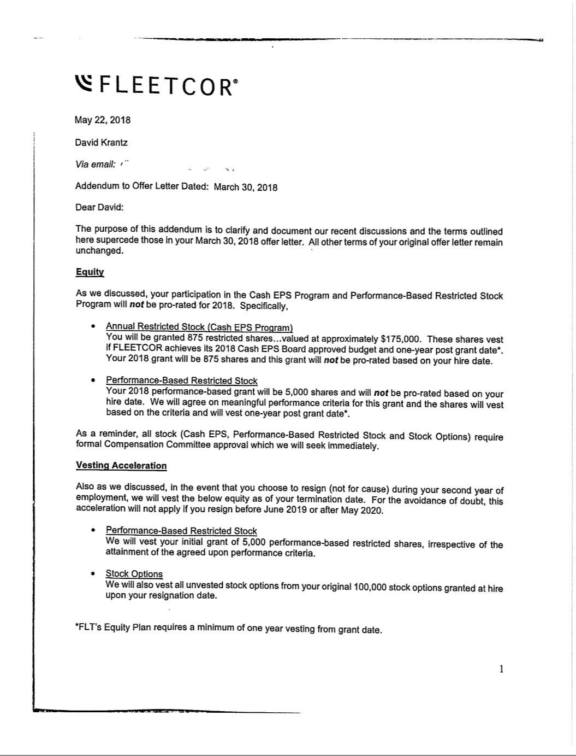

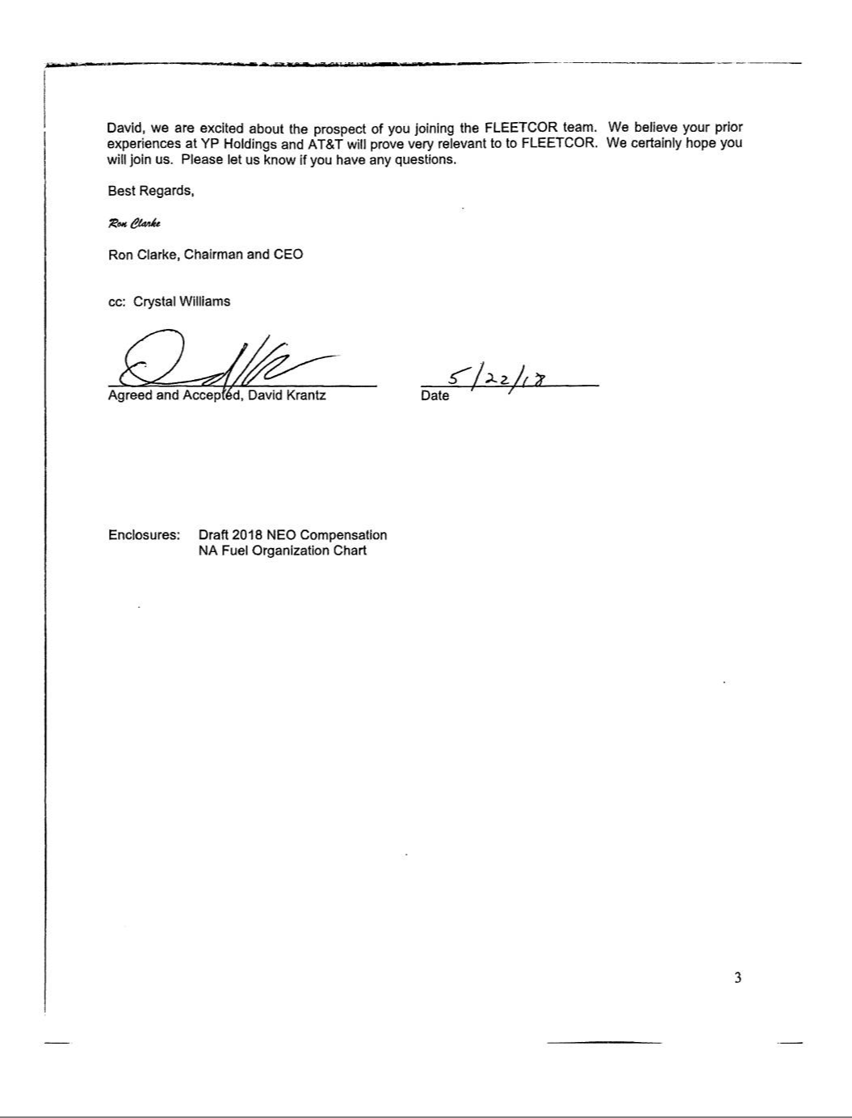

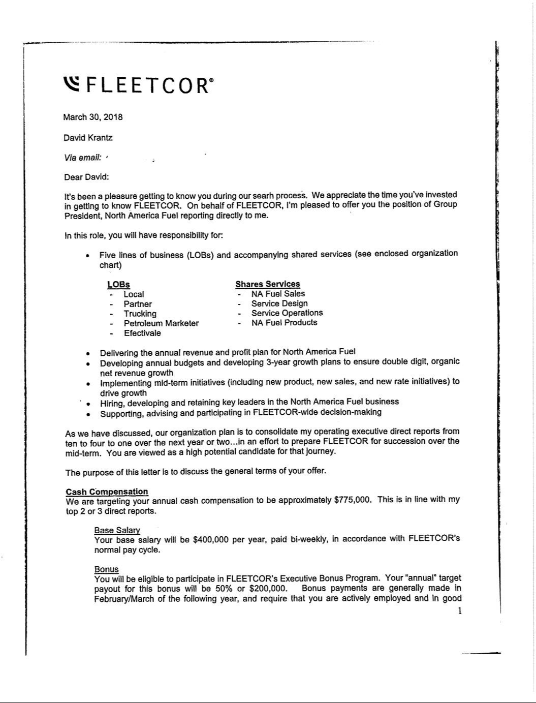

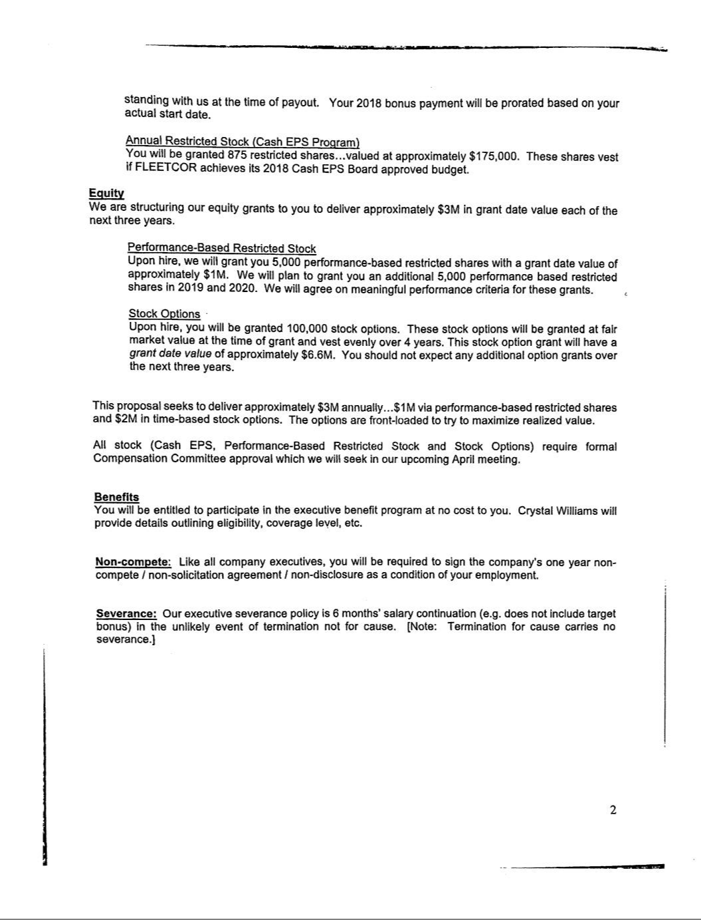

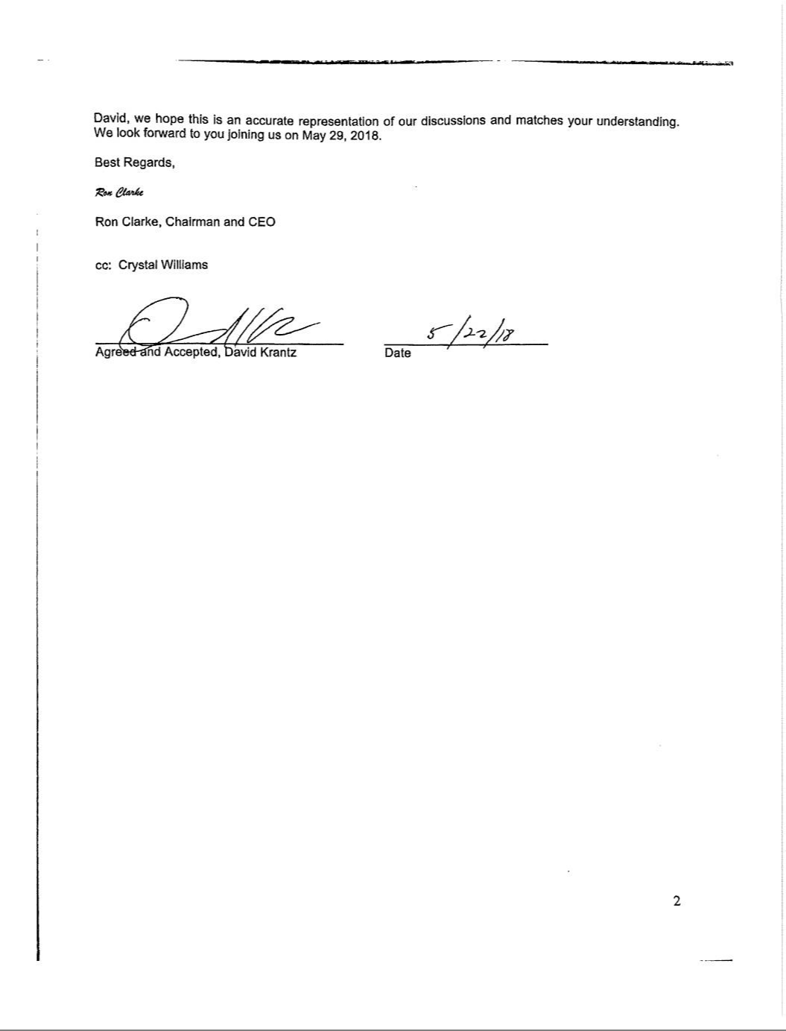

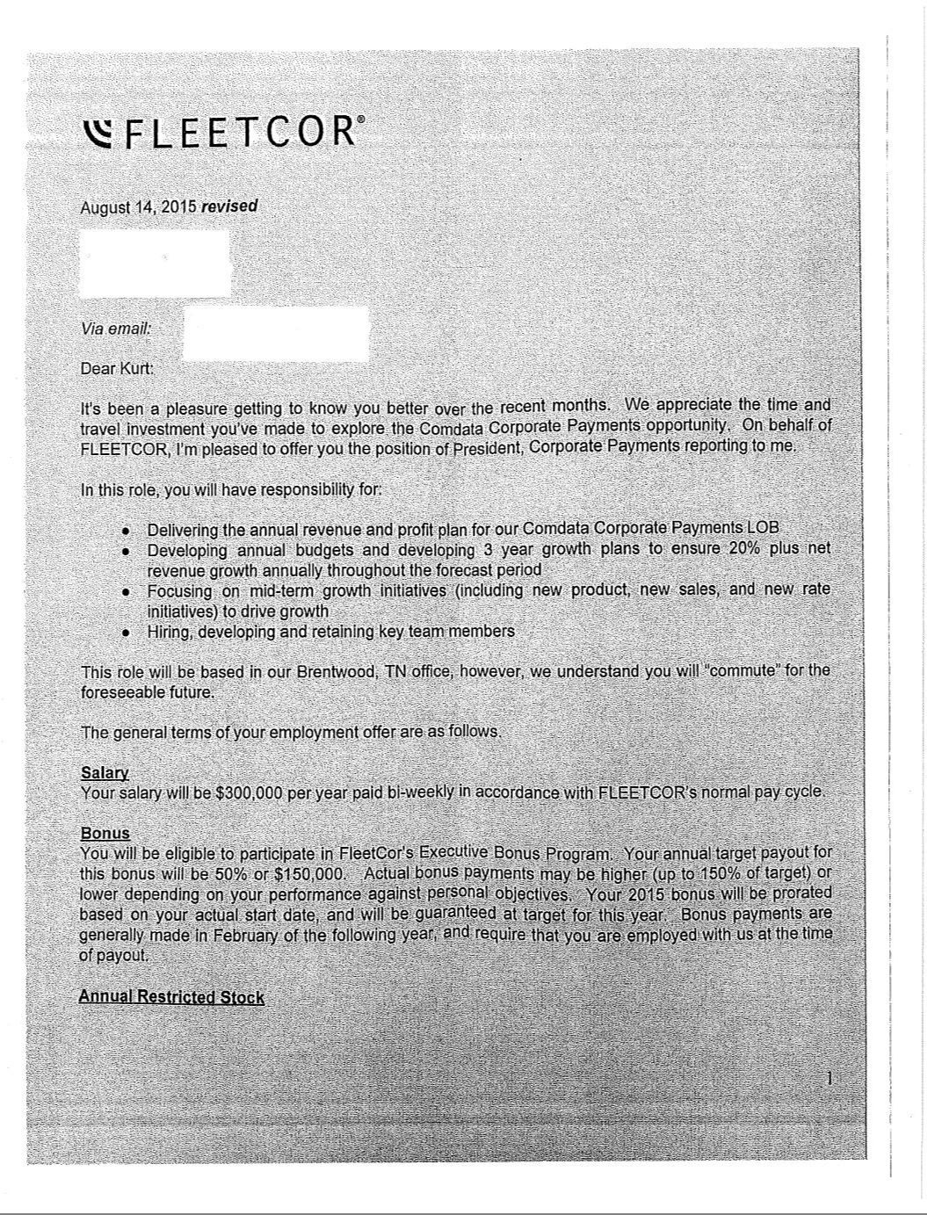

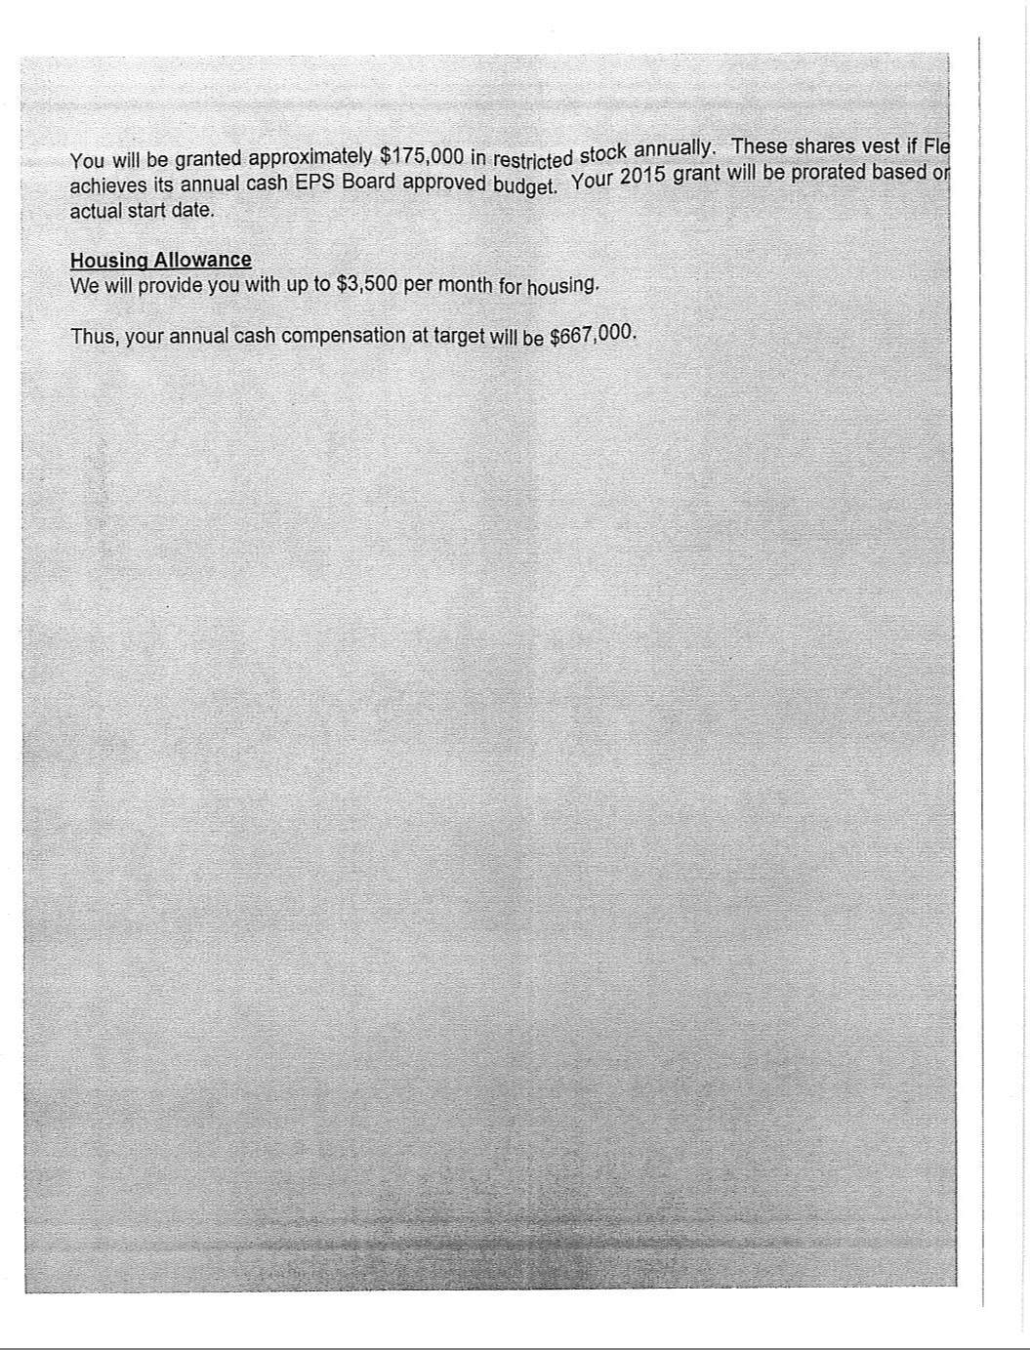

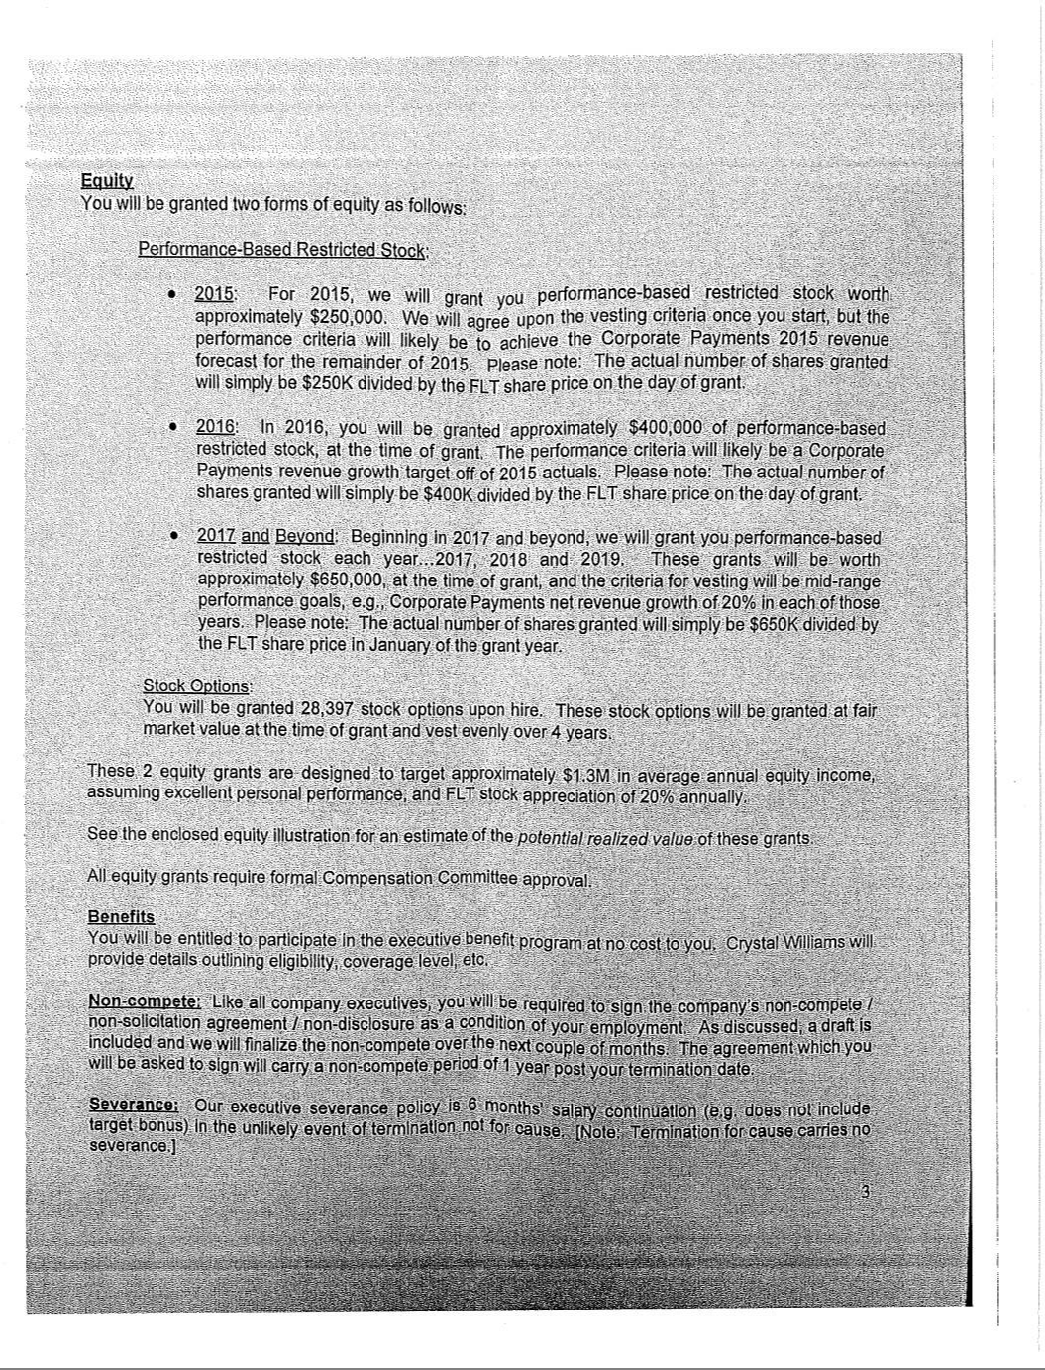

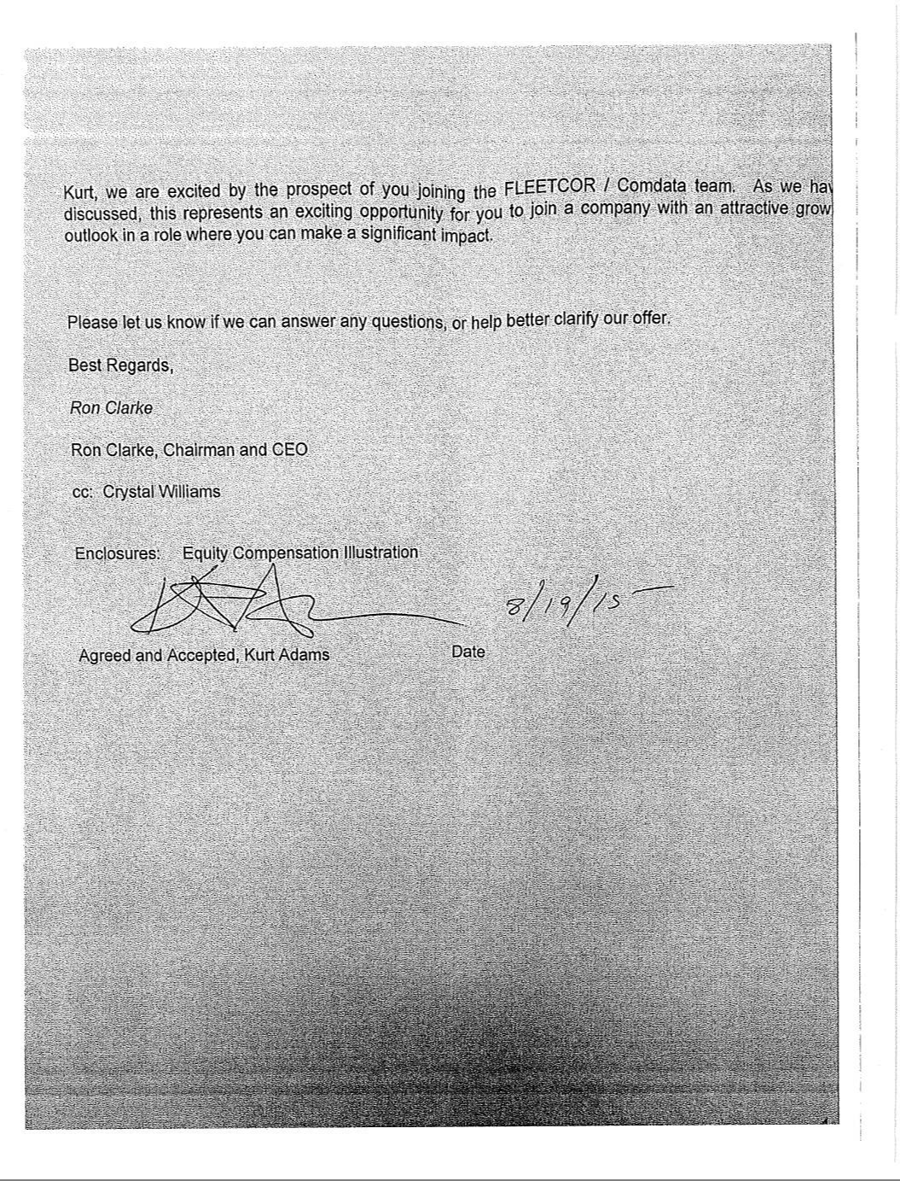

EXECUTION VERSION

FIFTH AMENDMENT TO FIFTH AMENDED AND RESTATED RECEIVABLES PURCHASE AGREEMENT

This FIFTH AMENDMENT TO FIFTH AMENDED AND RESTATED RECEIVABLES PURCHASE AGREEMENT (this “Amendment”), dated as of

December 19, 2018, is entered into by and among the following parties:

- FLEETCOR FUNDING LLC, as Seller (the “Seller”);

- FLEETCOR TECHNOLOGIES OPERATING COMPANY, LLC, as Servicer (the “Servicer”);

- PNC BANK, NATIONAL ASSOCIATION (“PNC”), as a Committed Purchaser, as the sole Swingline Purchaser and as the Purchaser Agent for its Purchaser Group;

- WELLS FARGO BANK, NATIONAL ASSOCIATION (“Wells”), as a Committed Purchaser and as the Purchaser Agent for its Purchaser Group;

- REGIONS BANK (“Regions”), as a Committed Purchaser and as the Purchaser Agent for its Purchaser Group;

- MUFG BANK, LTD. (“MUFG”), as a Committed Purchaser and as the Purchaser Agent for its and Victory’s Purchaser Group;

- VICTORY RECEIVABLES CORPORATION (“Victory”), as a Conduit Purchaser for MUFG’s Purchaser Group;

- MIZUHO BANK, LTD. (“Mizuho”), as a Committed Purchaser; and

- PNC BANK, NATIONAL ASSOCIATION, as Administrator

(in such capacity, the “Administrator”).

BACKGROUND

- The parties hereto are parties to that certain Fifth Amended and Restated Receivables Purchase Agreement dated as of November 14, 2014 (as amended, restated, supplemented or otherwise modified through the date hereof, the “Receivables Purchase Agreement”). Capitalized terms used and not otherwise defined herein have the respective meaning assigned to such terms in the Receivables Purchase Agreement.

- On the Effective Date (defined below), the Seller, as seller, and Fleetcor, as buyer, are entering into that certain Assignment Agreement in connection herewith whereby the Seller is selling now existing Chevron Receivables to Fleetcor (the “Assignment Agreement”).

- The parties hereto desire to amend the Receivables Purchase Agreement on the terms and subject to the conditions set forth herein.

NOW, THEREFORE, for good and valuable consideration, the receipt and sufficiency of which are hereby acknowledged, the parties hereto hereby agree as follows:

SECTION 1. Amendments to the Receivables Purchase Agreement. The Receivables Purchase Agreement is hereby amended on and after the Effective Date to reflect the marked changes shown on Exhibit A attached hereto.

SECTION 2. Representations and Warranties of the Seller and Servicer. Each of the Seller and the Servicer hereby represents and warrants, as to itself, to each of the Administrator, each Purchaser and each Purchaser Agent as follows as of the date hereof and on the Effective Date:

- the representations and warranties made by it in the Transaction Documents are true and correct as of the date hereof (unless stated to relate solely to an earlier date, in which case such representations or warranties were true and correct as of such earlier date);

- no event has occurred and is continuing, or would result from the transactions contemplated hereby, that constitutes a Termination Event or an Unmatured Termination Event, and the Facility Termination Date has not occurred;

- the execution and delivery by such Person of this Amendment, and the performance of each of its obligations under this Amendment and the Receivables Purchase Agreement, as amended hereby, are within each of its corporate powers and have been duly authorized by all necessary corporate action on its part; and

- this Amendment and the Receivables Purchase Agreement, as amended hereby, are such Person’s valid and legally binding obligations, enforceable in accordance with its terms.

SECTION 3. Effect of Amendment. All provisions of the Receivables Purchase Agreement, as expressly amended and modified by this Amendment, shall remain in full force and effect. After this Amendment becomes effective, all references in the Receivables Purchase Agreement (or in any other Transaction Document) to “this Receivables Purchase Agreement”, “this Agreement”, “hereof”, “herein” or words of similar effect referring to the Receivables Purchase Agreement shall be deemed to be references to the Receivables Purchase Agreement as amended by this Amendment. This Amendment shall not be deemed, either expressly or impliedly, to waive, amend or supplement any provision of the Receivables Purchase Agreement other than as set forth herein.

SECTION 4. Effectiveness. This Amendment shall be effective as of the date (such date, the “Effective Date”) on which all of the following conditions precedent have been satisfied: (a) the Administrator’s receipt of counterparts of this Amendment and the Assignment Agreement; (b) the receipt by the Seller of the amounts owing under the Assignment Agreement; and (c) receipt by the Administrator of a written notice in substantially the form of Exhibit B attached hereto (an “Effectiveness Notice”) executed by the Seller and Fleetcor; provided, however, if each of the conditions precedent set forth in this Section 4 have not been satisfied in full 60 days after the date hereof, this Amendment shall be void and have no force and effect unless such period is extended in writing by the Administrator in their sole discretion.

SECTION 5. Miscellaneous. This Amendment shall be binding upon, and inure to the benefit of, the parties hereto and their respective successors and assigns. This Amendment may be executed in any number of counterparts and by different parties on separate counterparts, each of which when so executed shall be deemed to be an original and all of which when taken together shall constitute but one and the same instrument. Delivery of an executed counterpart of a signature page to this Amendment by facsimile or electronic transmission shall be effective as delivery of a manually executed counterpart hereof.

SECTION 6. Governing Law. THIS AMENDMENT SHALL BE DEEMED TO BE A CONTRACT MADE UNDER AND GOVERNED BY THE INTERNAL LAWS OF THE STATE OF NEW YORK (INCLUDING FOR SUCH PURPOSE SECTIONS 5-1401 AND 5‑1402 OF THE GENERAL OBLIGATIONS LAW OF THE STATE OF NEW YORK).

SECTION 7. Severability. If any one or more of the agreements, provisions or terms of this Amendment shall for any reason whatsoever be held invalid or unenforceable, then such agreements, provisions or terms shall be deemed severable from the remaining agreements, provisions and terms of this Amendment and shall in no way affect the validity or enforceability of the provisions of this Amendment or the Receivables Purchase Agreement.

SECTION 8. Section Headings. The various headings of this Amendment are included for convenience only and shall not affect the meaning or interpretation of this Amendment, the Receivables Purchase Agreement or any provision hereof or thereof.

SECTION 9. Consent to Assignment Agreement. Each Person party hereby consents to Fleetcor and the Seller’s execution, delivery of the Assignment Agreement and performance of its obligations thereunder so long as the same is in substantially the form attached hereto as Exhibit C.

[SIGNATURES BEGIN ON NEXT PAGE]

IN WITNESS WHEREOF, the parties hereto have executed this Amendment by their duly authorized officers as of the date first above written.

FLEETCOR FUNDING LLC, as Seller

By: /s/ Steve Pisciotta

Name: Steve Pisciotta

Title: Treasurer

FLEETCOR TECHNOLOGIES OPERATING COMPANY, LLC, as Servicer

By: /s/ Steve Pisciotta

Name: Steve Pisciotta

Title: Treasurer

PNC BANK, NATIONAL ASSOCIATION,

as a Committed Purchaser and as Purchaser Agent for its Purchaser Group

By:/s/ Michael Brown

Name: Michael Brown

Title: Senior Vice President

WELLS FARGO BANK,

NATIONAL ASSOCIATION,

as a Committed Purchaser and as Purchaser Agent for its Purchaser Group

By:/s/ Jason Barwig

Name: Jason Barwig

Title: Assistant Vice President

REGIONS BANK, as a Committed Purchaser and as Purchaser Agent for its Purchaser Group

By: /s/ Kathy Myers

Name: Kathy Myers

Title: Vice President

MUFG BANK, LTD., as a Committed Purchaser

By:/s/ Eric Williams

Name: Eric Williams

Title: Managing Director

VICTORY RECEIVABLES CORPORATION,

as a Conduit Purchaser for MUFG Bank, LTD.’s Purchaser Group

By:/s/ Kevin J Corrigan

Name: Kevin J Corrigan

Title: Vice President

MUFG BANK, LTD., as Purchaser Agent for its and Victory Receivables Corporation’s Purchaser Group

By:/s/ Eric Williams

Name: Eric Williams

Title: Managing Director

MIZUHO BANK, LTD., as a Committed Purchaser and as Purchaser Agent for its Purchaser Group

By:/s/ Richard A. Burke

Name: Richard A. Burke

Title: Managing Director

PNC BANK, NATIONAL ASSOCIATION,

as Administrator

By:/s/ Michael Brown

Name: Michael Brown

Title: Senior Vice President

EXHIBIT A

[See Attached]

EXHIBIT B

FORM OF EFFECTIVENESS NOTICE

___________________, 201_

PNC Bank, National Association

Three PNC Plaza

225 Fifth Avenue

Pittsburgh, PA 15222

Attention: Robyn Reeher

Re: Notice of Effectiveness: Fifth Amendment to Fifth A&R Receivables Purchase Agreement

Reference is hereby made to that certain Fifth Amendment to Fifth A&R Receivables Purchase Agreement (the “Amendment”), dated as of December 19, 2018, among FLEETCOR FUNDING LLC, as Seller (the “Seller”), FLEETCOR TECHNOLOGIES OPERATING COMPANY, LLC, as Servicer (the “Servicer”) and Buyer (the “Buyer”), PNC BANK, NATIONAL ASSOCIATION (“PNC”), as a Committed Purchaser, as the sole Swingline Purchaser and as the Purchaser Agent for its Purchaser Group; WELLS FARGO BANK, NATIONAL ASSOCIATION (“Wells”), as a Committed Purchaser and as the Purchaser Agent for its Purchaser Group, REGIONS BANK (“Regions”), as a Committed Purchaser and as the Purchaser Agent for its Purchaser Group, MUFG BANK, LTD. (“MUFG”), as a Committed Purchaser and as the Purchaser Agent for its and Victory’s Purchaser Group, VICTORY RECEIVABLES CORPORATION (“Victory”), as a Conduit Purchaser for MUFG’s Purchaser Group, MIZUHO BANK, LTD. (“Mizuho”), as a Committed Purchaser, and PNC BANK, NATIONAL ASSOCIATION, as Administrator (in such capacity, the “Administrator”). Capitalized terms that are used but not defined herein shall have the meanings set forth in, or by reference in, the Amendment. This notice is the “Effectiveness Notice” as defined in the Amendment.

Pursuant to Section 4 of the Amendment, the Seller hereby provides notice to the Administrator that the Seller desires that the Amendment become effective as of the date hereof.

[Signatures follow]

FLEETCOR FUNDING LLC,

as the Seller

By: |  | __________________________
Name:
Title:

FLEETCOR TECHNOLOGIES OPERATING COMPANY, LLC,

as the Buyer

By:

Name:

Title:

EXHIBIT C

ASSIGNMENT AGREEMENT

730571915 04351262

MB DRAFT 2/5/19

SIXTH AMENDMENT TO FIFTH AMENDED AND RESTATED RECEIVABLES PURCHASE AGREEMENT

This SIXTH AMENDMENT TO FIFTH AMENDED AND RESTATED RECEIVABLES PURCHASE AGREEMENT (this “Amendment”), dated as of

February [8], 2019, is entered into by and among the following parties:

- FLEETCOR FUNDING LLC, as Seller (the “Seller”);

- FLEETCOR TECHNOLOGIES OPERATING COMPANY, LLC, as Servicer (the “Servicer”);

- PNC BANK, NATIONAL ASSOCIATION (“PNC”), as a Committed Purchaser, as the sole Swingline Purchaser and as the Purchaser Agent for its Purchaser Group;

- WELLS FARGO BANK, NATIONAL ASSOCIATION (“Wells”), as a Committed Purchaser and as the Purchaser Agent for its Purchaser Group;

- REGIONS BANK (“Regions”), as a Committed Purchaser and as the Purchaser Agent for its Purchaser Group;

- MUFG BANK, LTD. (“MUFG”), as a Committed Purchaser and as the Purchaser Agent for its and Victory’s Purchaser Group;

- VICTORY RECEIVABLES CORPORATION (“Victory”), as a Conduit Purchaser for MUFG’s Purchaser Group;

- MIZUHO BANK, LTD. (“Mizuho”), as a Committed Purchaser and as the Purchaser Agent for its Purchaser Group;

- THE TORONTO-DOMINION BANK (“TD Bank”), as a Committed Purchaser and as the Purchaser Agent for its and Reliant Trust’s Purchaser Group;

- RELIANT TRUST (“Reliant Trust”), as a Conduit Purchaser for TD Bank’s Purchaser Group;

- THE BANK OF NOVA SCOTIA (“Scotia”), as a Committed Purchaser and as the Purchaser Agent for its and Liberty Street’s Purchaser Group;

- LIBERTY STREET FUNDING LLC, as a Conduit Purchaser for Scotia’s Purchaser Group; and

- PNC BANK, NATIONAL ASSOCIATION, as Administrator

(in such capacity, the “Administrator”).

BACKGROUND

- The parties hereto (with the exception of Reliant Trust, TD Bank, Liberty Street and Scotia (the “Additional Purchasers”)) are parties to that certain Fifth Amended and Restated Receivables Purchase Agreement dated as of November 14, 2014 (as amended, restated, supplemented or otherwise modified through the date hereof, the “Receivables Purchase Agreement”). Capitalized terms used and not otherwise defined herein have the respective meaning assigned to such terms in the Receivables Purchase Agreement.

- Concurrently herewith, the parties hereto are entering into that certain Amended and Restated Fee Letter in connection herewith (the “Amended Fee

Letter”).

- The parties hereto desire to amend the Receivables Purchase Agreement on the terms and subject to the conditions set forth herein.

NOW, THEREFORE, for good and valuable consideration, the receipt and sufficiency of which are hereby acknowledged, the parties hereto hereby agree as follows:

SECTION 1. Joinder and Rebalancing.

- Joinder. Effective as of the date hereof, (i) each of Reliant Trust and Liberty Street hereby becomes a party to this Agreement as a Conduit Purchaser hereunder with all the rights, interests, duties and obligations of a Conduit Purchaser hereunder, (ii) each of TD Bank and Scotia hereby becomes a party to this Agreement as a Committed Purchaser hereunder with all the rights, interests, duties and obligations of a Committed Purchaser hereunder, (iii) TD Bank, as a Committed Purchaser and Reliant Trust, as its related Conduit Purchaser, shall constitute the members of a new Purchaser Group, and TD Bank and Reliant Trust hereby appoint TD Bank as the Purchaser Agent for such Purchaser Group, (iv) Scotia, as a Committed Purchaser and Liberty Street, as its related Conduit Purchaser, shall constitute the members of a new Purchaser Group, and Scotia and Liberty Street hereby appoint Scotia as the Purchaser Agent for such Purchaser Group, and (v) each of each of TD Bank and Scotia hereby becomes a party to this Agreement as a Purchaser Agent hereunder with all the rights, interests, duties and obligations of a Purchaser Agent hereunder. In its capacity as a Committed Purchaser, each Additional Purchaser’s Commitment shall be the amount set forth on Schedule V hereto.

- Rebalancing of Capital. On the date hereof, the Seller will repay a portion of the outstanding Capital in the amounts for PNC (the “Reducing Purchaser”) specified in the flow of funds memorandum attached hereto as Exhibit A; provided that all accrued and unpaid Discount with respect to such Capital so repaid shall be payable by the Seller to the Reducing Purchaser, as applicable, on the next occurring Weekly Settlement Date. The Seller hereby requests that Regions, Victory, Mizuho, Reliant Trust and Liberty Street (collectively, the “Increasing Purchasers”) fund a Purchase on the date hereof in an amount set forth in Exhibit A hereto. Such Purchase shall be funded by each Increasing Purchasers on the date hereof in accordance with the terms of the Receivables Purchase Agreement and upon satisfaction of all conditions precedent thereto specified in the Receivables Purchase Agreement; provided, however, that no Purchase Notice shall be required therefor. For administrative convenience, the Seller hereby instructs the Increasing Purchasers to fund the foregoing Purchase by paying the proceeds thereof directly to the Reducing Purchaser to the account and in the amounts specified in Exhibit A hereto to be applied as the foregoing repayment of the Reducing Purchaser’s Capital (as applicable) on the Seller’s behalf. The Seller shall be deemed to have received the proceeds of such Purchase from the Increasing Purchasers for all purposes immediately upon receipt thereof by the Reducing Purchaser, respectively.

- Consents. The parties hereto hereby consent to the joinder of the Additional Purchasers as parties to the Receivables Purchase Agreement on the terms set forth in clause (a) above, to the non-ratable repayment of the Reducing Purchaser’s Capital on terms set forth in clause (b) above and the foregoing non-ratable Purchase to be funded by the Increasing Purchasers on the terms set forth in clause (b) above, in each case, as set forth above on a one-time basis.

- Credit Decision. Each Additional Purchaser (i) confirms to the Administrator that it has received a copy of the Receivables Purchase Agreement, the other Transaction Documents, and such other documents and information as it has deemed appropriate to make its own credit analysis and decision to enter into this Amendment and (ii) agrees that it will, independently and without reliance upon the Administrator (in any capacity) or any of its Affiliates, based on such documents and information as each Additional Purchaser shall deem appropriate at the time, continue to make its own credit decisions in taking or not taking action under the Receivables Purchase Agreement and any other Transaction Document. The Administrator makes no representation or warranty and assumes no responsibility with respect to (x) any statements, warranties or representations made in or in connection with the

Receivables Purchase Agreement, any other Transaction Document or any other instrument or document furnished pursuant thereto or the execution, legality, validity, enforceability, genuineness, sufficiency or value of the Receivables Purchase Agreement or the Receivables, any other Transaction Document or any other instrument or document furnished pursuant thereto or (y) the financial condition of any of the Seller, the Servicer, the parties to the Performance Guaranty or the Originators or the performance or observance by any of the Seller, the Servicer, the parties to the Performance Guaranty or the Originators of any of their respective obligations under the Receivables Purchase Agreement, any other Transaction Document, or any instrument or document furnished pursuant thereto.

- CP Rate. Reliant Trust hereby notifies the Seller, the Servicer and TD Bank that the “CP Rate” for Reliant Trust shall be determined pursuant to clause (b) of the definition thereof and the “CP Rate” so designated by Reliant shall be a rate equal to LMIR.

- Fifth Amendment. Each Additional Purchaser acknowledges and consents to the terms of the Fifth Amendment to the Receivables Purchase Agreement and the transactions contemplated thereby.

- Notice Addresses. Notices to each Additional Purchaser under the Transaction Documents should be sent to the address set forth below, or such other address designated by each Additional Purchaser from time to time in accordance with the Receivables Purchase Agreement:

If to Reliant Trust:

Address: Reliant Trust

130 Adelaide Street West
12th Floor

Toronto, ON, M5H 3P5

If to The Toronto-Dominion Bank:

Address: The Toronto-Dominion Bank

130 Adelaide Street West
12th Floor

Toronto, ON, M5H 3P5

Attention: ASG Asset Securitization

Email: asgoperations@tdsecurities.com

With a copy to:

Email: kristi.pahapill@tdsecurities.com

If to Liberty Street Funding LLC:

Address: Liberty Street Funding LLC

c/o Global Securitization Services, LLC

68 South Service Road, Suite 120

Melville, New York 11747

Attention: Jill A. Russo

Telephone No.: (212) 295-2742

Facsimile No.: (212) 302-8767

If to The Bank of Nova Scotia:

Address: The Bank of Nova Scotia

40 King Street W

Toronto, ON, M5W 2X6

Attention: Diane Emanuel

Telephone No.: (416) 350-1166

Email: diane.emanuel@scotiabank.com

With a copy to:

Address: The Bank of Nova Scotia

250 Vesey Street, 23rd Floor

New York, NY 10281

Attention: Darren Ward

Telephone No.: (212) 225-5264

Email: darren.ward@scotiabank.com

SECTION 2. Amendments to the Receivables Purchase Agreement. The Receivables Purchase Agreement is hereby amended as follows:

- The definition of “Concentration Percentage” set forth in Exhibit I to the Receivables Purchase Agreement is hereby amended and restated in its entirety as follows:

“Concentration Percentage” means (a) for each of the following Obligors: (i) Landstar Systems, Inc., (ii) United Parcel Service, Inc. and (iii) GoWireless, Inc., 4.00%, and (b) for any other Obligor, 3.00%.

- The definition of “Concentration Reserve Percentage” set forth in Exhibit I to the Receivables Purchase Agreement is hereby amended by deleting the percentage “10.00%” where it appears therein and substituting “13.00%” therefor.

- The definition of “Credit Risk Retention Rules” set forth in Exhibit I to the Receivables Purchase Agreement is hereby amended by deleting the phrase “Articles 404-410 of the EU Capital Requirements Regulation (including Article 122a of the Banking Consolidation Directive)” where it appears therein and substituting “Articles 5 and 6 of Regulation (EU) 2017/2402 of the European Parliament and of the Council” therefor.

- Schedule V to the Receivables Purchase Agreement is hereby replaced in its entirety with Schedule V attached hereto.

SECTION 3. Representations and Warranties of the Seller and Servicer. Each of the Seller and the Servicer hereby represents and warrants, as to itself, to each of the Administrator, each Purchaser and each Purchaser Agent as follows as of the date hereof:

- the representations and warranties made by it in the Transaction Documents are true and correct as of the date hereof (unless stated to relate solely to an earlier date, in which case such representations or warranties were true and correct as of such earlier date);

- no event has occurred and is continuing, or would result from the transactions contemplated hereby, that constitutes a Termination Event or an Unmatured Termination Event, and the Facility Termination Date has not occurred;

- the execution and delivery by such Person of this Amendment, and the performance of each of its obligations under this Amendment and the Receivables Purchase Agreement, as amended hereby, are within each of its corporate powers and have been duly authorized by all necessary corporate action on its part; and

- this Amendment and the Receivables Purchase Agreement, as amended hereby, are such Person’s valid and legally binding obligations, enforceable in accordance with its terms.

SECTION 4. Effect of Amendment. All provisions of the Receivables Purchase Agreement, as expressly amended and modified by this Amendment, shall remain in full force and effect. After this Amendment becomes effective, all references in the Receivables Purchase Agreement (or in any other Transaction Document) to “this Receivables Purchase Agreement”, “this Agreement”, “hereof”, “herein” or words of similar effect referring to the Receivables Purchase Agreement shall be deemed to be references to the Receivables Purchase Agreement as amended by this Amendment. This Amendment shall not be deemed, either expressly or impliedly, to waive, amend or supplement any provision of the Receivables Purchase Agreement other than as set forth herein.

SECTION 5. Effectiveness. This Amendment shall be effective as of the date hereof and upon satisfaction of the following conditions precedent: (a) the Administrator’s receipt of (i) counterparts of this Amendment and the Amended Fee Letter duly executed by each of the parties hereto and (ii) such other agreements, documents, opinions, and instruments as the Administrator shall request, (b) the receipt by each Purchaser Agent of the fees owing under the Amended Fee Letter.

SECTION 6. Miscellaneous. This Amendment shall be binding upon, and inure to the benefit of, the parties hereto and their respective successors and assigns. This Amendment may be executed in any number of counterparts and by different parties on separate counterparts, each of which when so executed shall be deemed to be an original and all of which when taken together shall constitute but one and the same instrument. Delivery of an executed counterpart of a signature page to this Amendment by facsimile or electronic transmission shall be effective as delivery of a manually executed counterpart hereof.

SECTION 7. Governing Law. THIS AMENDMENT SHALL BE DEEMED TO BE A CONTRACT MADE UNDER AND GOVERNED BY THE INTERNAL LAWS OF THE STATE OF NEW YORK (INCLUDING FOR SUCH PURPOSE SECTIONS 5-1401 AND 5‑1402 OF THE GENERAL OBLIGATIONS LAW OF THE STATE OF NEW YORK).

SECTION 8. Severability. If any one or more of the agreements, provisions or terms of this Amendment shall for any reason whatsoever be held invalid or unenforceable, then such agreements, provisions or terms shall be deemed severable from the remaining agreements, provisions and terms of this Amendment and shall in no way affect the validity or enforceability of the provisions of this Amendment or the Receivables Purchase Agreement.

SECTION 9. Section Headings. The various headings of this Amendment are included for convenience only and shall not affect the meaning or interpretation of this Amendment, the Receivables Purchase Agreement or any provision hereof or thereof.

[SIGNATURES BEGIN ON NEXT PAGE]

IN WITNESS WHEREOF, the parties hereto have executed this Amendment by their duly authorized officers as of the date first above written.

FLEETCOR FUNDING LLC, as Seller

By:/s/ Steve Pisciotta

Name: Steve Pisciotta

Title: Treasurer

FLEETCOR TECHNOLOGIES OPERATING COMPANY, LLC, as Servicer

By:/s/ Steve Pisciotta

Name: Steve Pisciotta

Title: Treasurer

PNC BANK, NATIONAL ASSOCIATION,

as a Committed Purchaser and as Purchaser Agent for its Purchaser Group

By:/s/ Michael Brown

Name: Michael Brown

Title: Senior Vice President

WELLS FARGO BANK,

NATIONAL ASSOCIATION,

as a Committed Purchaser and as Purchaser Agent for its Purchaser Group

By:/s/ Jason Barwig

Name: Jason Barwig

Title: Assistant Vice President

REGIONS BANK, as a Committed Purchaser and as Purchaser Agent for its Purchaser Group

By:/s/ Kathy Myers

Name: Kathy Myers

Title: Vice President

MUFG BANK, LTD., as a Committed Purchaser

By:/s/ Eric Williams

Name: Eric Williams

Title: Managing Director

VICTORY RECEIVABLES CORPORATION,

as a Conduit Purchaser for MUFG Bank, Ltd.’s Purchaser Group

By:/s/ Kevin J Corrigan

Name: Kevin J Corrigan

Title: Vice President

MUFG BANK, LTD., as Purchaser Agent for its and Victory Receivables Corporation’s Purchaser Group

By:/s/ Eric Williams

Name: Eric Williams

Title: Managing Director

MIZUHO BANK, LTD., as a Committed Purchaser and as Purchaser Agent for its Purchaser Group

By:/s/ Richard A. Burke

Name: Richard A. Burke

Title: Managing Director

THE TORONTO-DOMINION BANK, as a Committed Purchaser

By:/s/ Bradley Purkis

Name: Bradley Purkis

Title: Managing Director

COMPUTERSHARE TRUST COMPANY OF CANADA, in its capacity as trustee of RELIANT TRUST, by its U.S. Financial Services Agent, THE TORONTO-DOMINION BANK, as a Conduit Purchaser for The Toronto-Domino Bank’s Purchaser Group

By:/s/ Bradley Purkis

Name: Bradley Purkis

Title: Managing Director

THE TORONTO-DOMINION BANK, as Purchaser Agent for its and Reliant Trust’s Purchaser Group

By:/s/ Bradley Purkis

Name: Bradley Purkis

Title: Managing Director

THE BANK OF NOVA SCOTIA, as a Committed Purchaser

By:/s/ Diane Emanuel

Name: Diane Emanuel

Title: Managing Director & Co-Head U.S. Execution

LIBERTY STREET FUNDING LLC, as a Conduit Purchaser for The Bank of Nova Scotia’s Purchaser Group

By:/s/ Jill A. Russo

Name: Jill A. Russo

Title: Vice President

THE BANK OF NOVA SCOTIA, as Purchaser Agent for its and Liberty Street Funding LLC’s Purchaser Group

By:/s/ Diane Emanuel

Name: Diane Emanuel

Title: Managing Director & Co-Head U.S. Execution

PNC BANK, NATIONAL ASSOCIATION,

as Administrator

By:/s/ Michael Brown

Name: Michael Brown

Title: Senior Vice President

 |  |  |  |  |  | SCHEDULE V
 |  |  | PURCHASER GROUPS AND COMMITMENTS
 | Purchaser Group of PNC Bank, National Association
 | Party |  |  | Capacity |  |  | Commitment
 | PNC Bank, National Association |  |  | Committed Purchaser |  |  | $370,000,000
 | PNC Bank, National Association |  |  | Purchaser Agent |  |  | N/A
 | Purchaser Group of Wells Fargo Bank, National Association
 | Party |  |  | Capacity |  |  | Commitment
 | Wells Fargo Bank, National Association |  |  | Committed Purchaser |  |  | $190,000,000
 | Wells Fargo Bank, National Association |  |  | Purchaser Agent |  |  | N/A
 | Purchaser Group of Regions Bank
 | Party |  |  | Capacity |  |  | Commitment
 | Regions Bank |  |  | Committed Purchaser |  |  | $125,000,000
 | Regions Bank |  |  | Purchaser Agent |  |  | N/A
 | Purchaser Group of MUFG Bank, Ltd.
 | Party |  |  | Capacity |  |  | Commitment
 | Victory Receivables Corporation |  |  | Conduit Purchaser |  |  | N/A
 | MUFG Bank, Ltd. |  |  | Committed Purchaser |  |  | $190,000,000
 | MUFG Bank, Ltd. |  |  | Purchaser Agent |  |  | N/A
 | Purchaser Group of Mizuho Bank, Ltd.
 | Party |  |  | Capacity |  |  | Commitment
 | Mizuho Bank, Ltd. |  |  | Committed Purchaser |  |  | $125,000,000
 | Mizuho Bank, Ltd. |  |  | Purchaser Agent |  |  | N/A
 | Purchaser Group of The Toronto-Dominion Bank
 | Party |  |  | Capacity |  |  | Commitment
 | Reliant Trust |  |  | Conduit Purchaser |  |  | N/A
 | The Toronto-Dominion Bank |  |  | Committed Purchaser |  |  | $125,000,000
 | The Toronto-Dominion Bank |  |  | Purchaser Agent |  |  | N/A
 | Purchaser Group of The Bank of Nova Scotia
 | Party |  |  | Capacity |  |  | Commitment
 | Liberty Street Funding LLC |  |  | Conduit Purchaser |  |  | N/A
 | The Bank of Nova Scotia |  |  | Committed Purchaser |  |  | $75,000,000
 | The Bank of Nova Scotia |  |  | Purchaser Agent |  |  | N/A

EXHIBIT A

FLOW OF FUNDS MEMORANDUM

[See Attached]

731105780 04351262

Exhibit 31.1

CERTIFICATIONS

I, Ronald F. Clarke, certify that:

- I have reviewed this quarterly report on Form 10-Q of FleetCor Technologies, Inc.;

- Based on my knowledge, this report does not contain any untrue statement of a material fact or omit to state a material fact necessary to make the statements made, in light of the circumstances under which such statements were made, not misleading with respect to the period covered by this report;

- Based on my knowledge, the financial statements, and other financial information included in this report, fairly present in all material respects the financial condition, results of operations and cash flows of the registrant as of, and for, the periods presented in this report;

- The registrant’s other certifying officer and I are responsible for establishing and maintaining disclosure controls and procedures (as defined in Exchange Act Rules 13a-15(e) and 15d-15(e)) and internal control over financial reporting (as defined in Exchange Act Rules 13a-15(f) and 15d-15(f)) for the registrant and have:

- Designed such disclosure controls and procedures, or caused such disclosure controls and procedures to be designed under our supervision, to ensure that material information relating to the registrant, including its consolidated subsidiaries, is made known to us by others within those entities, particularly during the period in which this report is being prepared;

- Designed such internal control over financial reporting, or caused such internal control over financial reporting to be designed under our supervision, to provide reasonable assurance regarding the reliability of financial reporting and the preparation of financial statements for external purposes in accordance with generally accepted accounting principles;

- Evaluated the effectiveness of the registrant’s disclosure controls and procedures and presented in this report our conclusions about the effectiveness of the disclosure controls and procedures, as of the end of the period covered by this report based on such evaluation; and

- Disclosed in this report any change in the registrant’s internal control over financial reporting that occurred during the registrant’s most recent fiscal quarter (the registrant’s fourth fiscal quarter in the case of an annual report) that has materially affected, or is reasonably likely to materially affect, the registrant’s internal control over financial reporting; and

- The registrant’s other certifying officer and I have disclosed, based on our most recent evaluation of internal control over financial reporting, to the registrant’s auditors and the audit committee of the registrant’s Board of Directors (or persons performing the equivalent functions):

- All significant deficiencies and material weaknesses in the design or operation of internal control over financial reporting which are reasonably likely to adversely affect the registrant’s ability to record, process, summarize and report financial information; and

- Any fraud, whether or not material, that involves management or other employees who have a significant role in the registrant’s internal control over financial reporting.

/s/ Ronald F. Clarke

Ronald F. Clarke

Chief Executive Officer

May 10, 2019

Exhibit 31.2

CERTIFICATIONS

I, Eric R. Dey, certify that:

- I have reviewed this quarterly report on Form 10-Q of FleetCor Technologies, Inc.;

- Based on my knowledge, this report does not contain any untrue statement of a material fact or omit to state a material fact necessary to make the statements made, in light of the circumstances under which such statements were made, not misleading with respect to the period covered by this report;

- Based on my knowledge, the financial statements, and other financial information included in this report, fairly present in all material respects the financial condition, results of operations and cash flows of the registrant as of, and for, the periods presented in this report;

- The registrant’s other certifying officer and I are responsible for establishing and maintaining disclosure controls and procedures (as defined in Exchange Act Rules 13a-15(e) and 15d-15(e)) and internal control over financial reporting (as defined in Exchange Act Rules 13a-15(f) and 15d-15(f)) for the registrant and have:

- Designed such disclosure controls and procedures, or caused such disclosure controls and procedures to be designed under our supervision, to ensure that material information relating to the registrant, including its consolidated subsidiaries, is made known to us by others within those entities, particularly during the period in which this report is being prepared;

- Designed such internal control over financial reporting, or caused such internal control over financial reporting to be designed under our supervision, to provide reasonable assurance regarding the reliability of financial reporting and the preparation of financial statements for external purposes in accordance with generally accepted accounting principles;

- Evaluated the effectiveness of the registrant’s disclosure controls and procedures and presented in this report our conclusions about the effectiveness of the disclosure controls and procedures, as of the end of the period covered by this report based on such evaluation; and

- Disclosed in this report any change in the registrant’s internal control over financial reporting that occurred during the registrant’s most recent fiscal quarter (the registrant’s fourth fiscal quarter in the case of an annual report) that has materially affected, or is reasonably likely to materially affect, the registrant’s internal control over financial reporting; and

- The registrant’s other certifying officer and I have disclosed, based on our most recent evaluation of internal control over financial reporting, to the registrant’s auditors and the audit committee of the registrant’s Board of Directors (or persons performing the equivalent functions):

- All significant deficiencies and material weaknesses in the design or operation of internal control over financial reporting which are reasonably likely to adversely affect the registrant’s ability to record, process, summarize and report financial information; and

- Any fraud, whether or not material, that involves management or other employees who have a significant role in the registrant’s internal control over financial reporting.

/s/ Eric R. Dey

Eric R. Dey

Chief Financial Officer

May 10, 2019

Exhibit 32.1

CERTIFICATIONS PURSUANT TO

SECTION 906 OF THE SARBANES-OXLEY ACT OF 2002

(18 U.S.C. SECTION 1350)

In connection with the Quarterly Report of FleetCor Technologies, Inc., a Delaware corporation (the “Company”), on Form 10-Q for the period ended March 31, 2019, as filed with the Securities and Exchange Commission (the “Report”), Ronald F. Clarke, Chief Executive Officer of the Company, does hereby certify, pursuant to § 906 of the Sarbanes-Oxley Act of 2002 (18 U.S.C. § 1350), that to his knowledge:

- The Report fully complies with the requirements of Section 13(a) or 15(d) of the Securities Exchange Act of 1934; and

- The information contained in the Report fairly presents, in all material respects, the financial condition and results of operations of the Company.

/s/ Ronald F. Clarke

Ronald F. Clarke

Chief Executive Officer

May 10, 2019

[A signed original of this written statement required by Section 906 has been provided to FleetCor Technologies, Inc. and will be retained by FleetCor Technologies, Inc. and furnished to the Securities and Exchange Commission or its staff upon request.]

Exhibit 32.2

CERTIFICATIONS PURSUANT TO

SECTION 906 OF THE SARBANES-OXLEY ACT OF 2002

(18 U.S.C. SECTION 1350)

In connection with the Quarterly Report of FleetCor Technologies, Inc., a Delaware corporation (the “Company”), on Form 10-Q for the period ended March 31, 2019, as filed with the Securities and Exchange Commission (the “Report”), Eric R. Dey, Chief Financial Officer of the Company, does hereby certify, pursuant to § 906 of the Sarbanes-Oxley Act of 2002 (18 U.S.C. § 1350), that to his knowledge:

- The Report fully complies with the requirements of Section 13(a) or 15(d) of the Securities Exchange Act of 1934; and

- The information contained in the Report fairly presents, in all material respects, the financial condition and results of operations of the Company.

/s/ Eric R. Dey

Eric R. Dey

Chief Financial Officer

May 10, 2019

[A signed original of this written statement required by Section 906 has been provided to FleetCor Technologies, Inc. and will be retained by FleetCor Technologies, Inc. and furnished to the Securities and Exchange Commission or its staff upon request.]

